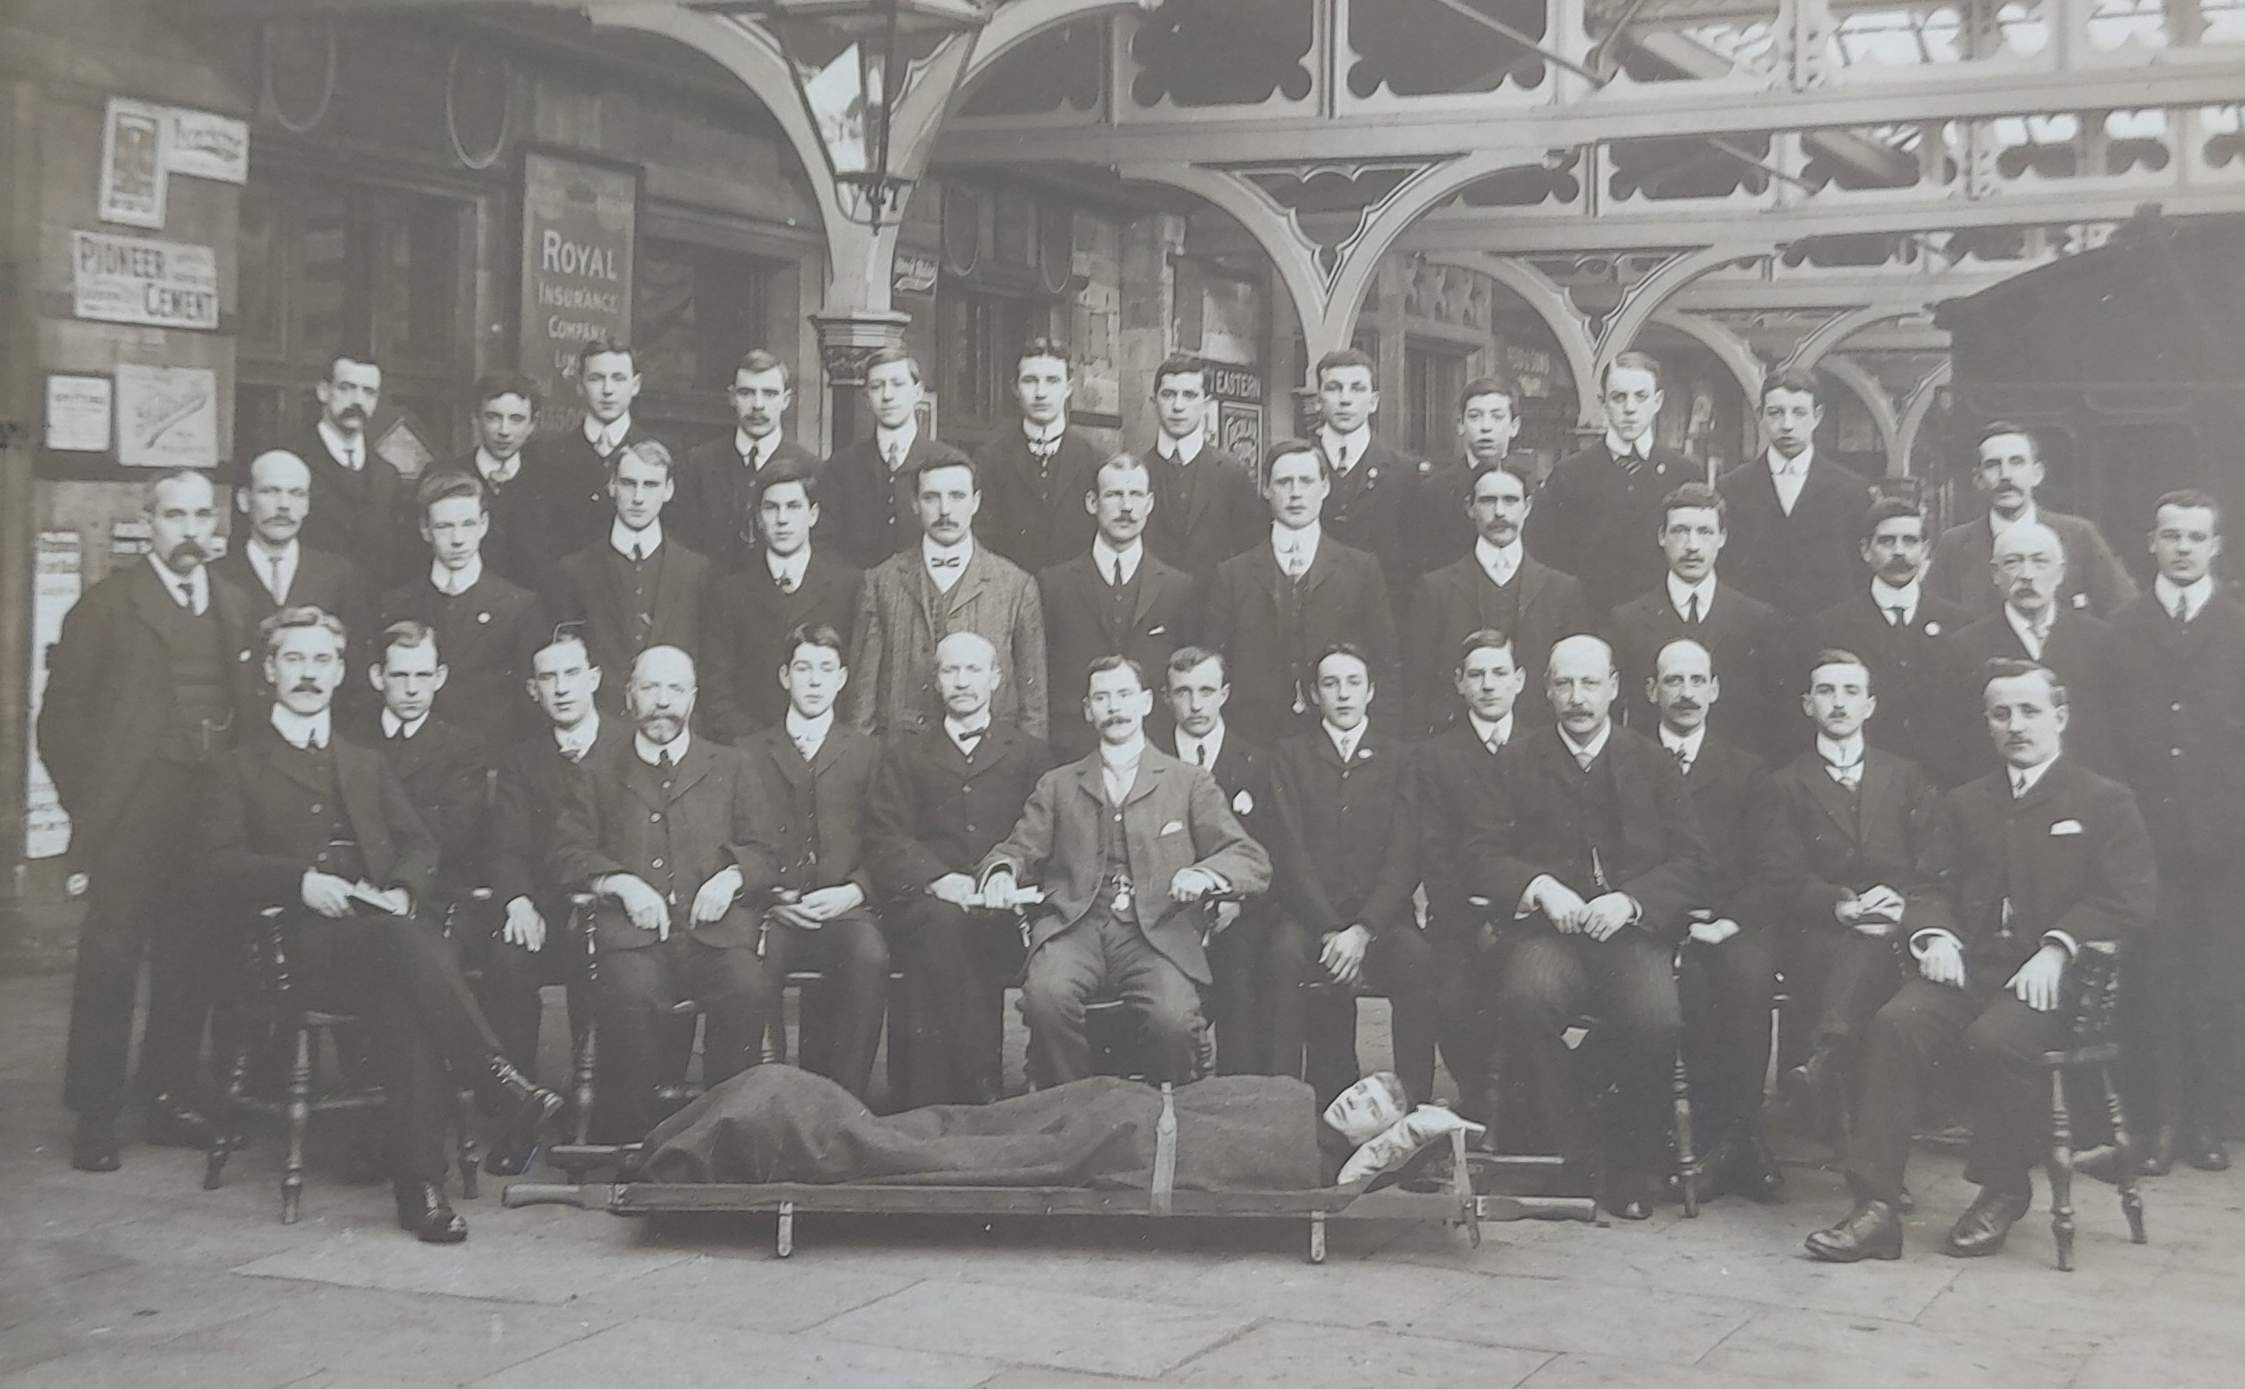
Talking Tees Valley Activity Pack
Dangerous Railways
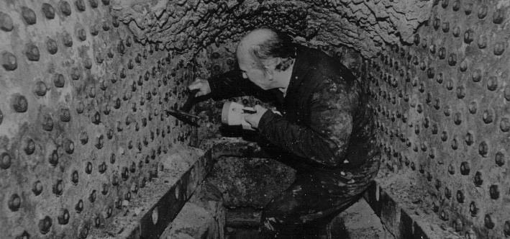

1

Welcome to another edition of the Talking Tees Valley Activity Pack

Each month we will use objects from our museums in the Tees Valley to take a closer look at the lives and stories from people in our area.

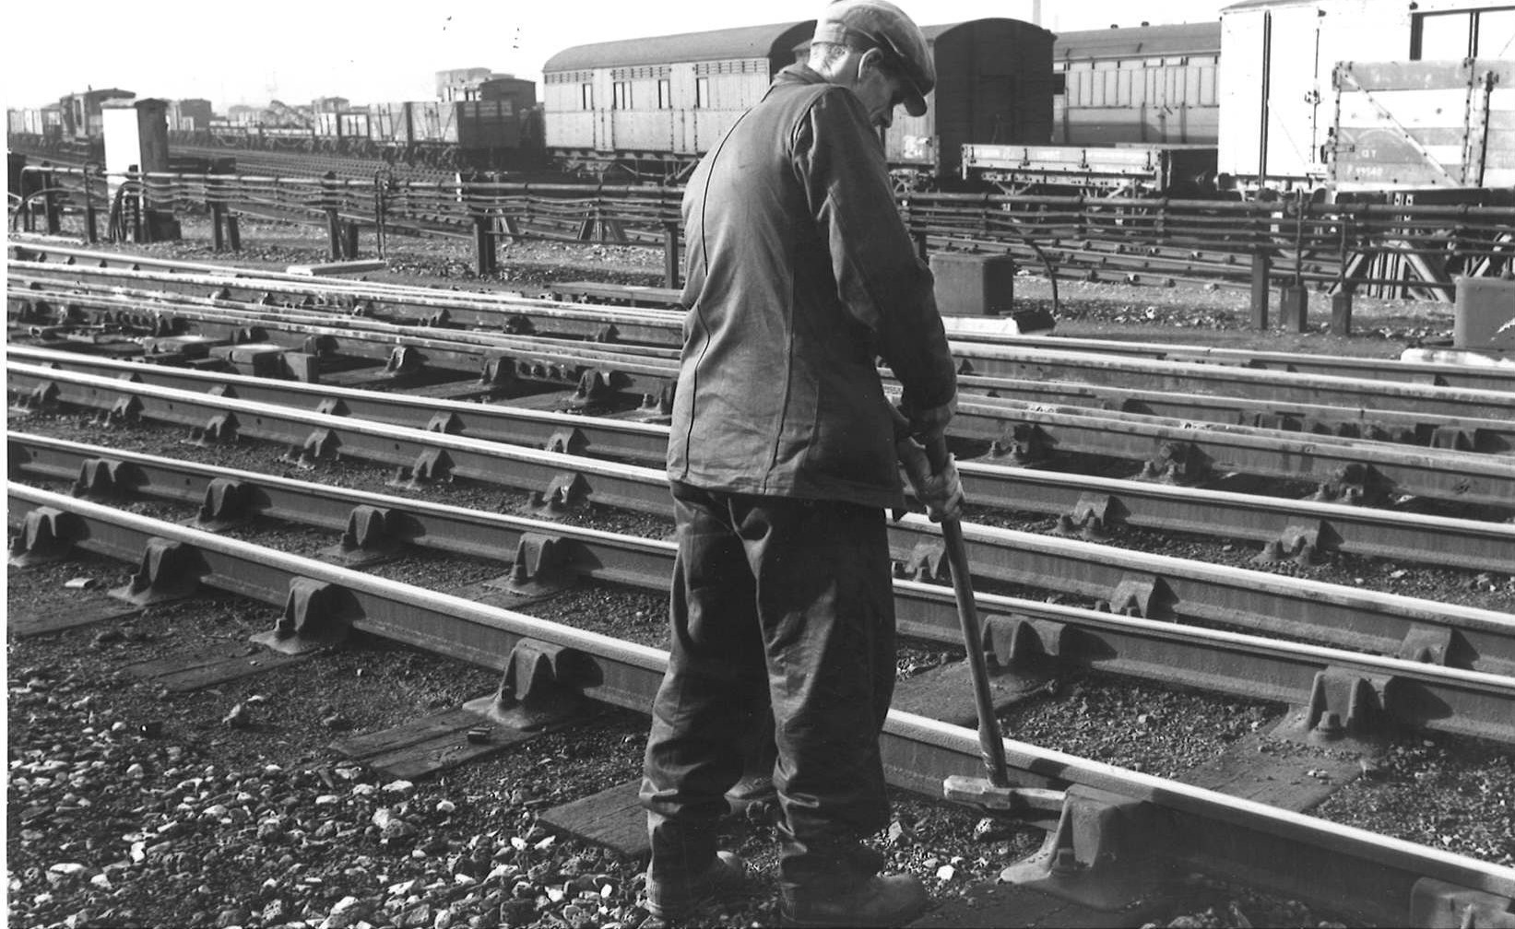
In this pack we are exploring railway accidents, why they happened and the safety movements that aimed to make the railways a safer place for everyone.

Since their first creation in the early 1800s railways have been dangerous places. From trains derailing, locomotives exploding, men being injured and killed during the vast construction of the lines, viaducts, and tunnels, to the shunters getting crushed between wagons, it wasn’t easy or safe work.



Accidents on the railways were common for those who worked on or with them as it meant working with heavy pieces of machinery that could be unpredictable. It was physical work that involved getting close to moving engines and men had to be constantly aware of their surroundings.

Did you Know…

Between 1875 and 1899 an average of 10 railway men were killed every week while working, with a further 50 injured! There was no compensation in place for those who were injured or died on duty. In 1897 the Workman’s Compensation Act was passed, which finally gave working men the compensation they deserved.




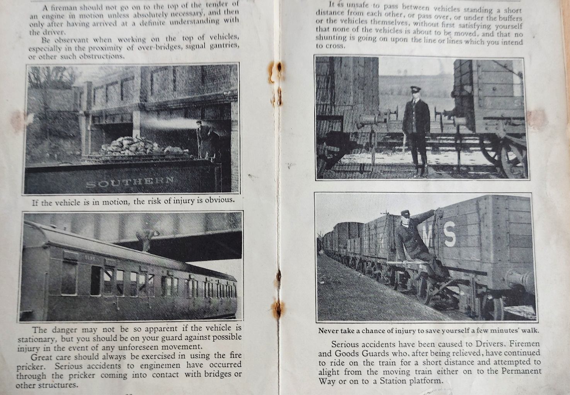

By 1913, the Great Western Railway (GWR) introduced a safety campaign to raise awareness of working on the railways. Because many people couldn’t read at the time the campaign included lots of images showing dangerous working practices. This safety booklet was handed out to employees at Bank Top Railway Station, Darlington, giving examples of what not to do at work!

The Prevention of Accidents Safety booklet, 1930s.

2


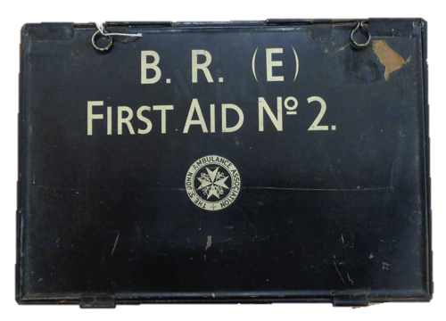
By 1894, the North Eastern Railway (NER) Manager Sir George Gibb saw these statistics and knew something needed to be done. He introduced a system of first aid training in association with the St Johns Ambulance Association.

It was an incredibly popular movement and allowed the working classes to learn medical knowledge for the first time.

The first aid kit was first developed by Johnson and Johnson in 1888, after learning about the vast injuries railway employees in America sustained.

They based the kit on what railway surgeons advised would be best at the scene of an accident where no one was medically trained.

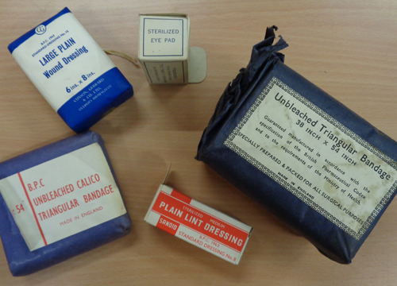

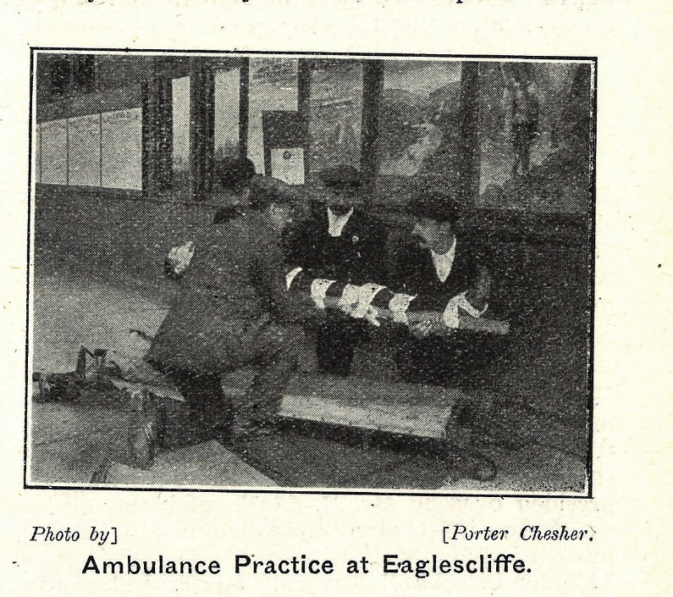

By 1911, 6,000 NER men had certificates in first aid by the St Johns Ambulance Association. These trained first aid responders were able to save countless lives and were often the first on the scene when one of their colleagues had an accident.

First Aid classes soon developed into competitions across the divisional areas with towns competing against each other to win a shield for the best First Aid practice.

3

Have you ever learned First Aid or worked with the St Johns Ambulance association?

4

Darlington North Road Locomotive Works built steam engines and wagons for a hundred years. It opened in 1863 and employed over 2,000 men at its peak. They kept a series of accident books at the works, detailing the many cuts, bruises, burns and fractures that occurred.

Did you know…

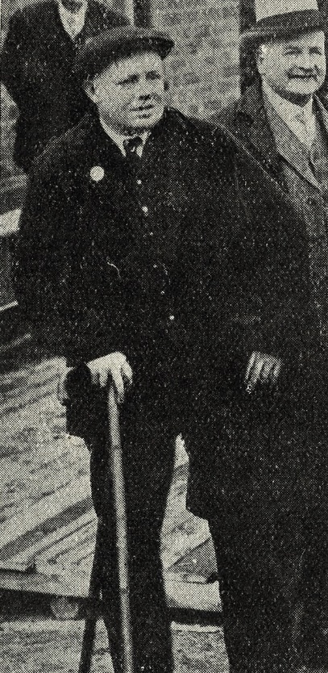



Accidents that led to amputation were so common on the railways that North Road Works started to produce their own artificial limbs for those who lost them through railway accidents.

Railway men who fought in the First World War also qualified for a limb from the railway company.

Alfred Ampleford had been working for the N.E.R since 1906 and lost his leg in 1917 whilst in active service. He came home and took up work as a lavatory attendant in 1939 for the London North Eastern Railway (LNER). He was the first person to receive a N.E.R cottage home.



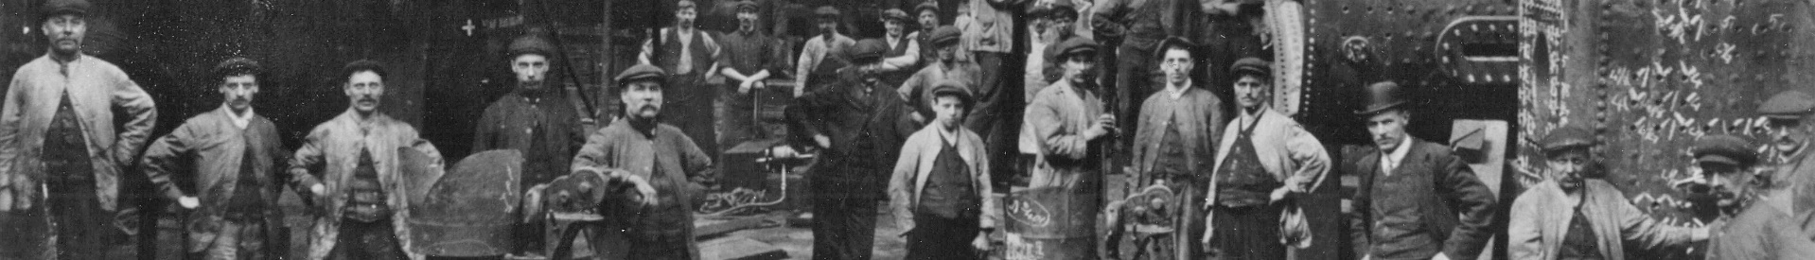

Have you ever had an accident at work? If so, did your employer look after you?

During the First World War women were employed in North Road Work which had been turned over to making munitions, employing over 1,000 women to create shells.

On June 20th, 1917, Annie Muriel Wilson, aged 19, seriously injured her finger when it was caught between a shell case and an industrial roller. She was off work a month and received 12 shillings and 15 pence as compensation, a very high amount for a young girl at the time.

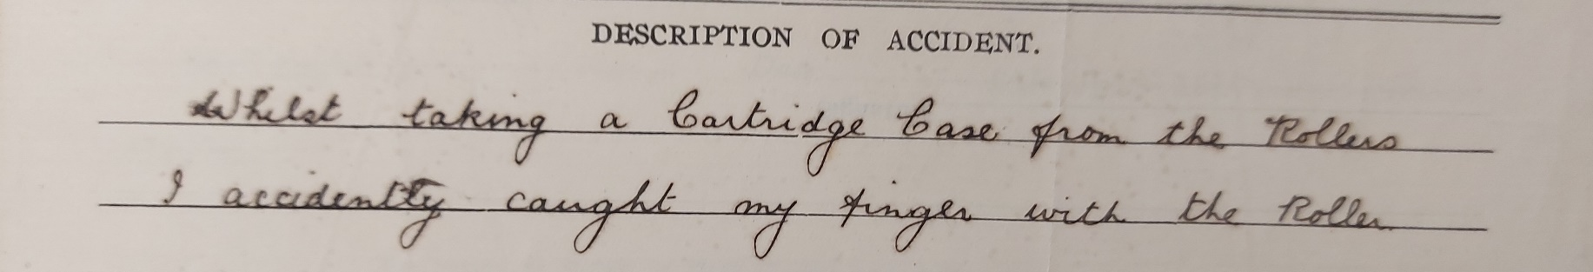
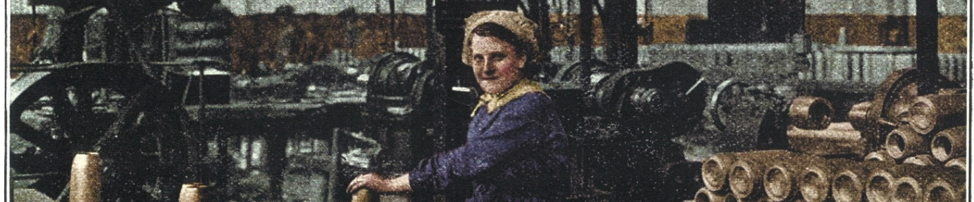



What do you think it would have been like working as a Munitions worker? What sounds and smells would the machinery make? Would it be scary knowing accidents like Annie’s were commonplace?



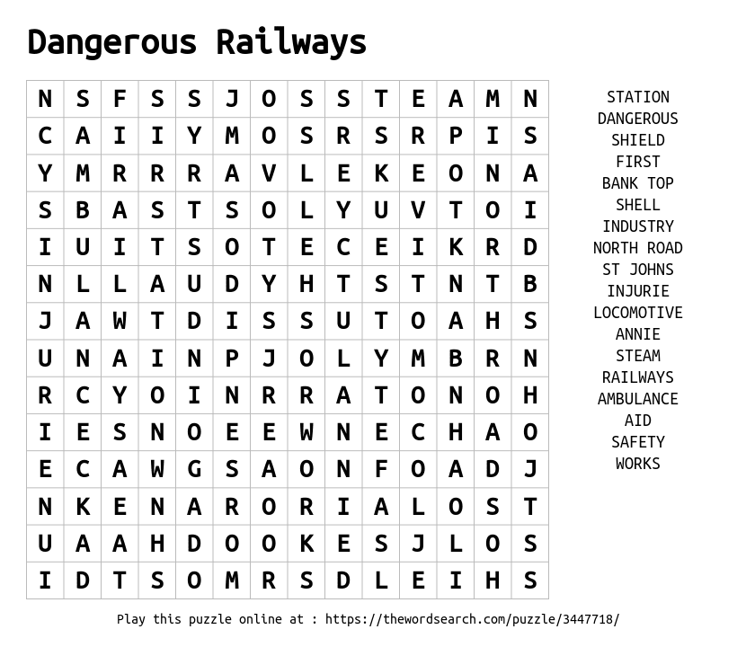

5


Get in touch with us at – Teesvalleymuseums@stockton.gov.uk
All previous Talking Tees Valley Packs can be found here - https://teesvalleymuseums.org/news/

Images in this pack are courtesy of Hopetown Darlington.

