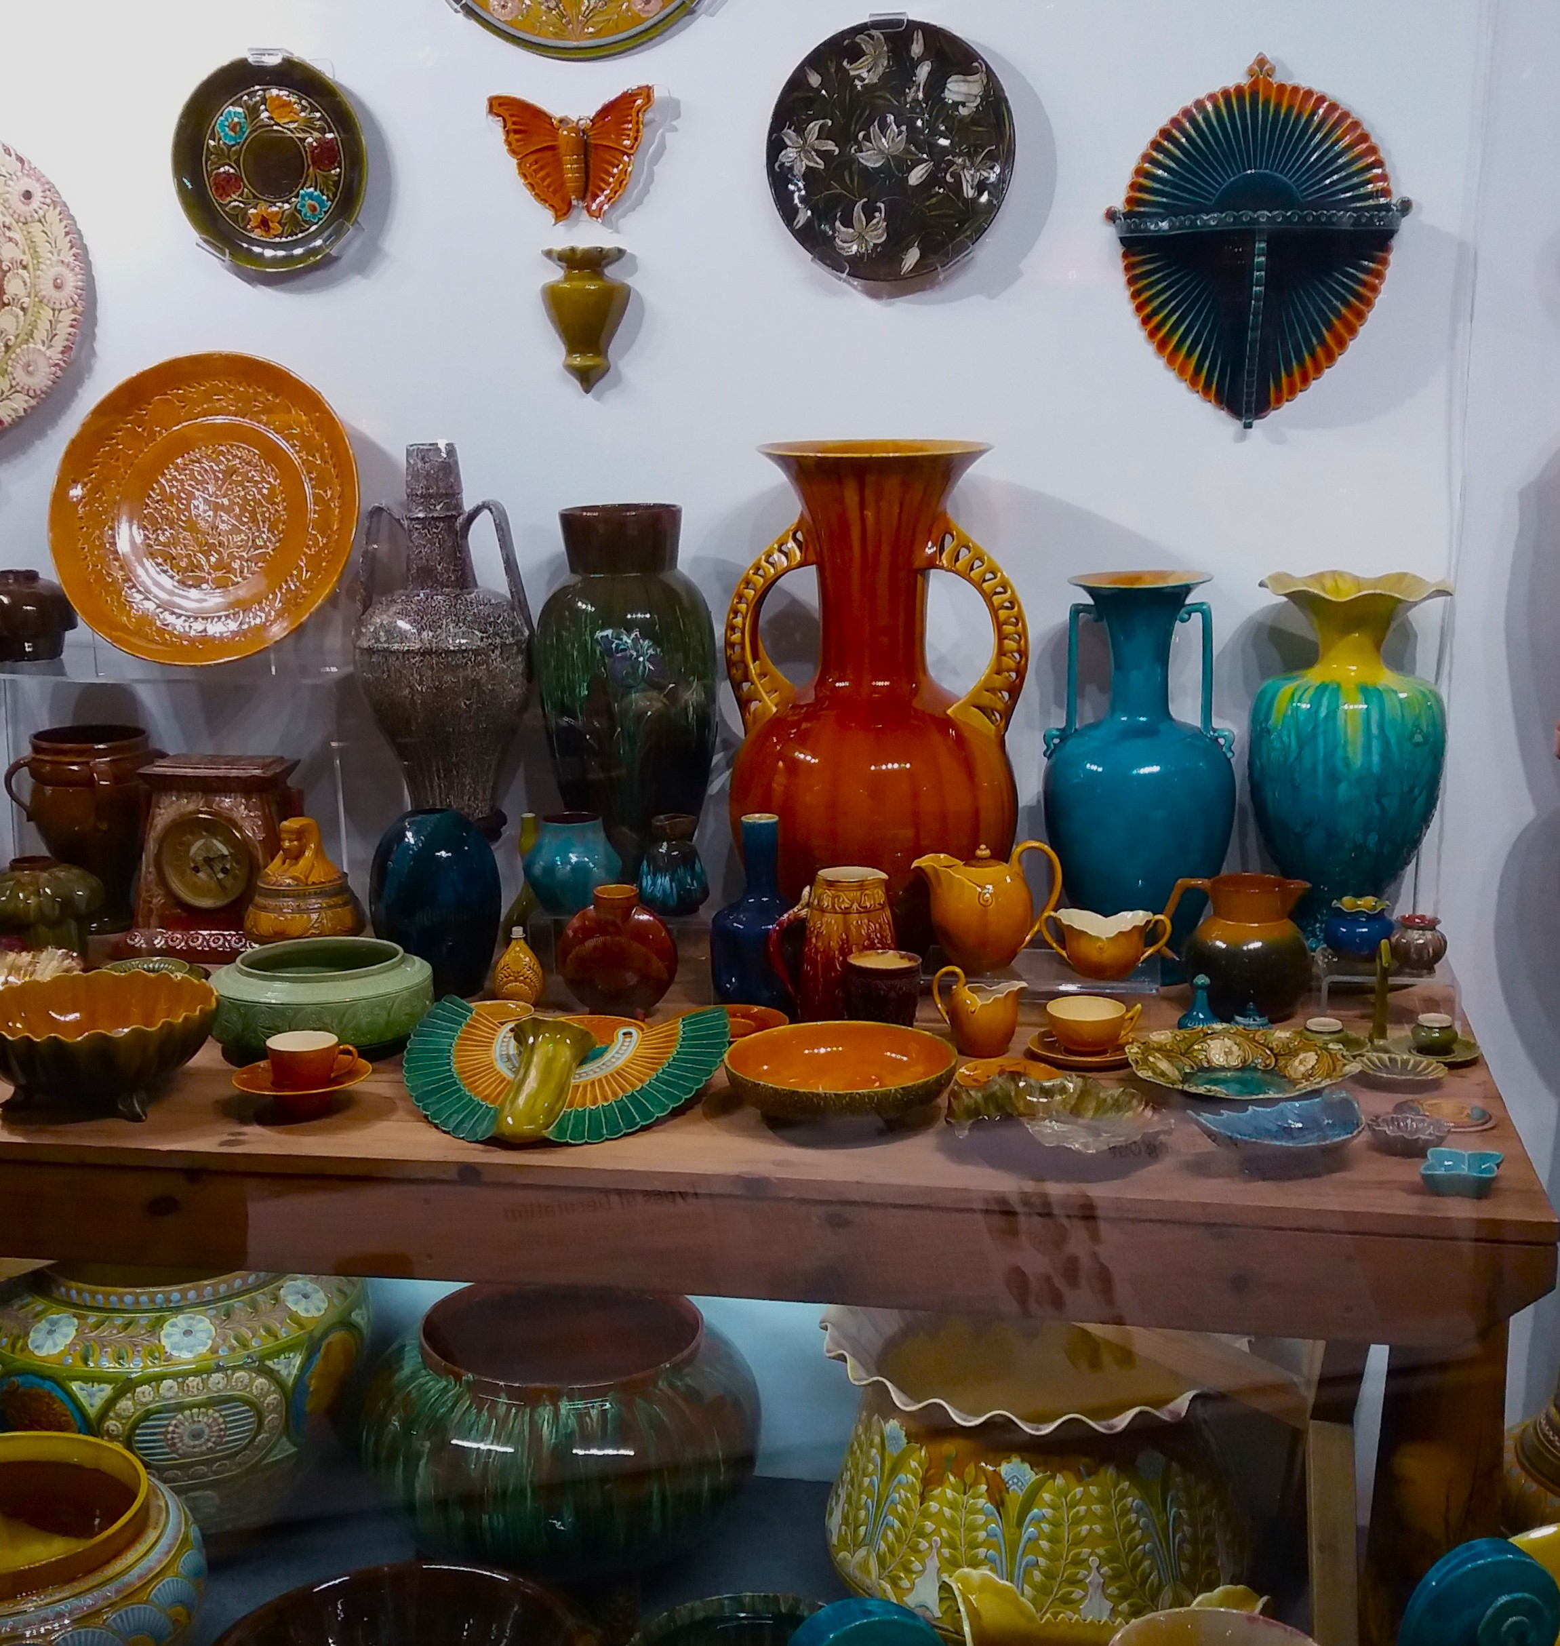
Linthorpe Art Pottery
Talking Tees Valley Activity Pack

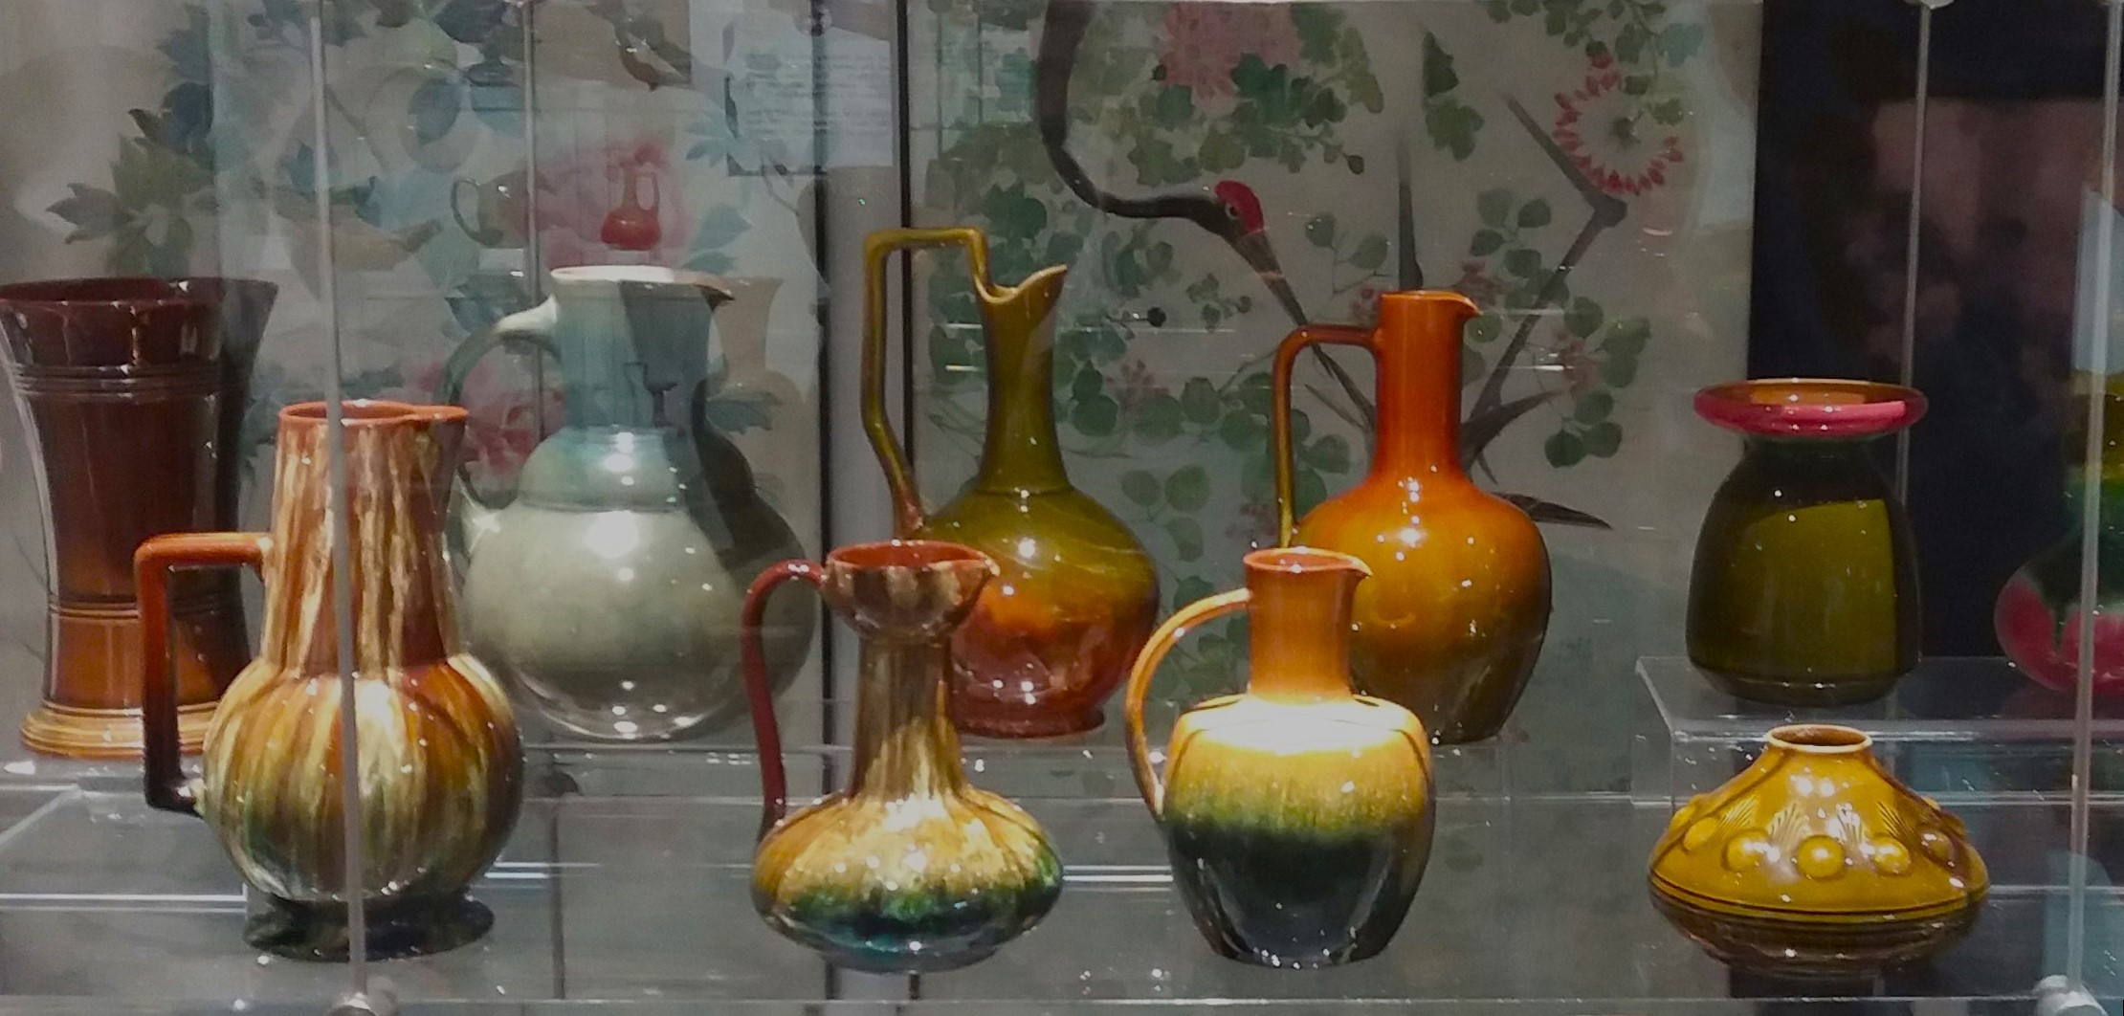
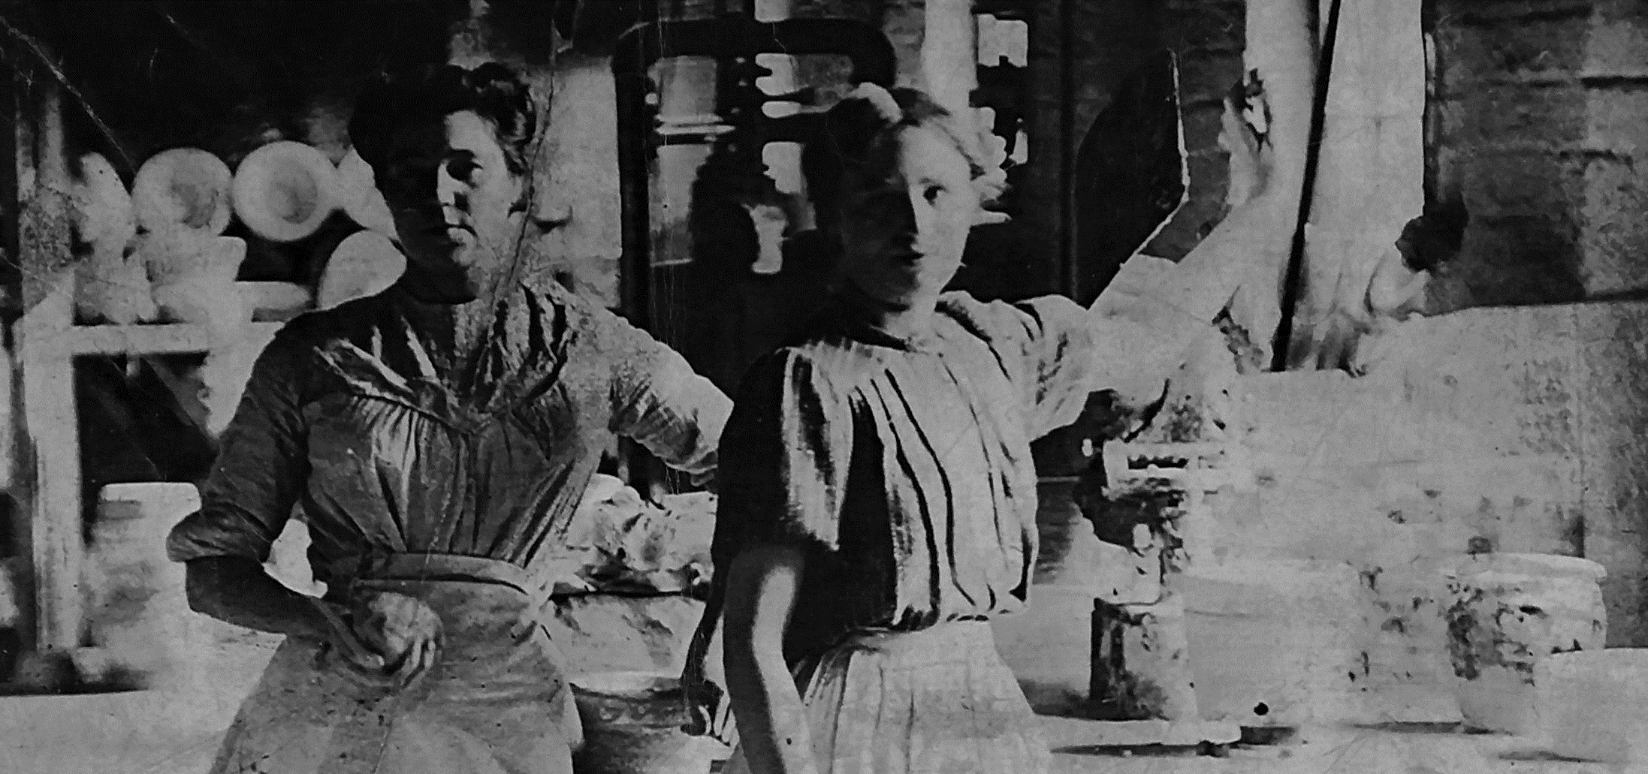

Each month we use objects from our museums in the Tees Valley to take a closer look at the lives and stories from people in our area.

This month we are looking into the Linthorpe Art Pottery, the most well-known ceramic makers in Middlesbrough. Read on to find out how they began, what kinds of pottery they made, and have a go at designing your own Linthorpe Art Pottery.
Most of the photos in this pack were taken at Dorman Museum, who hold one of the biggest collections of Linthorpe Art Pottery in the country. It shows off the vast variety of designs that the pottery liked to innovate in.
Welcome to another edition of the Talking Tees Valley Activity Pack

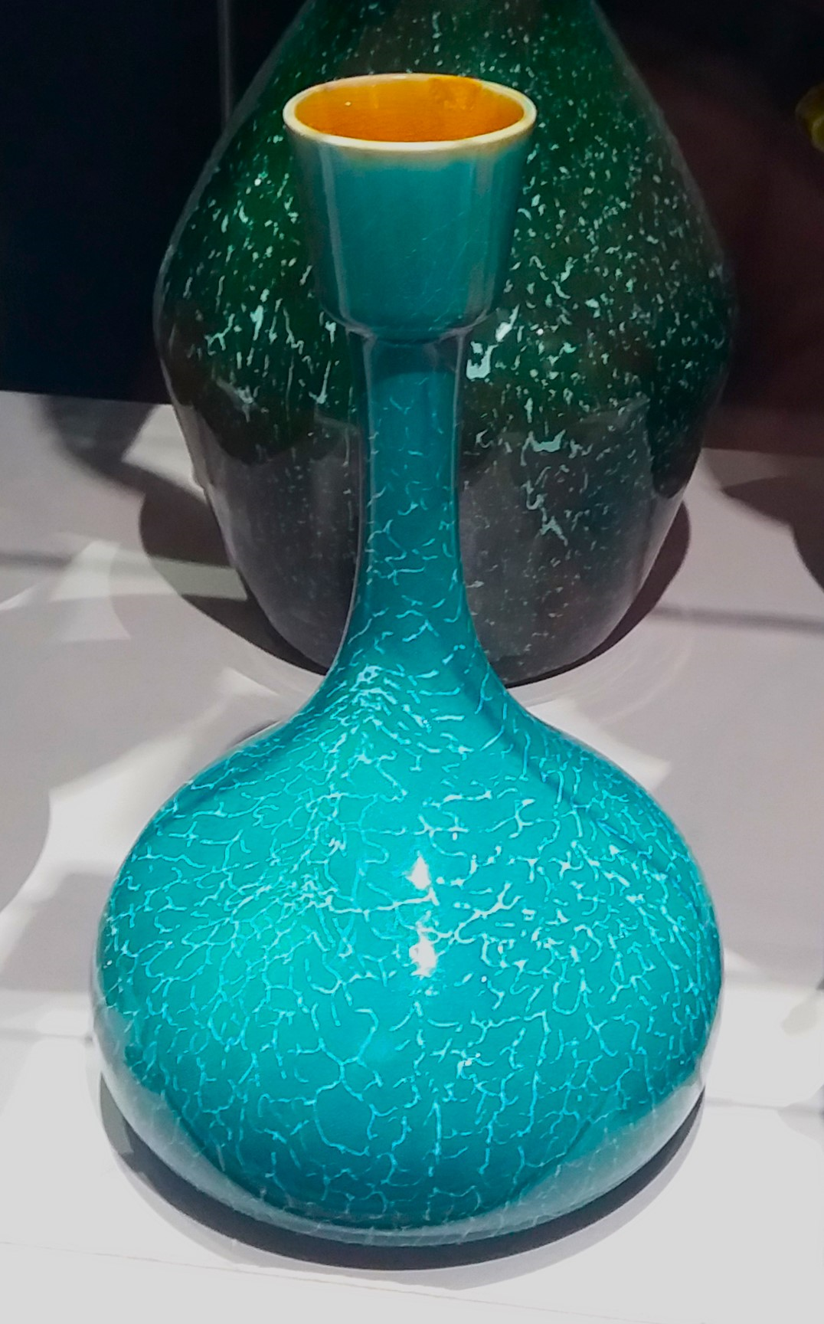
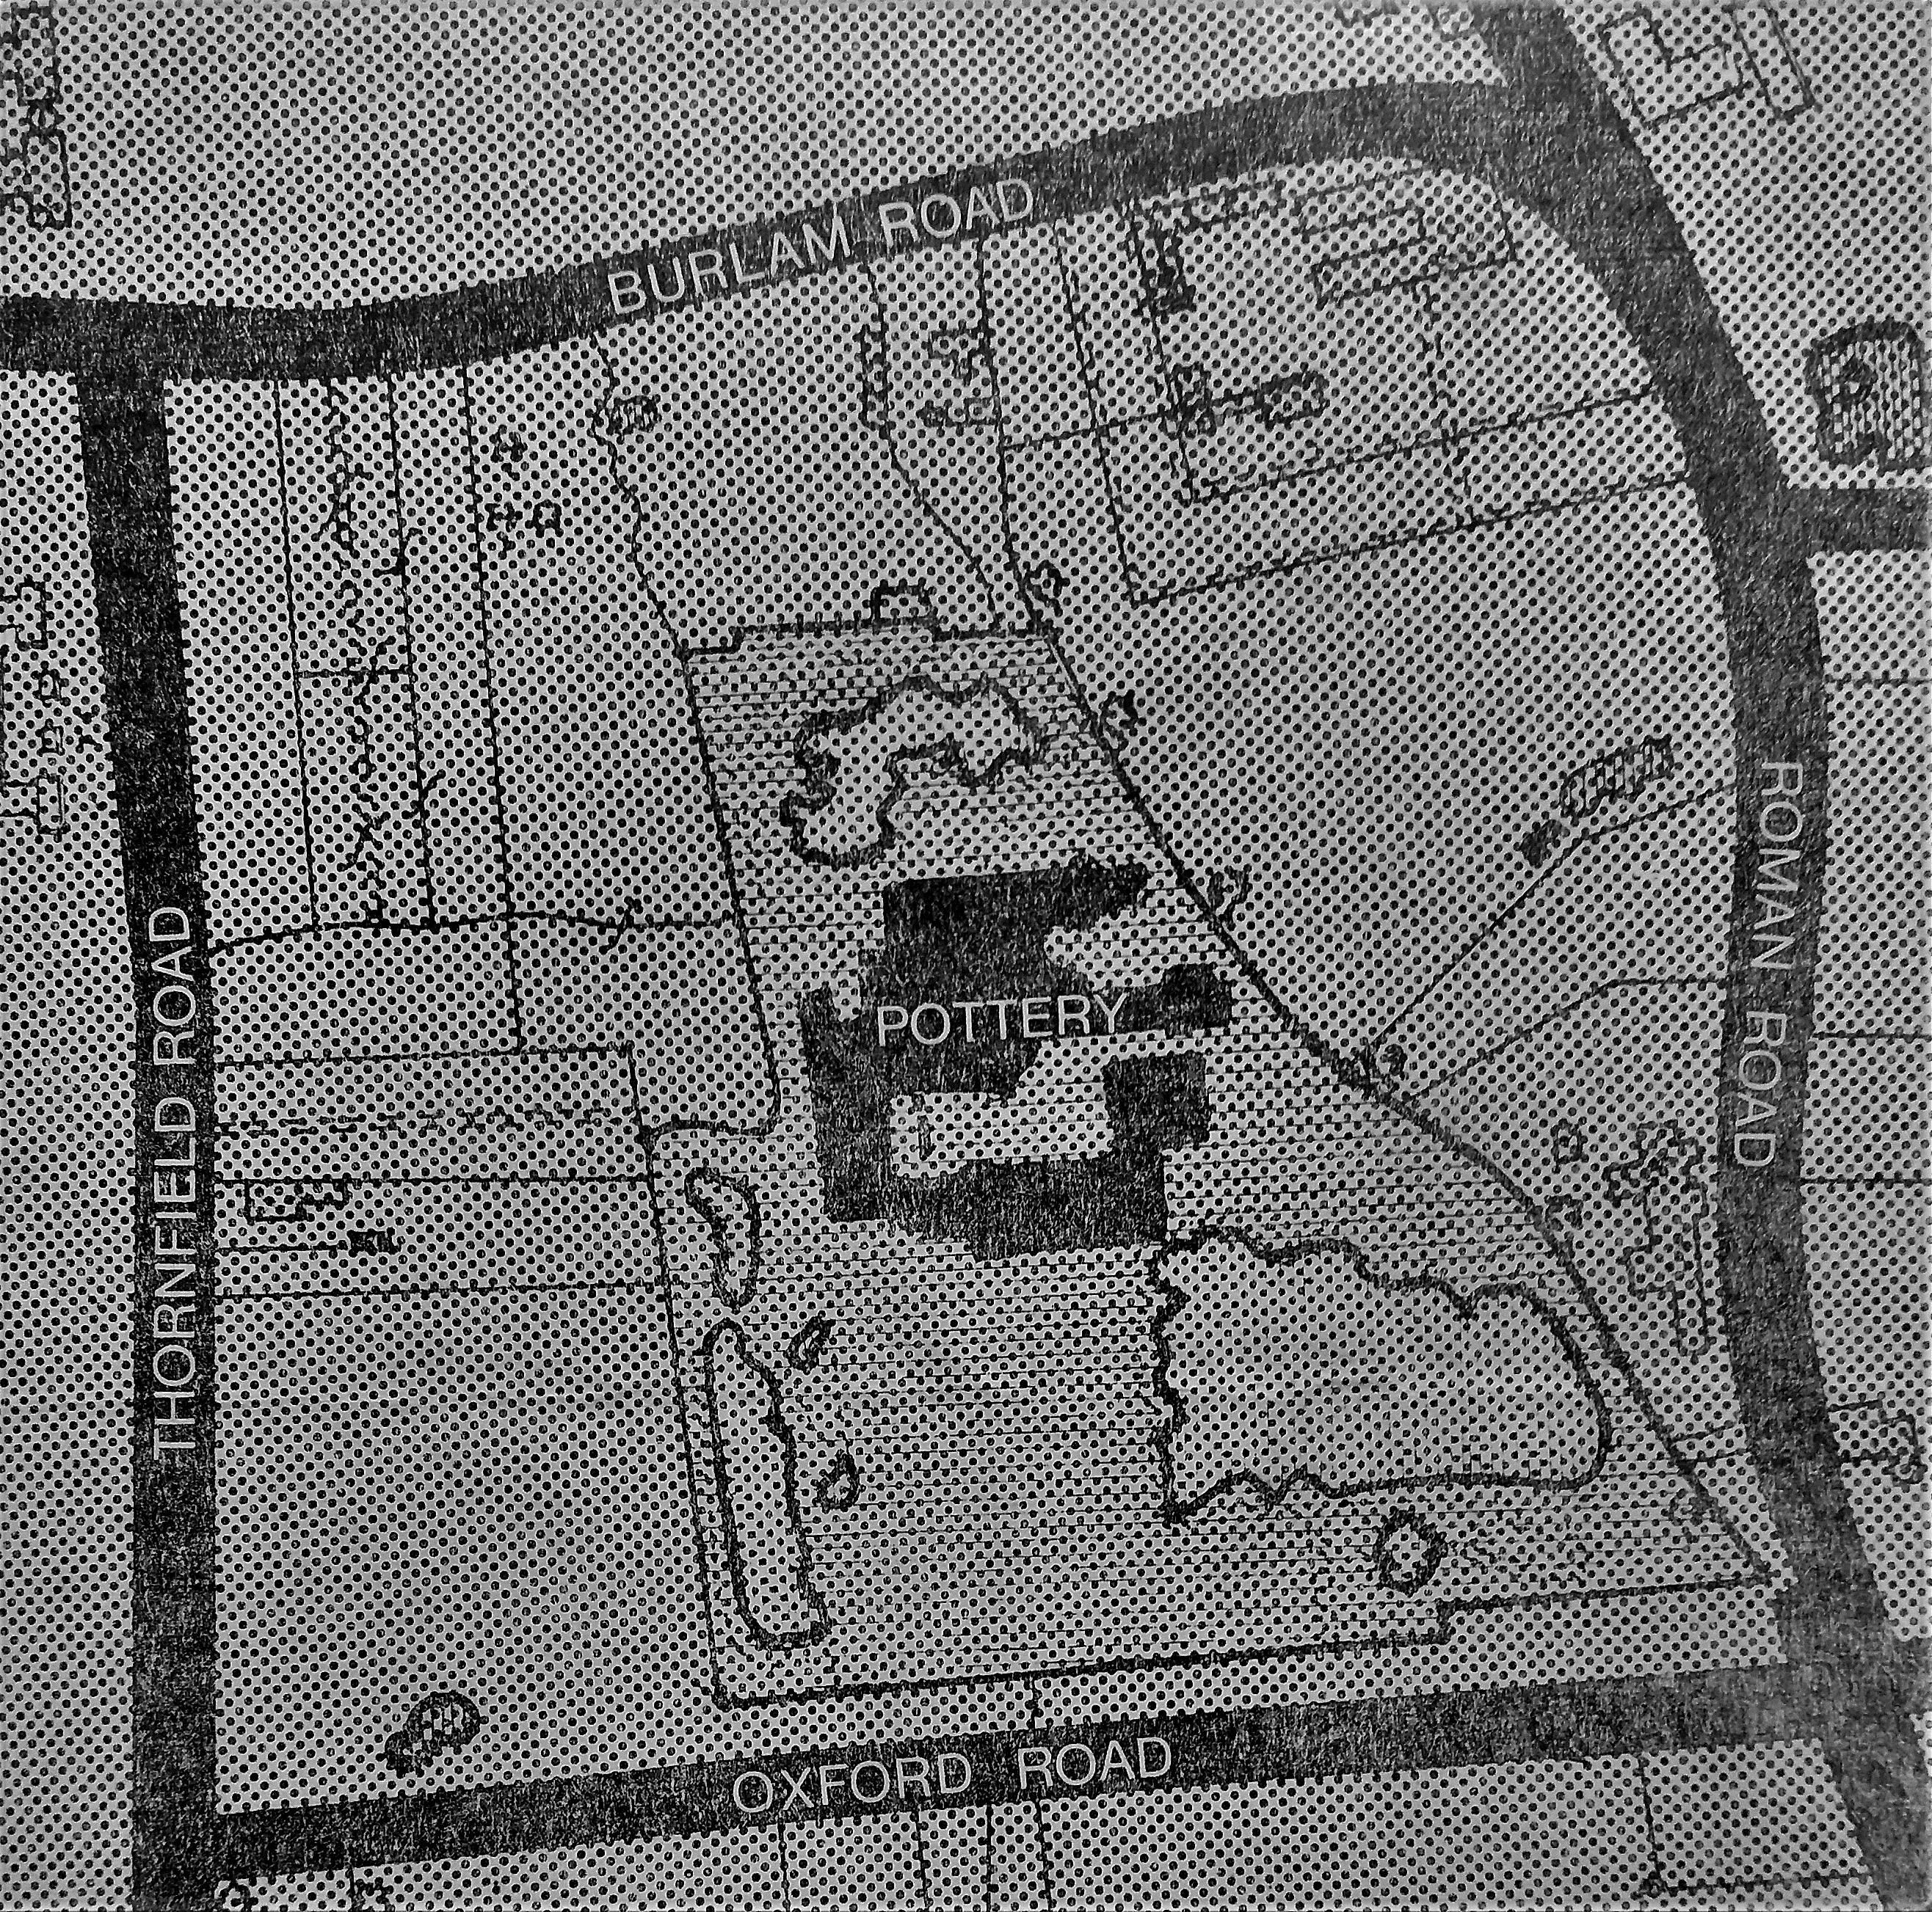

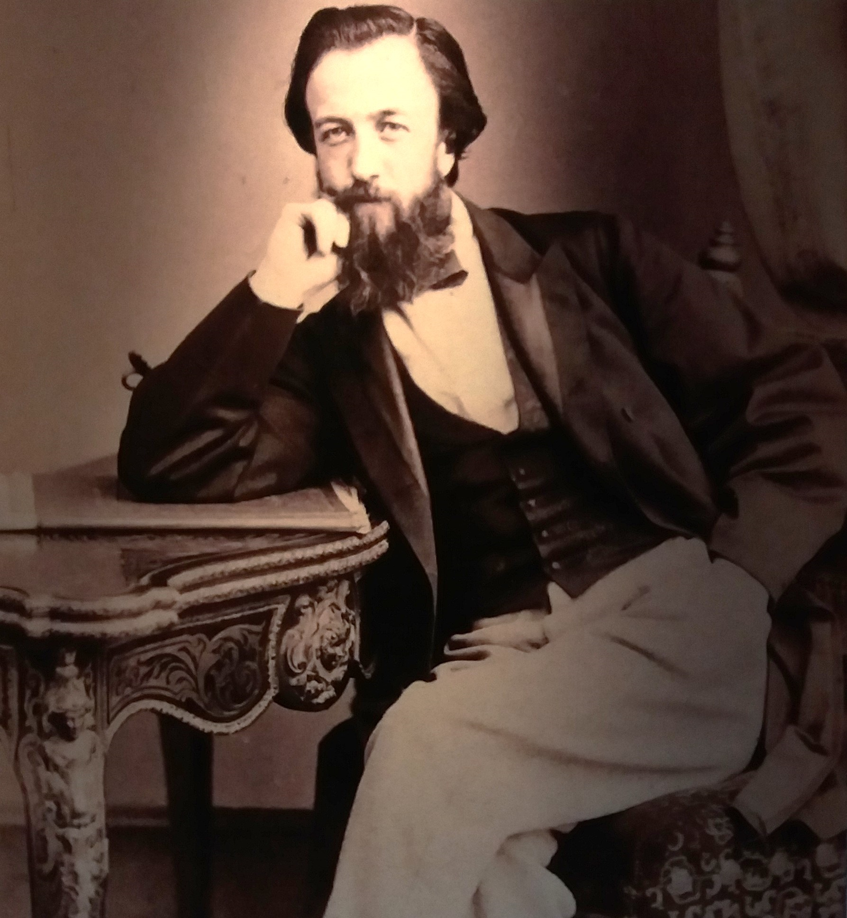

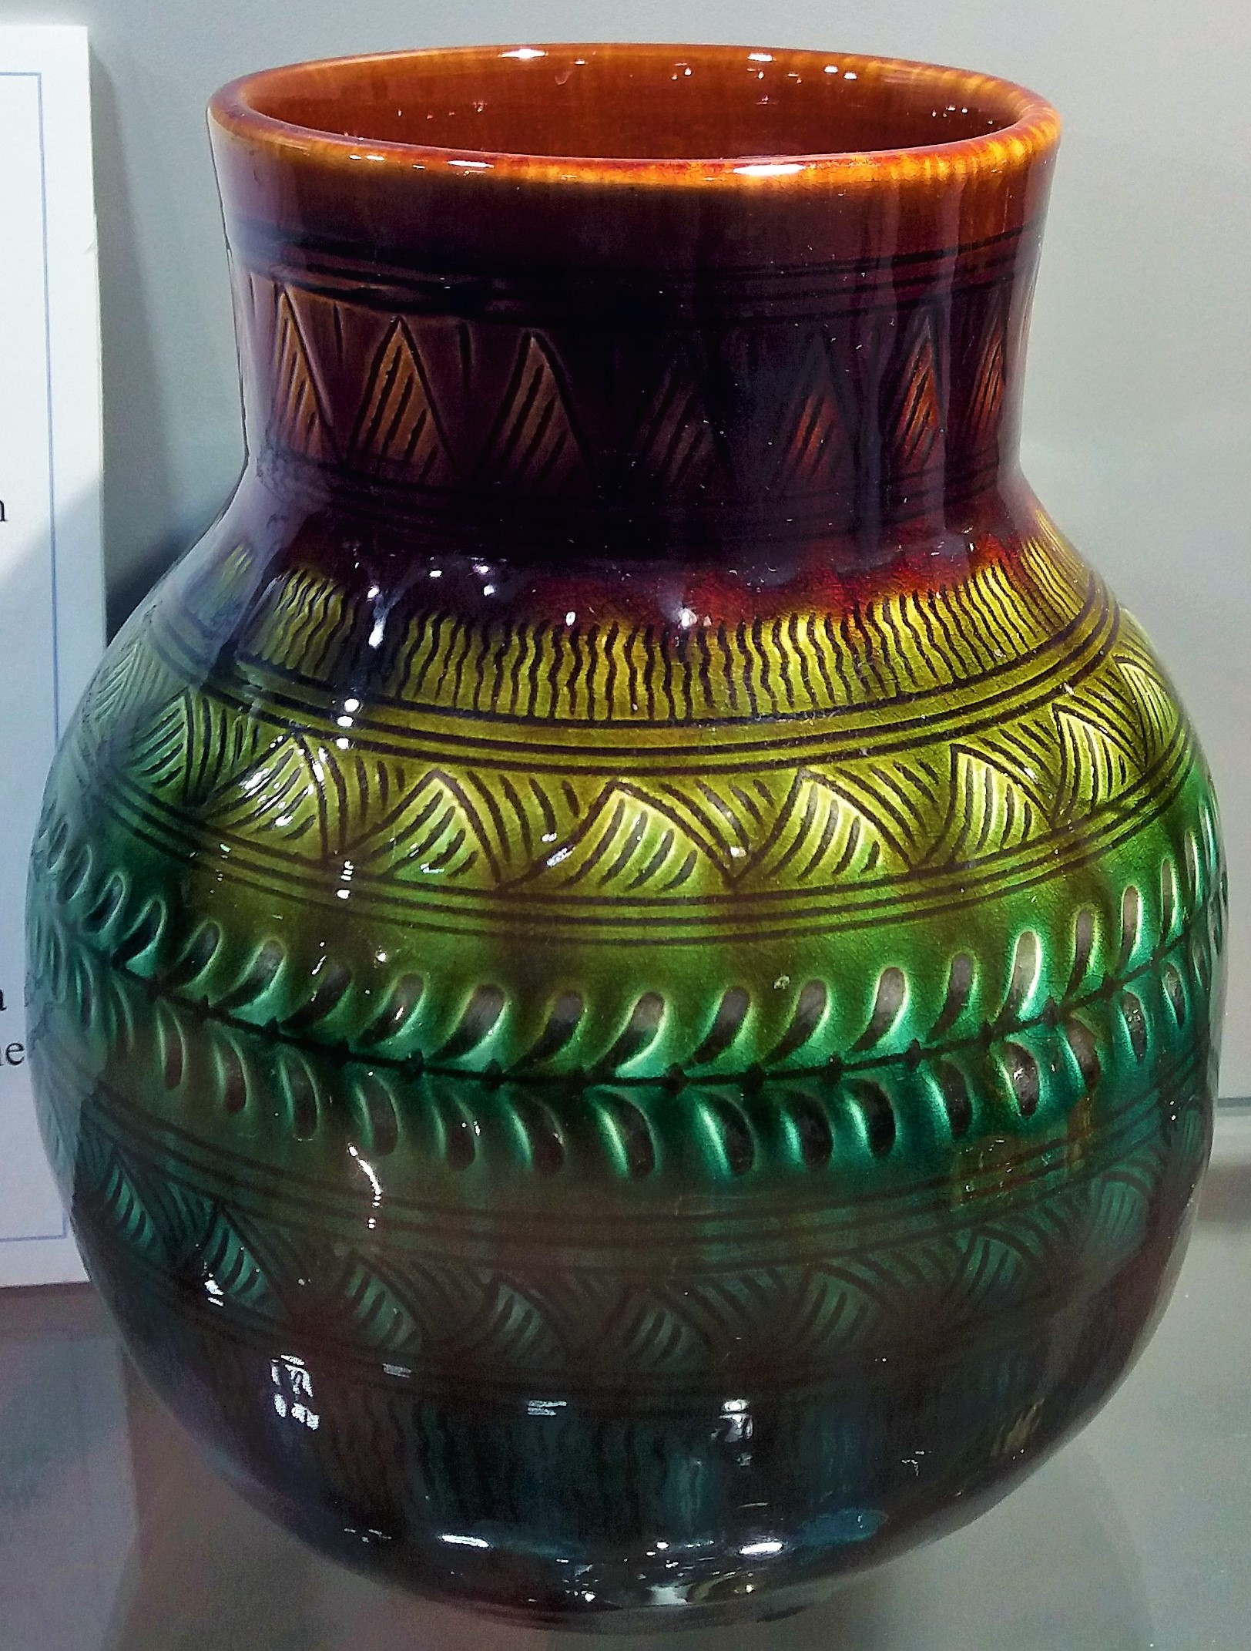
Clay was made into a liquid consistency and then poured into moulds. Once hardened they were removed and, depending on the design, decorated with a glaze, layer of paint, ceramic embellishment or ‘sgraffito’ marking.

‘Sgraffito’ is a term used by artists to describe a method of scratching a design into clay when it is soft.
How Linthorpe Art Pottery was made
It was on the site of Harrison’s old brick works that Linthorpe Art Pottery was founded.
Dresser and Harrison hired local people, as well as skilled potters from Staffordshire and London. They would invest further in their workforce by sending them to the Darlington School of Art and the Middlesbrough Mechanics Institute to learn extra skills.
Some of Linthorpe Art Pottery’s pieces are highly recognizable vases and plates in bright colours and eye-catching designs. But the Pottery made so much more – jugs, cup and saucer sets, wall ornaments, salt and pepper pots, tiles, umbrella handles and more.
Middlesbrough in the 1800s was a local source of red clay and a prime location for brickmaking. John Harrison was a local businessman and he opened the Sun Brick Works in Linthorpe, but it ran into financial difficulties in the early 1870s when the housing market fell. Harrison then decided to move into pottery manufacture and met Christopher Dresser.
John Harrison
In the mid-1870s he was sent to Japan and he drew a lot of inspiration from their pottery making. Two years later he founded the Linthorpe Art Pottery and he worked there as Art Superintendent until 1882.
As a young man in the 1850s Dresser designed homeware décor and was quickly moving into making ceramics.
Christopher Dresser
They were then fired in an oven kiln for about 24 hours and then given final glazings before being fired a second time.
The Linthorpe Art Pottery began in 1879 and was the business venture of two people – Christopher Dresser and John Harrison.


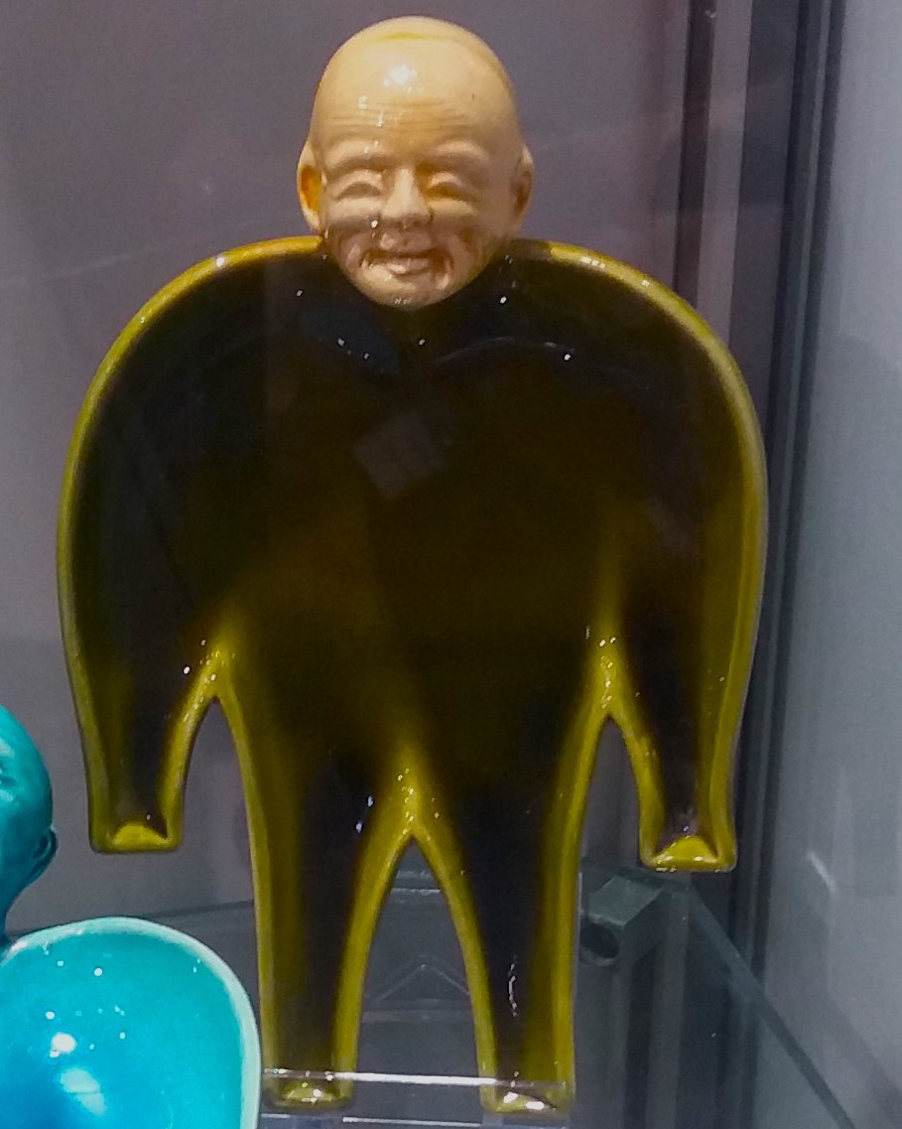
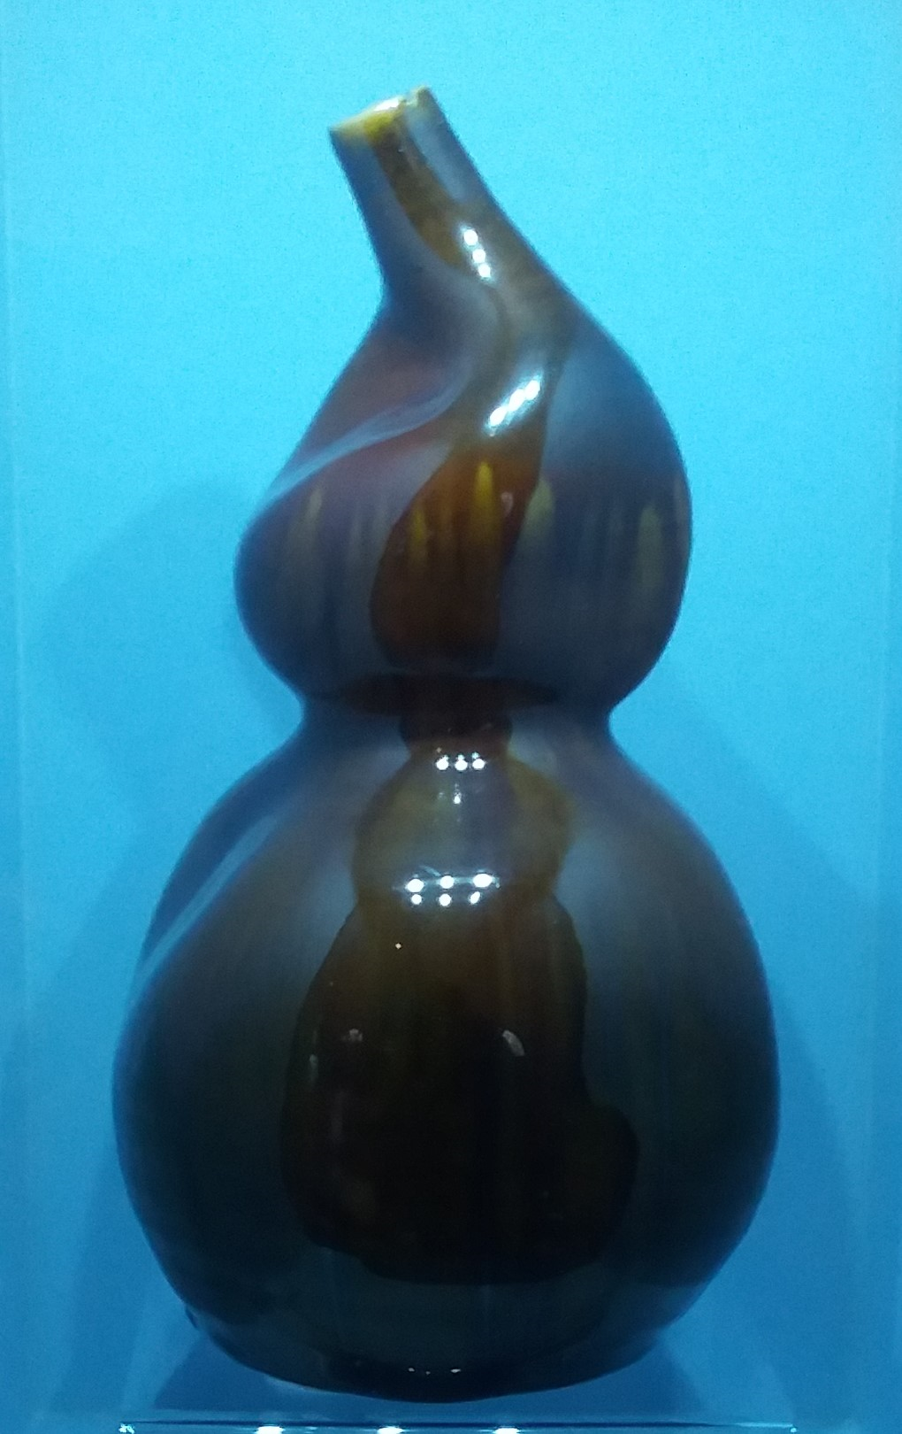
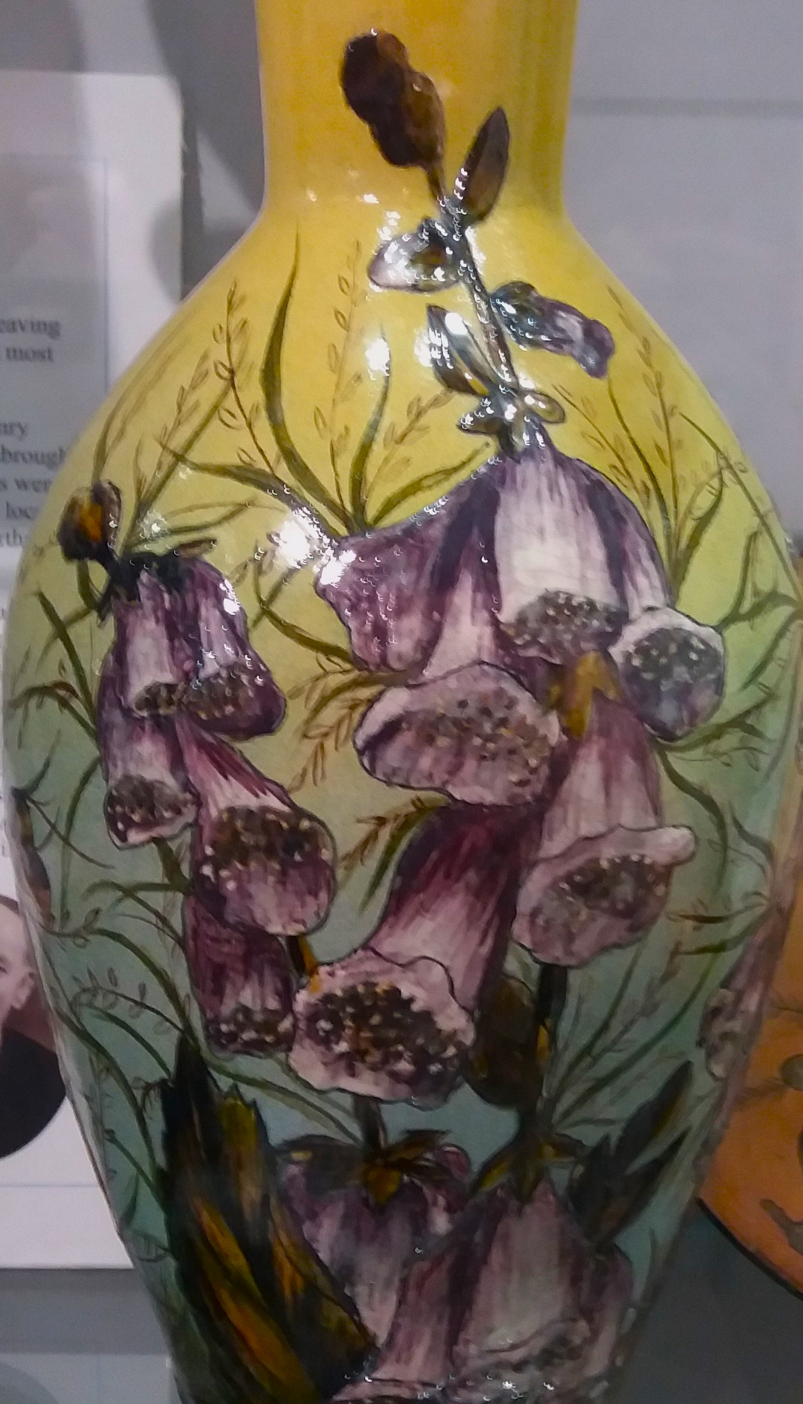
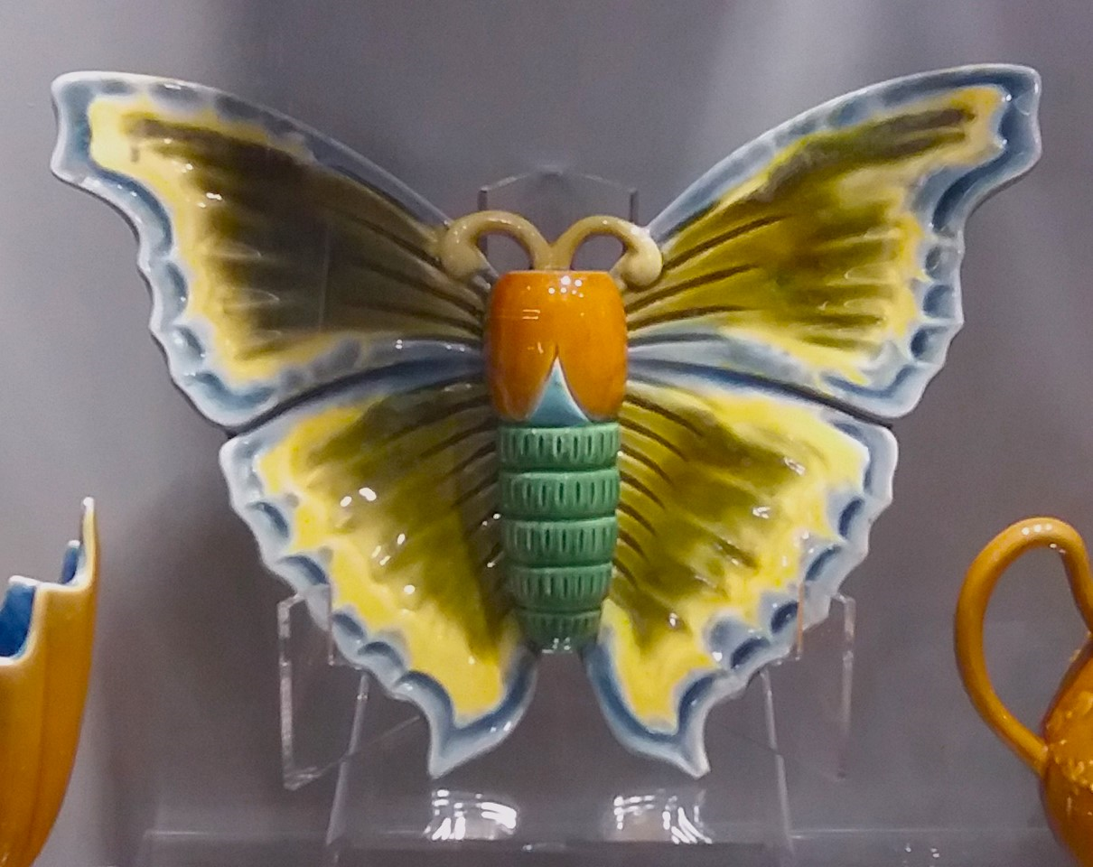
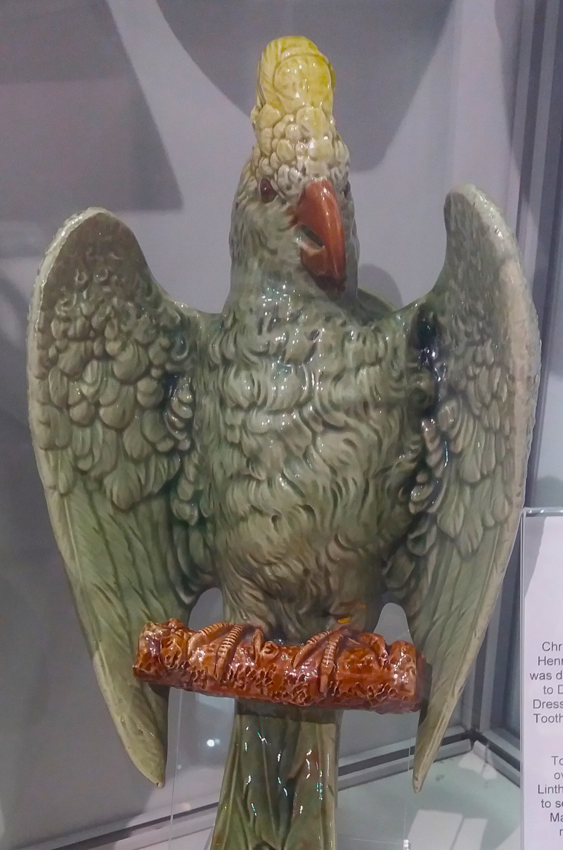
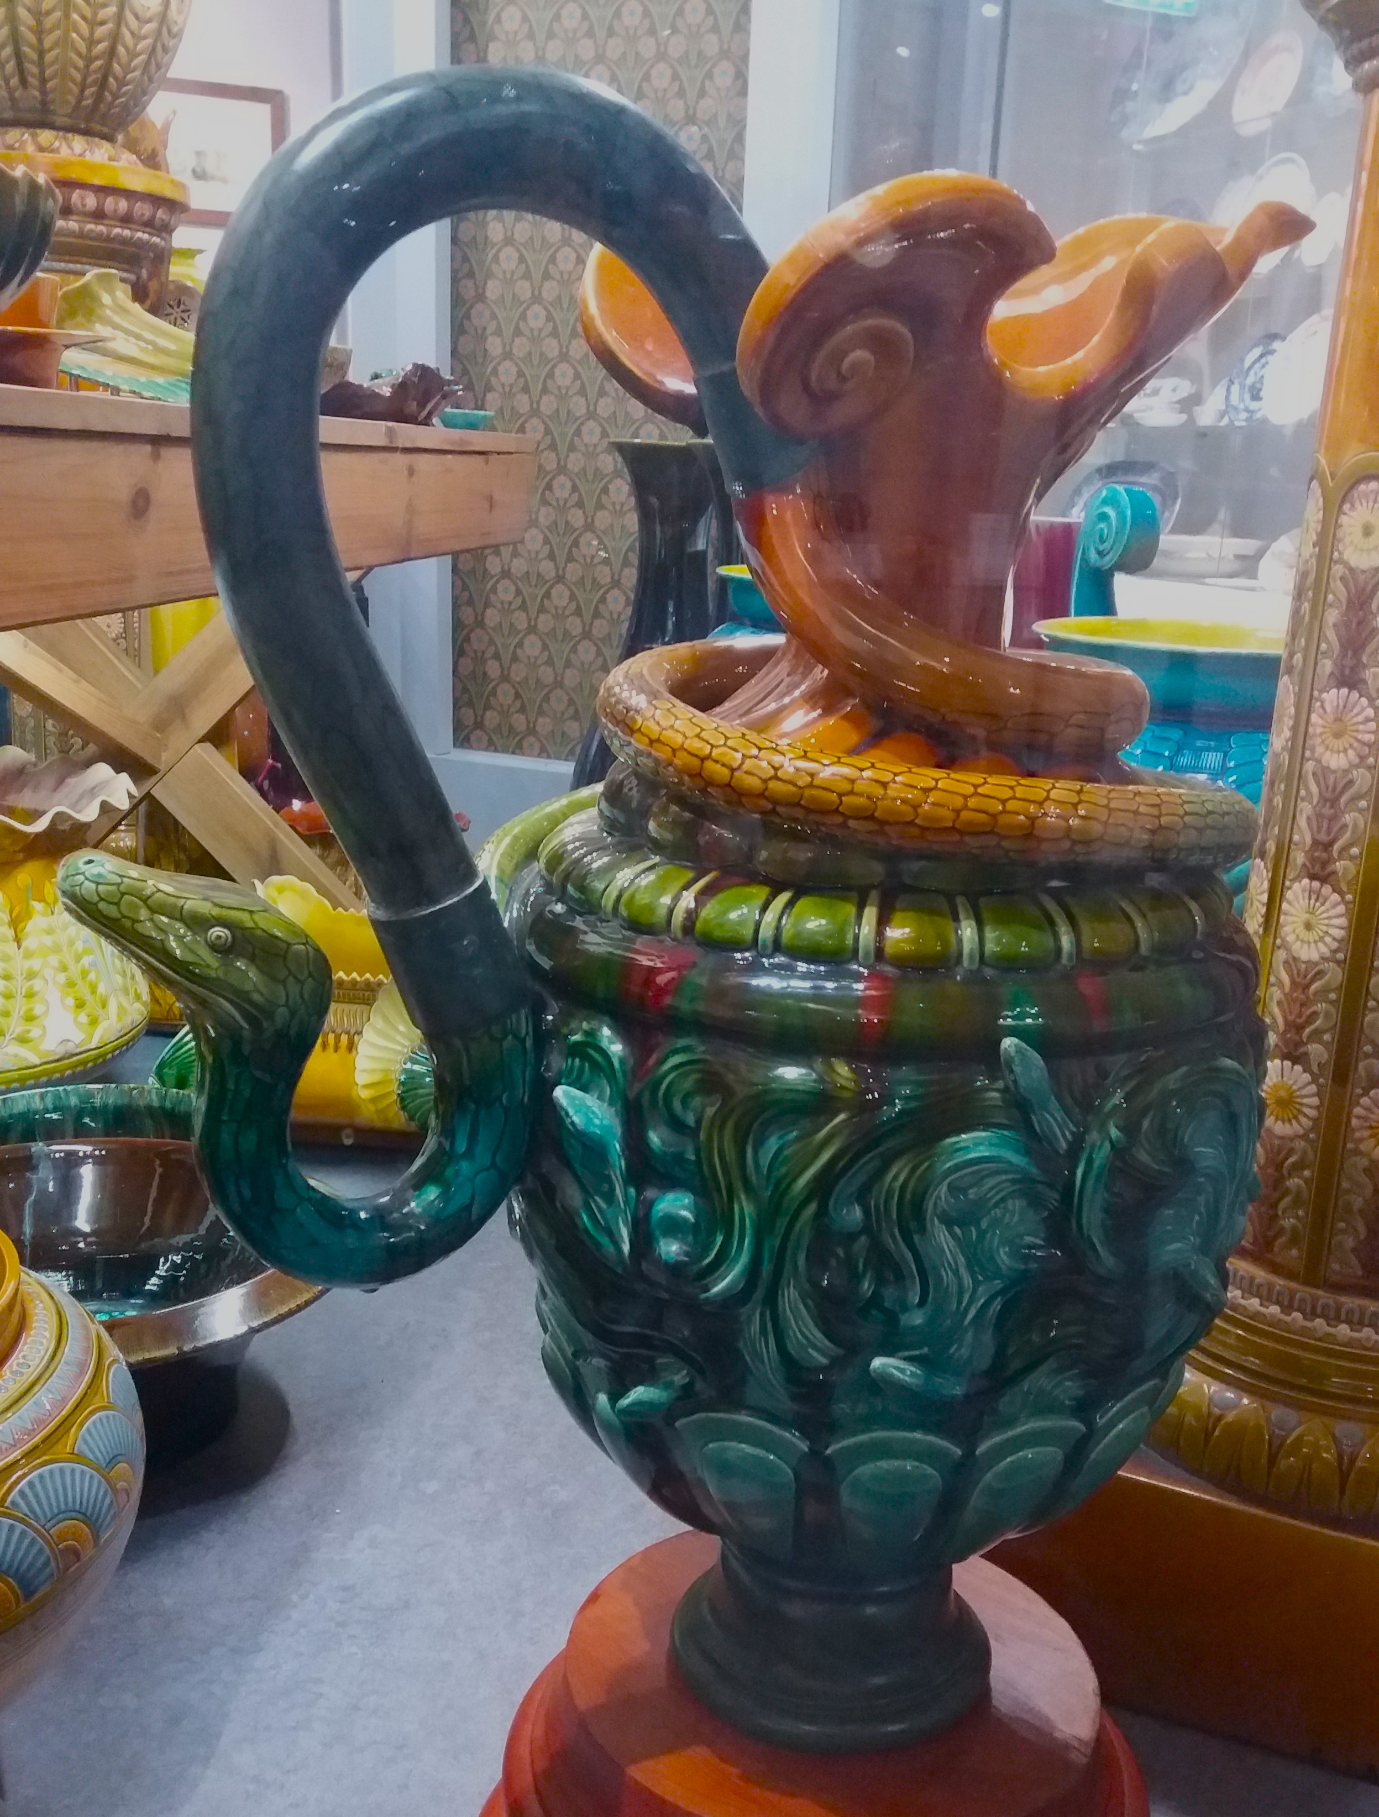
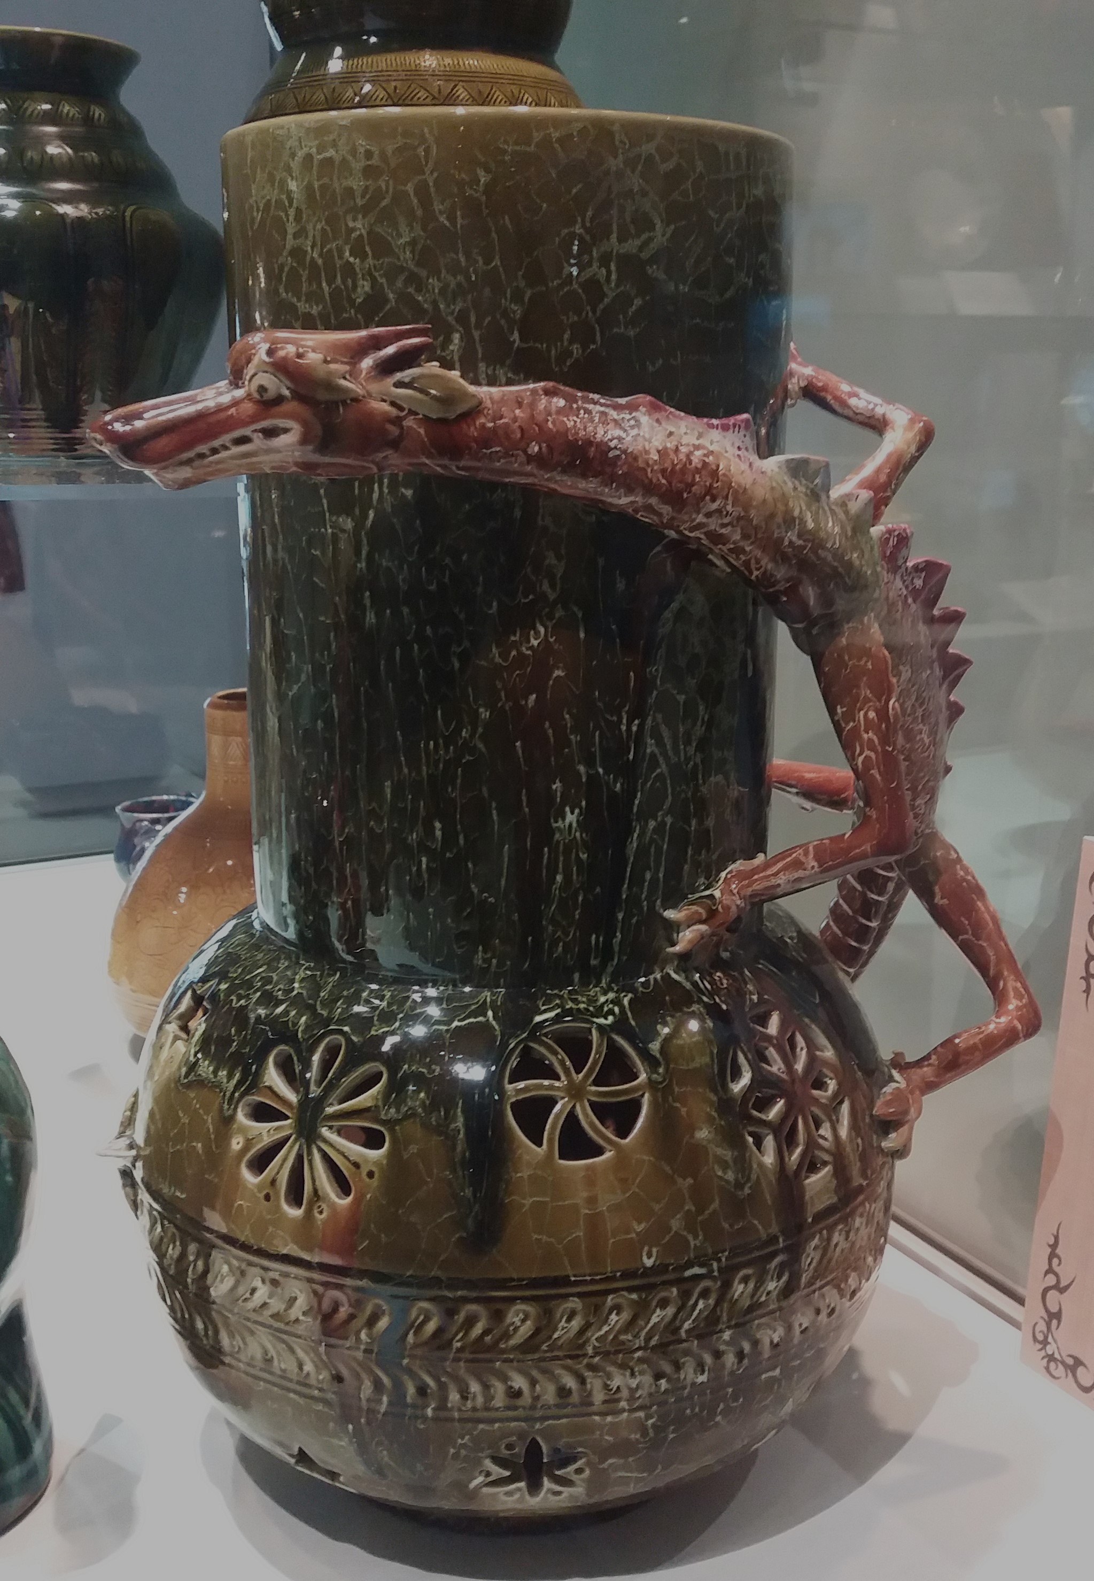
Dresser was also skilled in drawing flowers. He encouraged the painting of flowers on to his ceramics and for some to reflect the shape of a plant, like this one which is shaped like a gourd.
The Pottery’s workforce were encouraged to draw inspiration from nature themselves, so it was not uncommon to find pieces that were made to look like animals or insects.

This ashtray is a more unusual piece which takes inspiration from man- shaped Fijian drinking dishes and figures of the Japanese poet Saigyo Hoshi.
Inspirations
As the more creative founder of the Pottery Dresser was keen for his inspirations to be reflected by his company’s wares. He had studied the designs of countries like Japan, Egypt and Peru and wanted to include motifs of these.
This vase is decorated with a Japanese style dragon, which is serpent like and only has three claws for each paw.
Since every piece was also hand made and most were altered to include something different – a glaze, a handle or a different ceramic decoration – Linthorpe Art Pottery was likened to Nature, never repeating itself, and each piece became unique.
This Medusa vase, which was shown at an International Exhibition in Calcutta in 1883, is inspired by the Greek myth of Perseus cutting off the gorgon Medusa’s head. Although it was popular at the exhibition, it was too expensive for the Pottery to recreate for their customers.

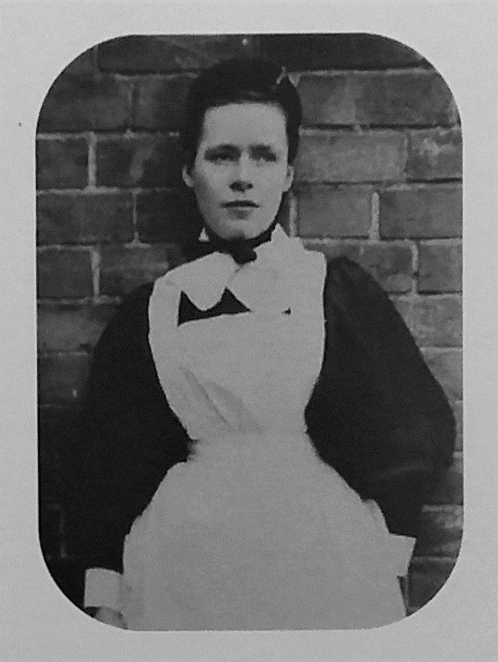
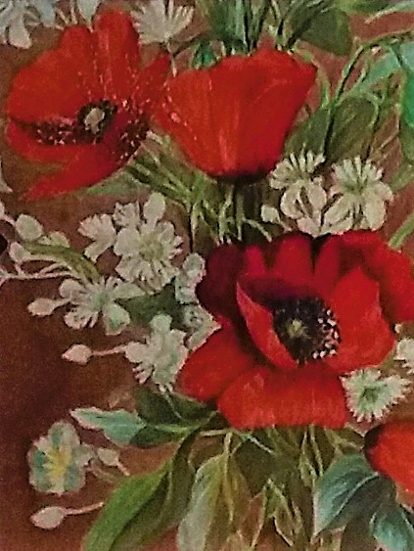
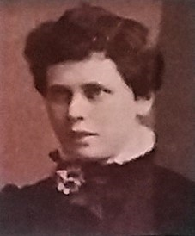
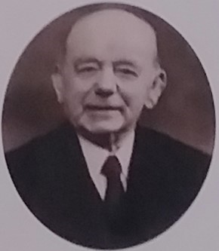
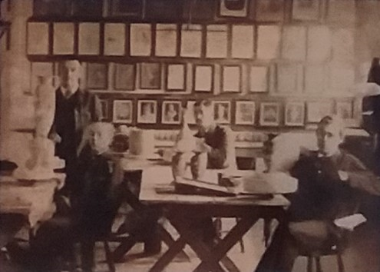
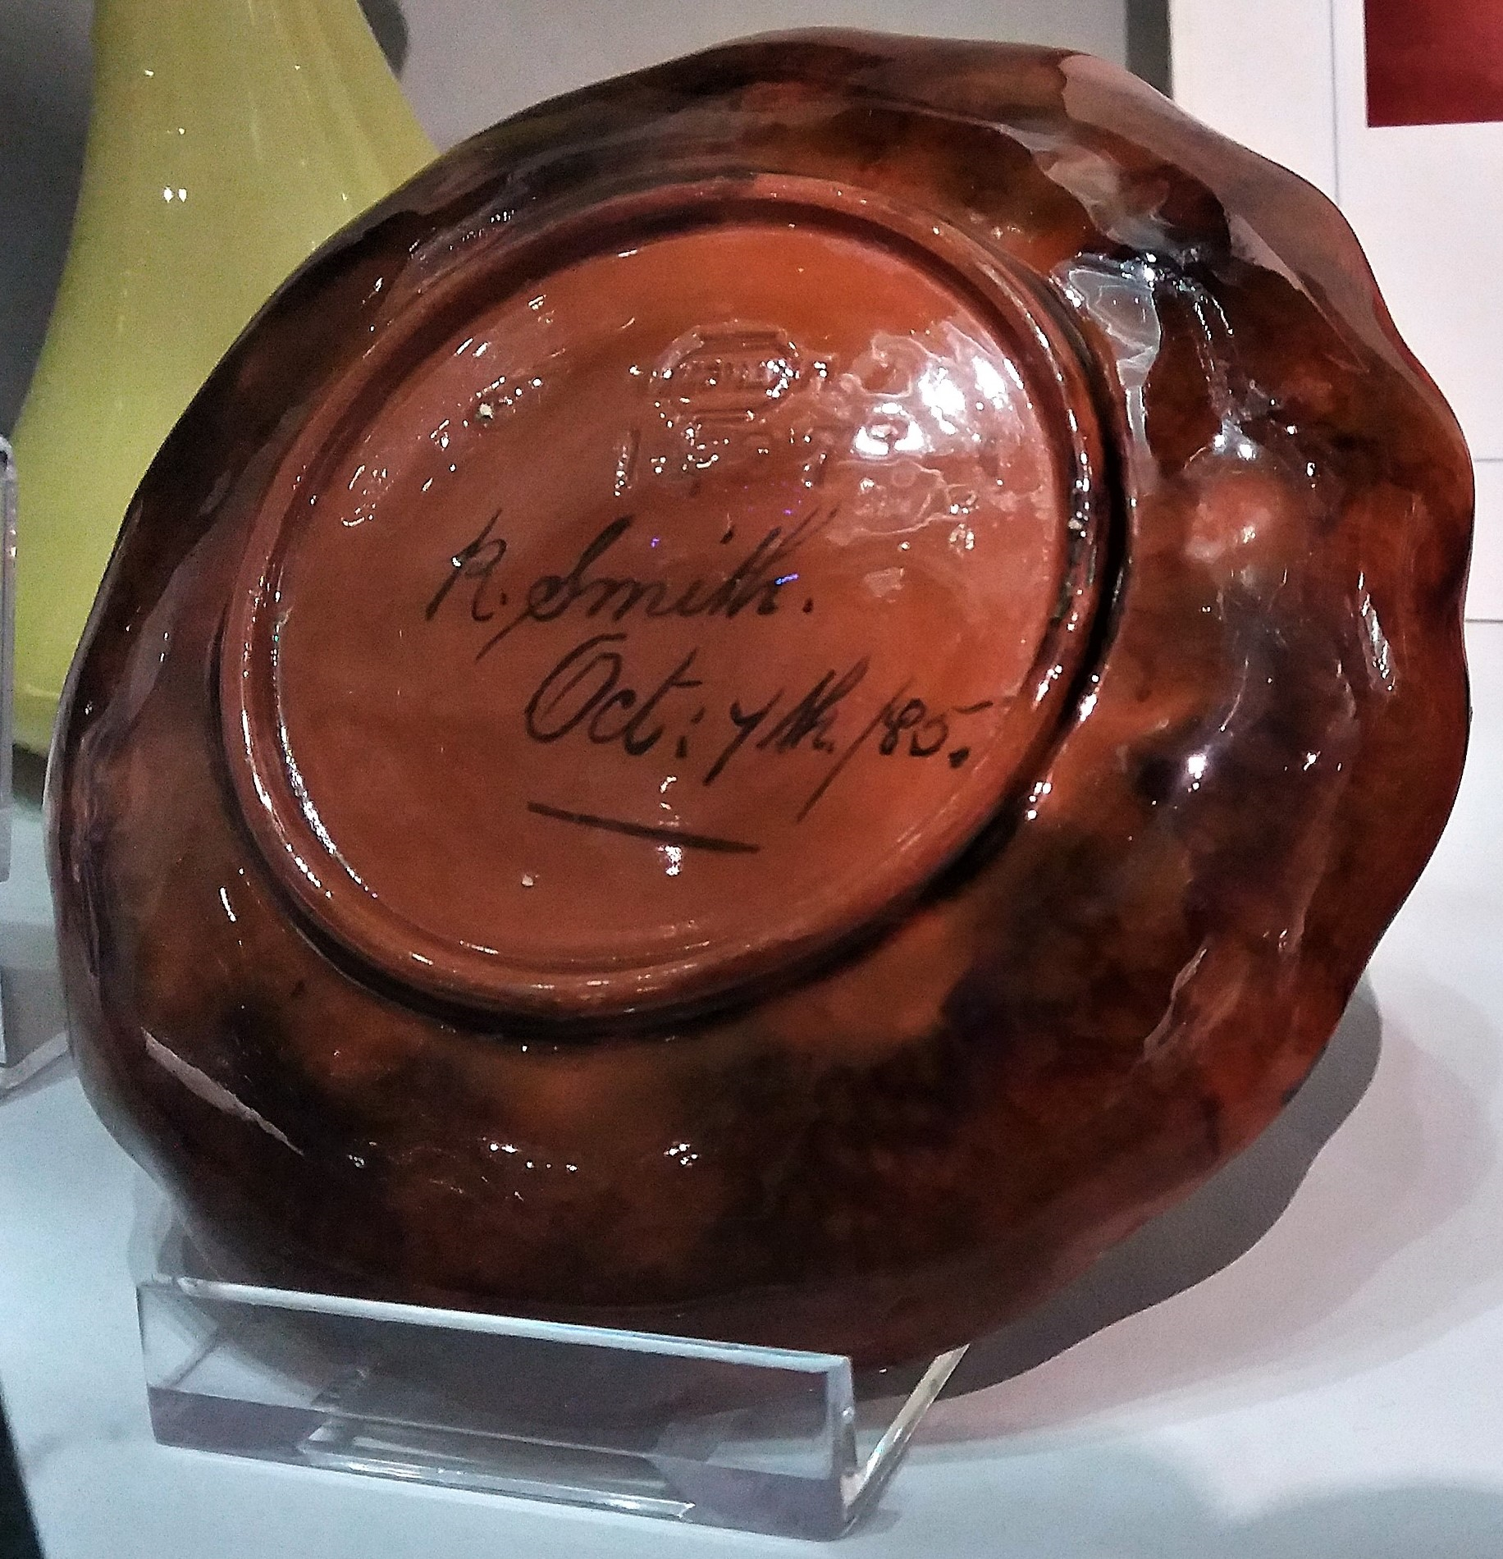
Florence Emma Minto
Florence started when she was just 15 as an underglaze decorator and painting finished works. She was especially talented in floral painting. In 1891 she took art examinations and was awarded certificates in drawing and design. In the end she decided not to become an Artist and instead became a Church Army Mission nurse in the early 1900s.
Rachel Smith

From the age of 17 Rachel worked as an underglaze decorator. She sometimes signed some of the pieces she worked on and listed her occupation in the 1881 Census as ‘Artist’. She would go on to work at Burmantofts Pottery in Leeds when Linthorpe Pottery closed in 1889.
People of Linthorpe Art Pottery
Linthorpe Art Pottery came to an end in 1889 following the death of John Harrison. Christopher Dresser had moved on to other business ventures and the company was deeply in debt. The building was sold off alongside all its pottery-making materials and the 100 strong work force were made redundant.
Although Linthorpe Art Pottery had only existed for 10 years, it nevertheless produced many great pieces that are still valued by collectors today.
Here are some of their stories -
The Pottery employed about 100 people in a range of roles including ceramic modeler and decorator. They had good working conditions, as the workshops were well-lit and ventilated, and the decorating rooms were filled with paintings to inspire workers’ designs.

Arthur Pascal Shorter

Arthur worked as a modeler shortly after leaving school. Part of his job was to figure out how colours changed during the firing process. After the closure of Linthorpe Pottery he continued to work as a potter’s clerk and decorator for Ault Pottery in Derbyshire.

Design your own Linthorpe Art Pottery

Imagine that you work at Linthorpe Art Pottery, and you can make any kind of pottery you like. Would you make a vase, or a teacup set, or something to hang on the wall? What would it look like?

In the space below you can draw your own pottery. Make it as unusually shaped and brightly coloured as you like!

For inspiration, look at the pictures of Linthorpe pottery in the pack.

All images used in this pack are courtesy of Dorman Museum and Preston Park Museum and Grounds.

You can find all our Talking Tees Valley packs through the Tees Valley Museums website under ‘Latest News’ or here: https://teesvalleymuseums.org/news/

If you would like to share your stories or contact us about the packs please e-mail teesvalleymuseums@stockton.gov.uk

