


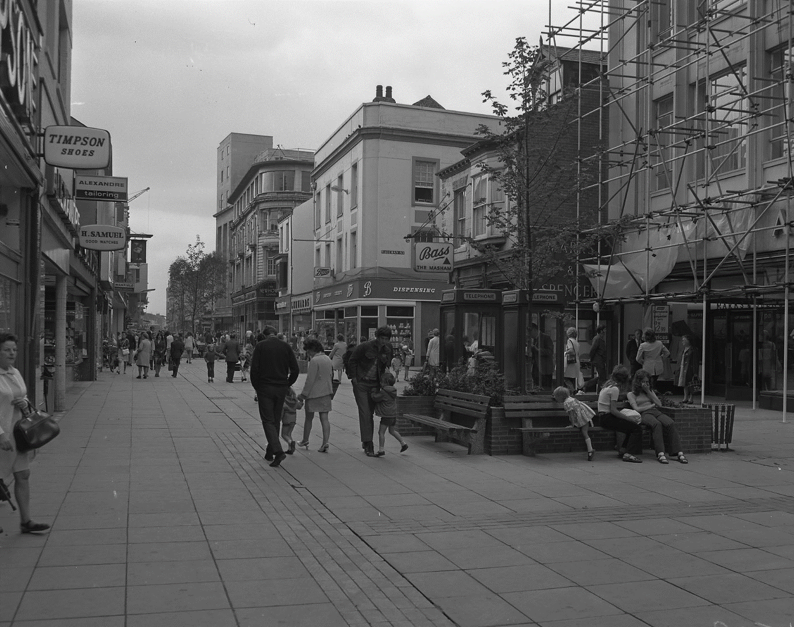
Middlesbrough in the 1970s
Talking Tees Valley Activity Pack
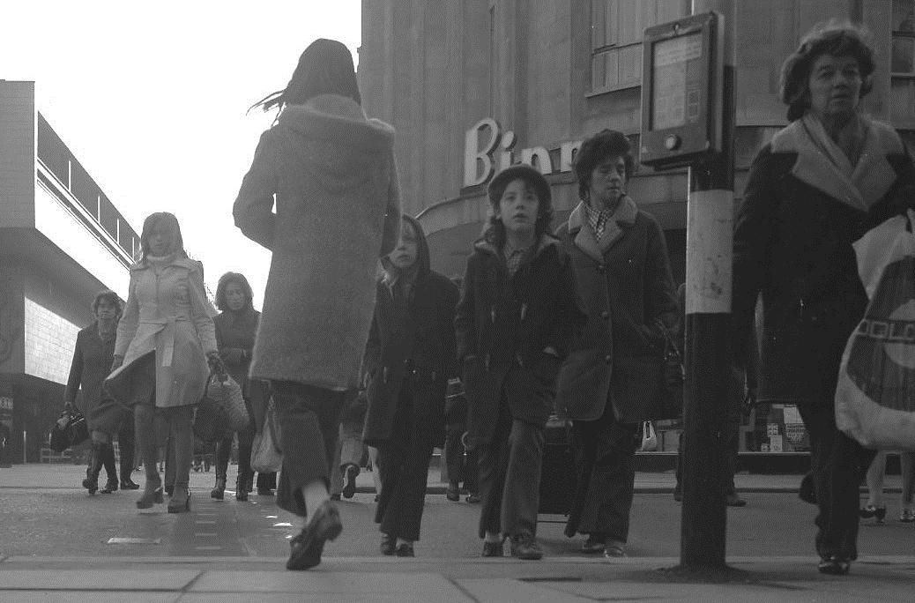
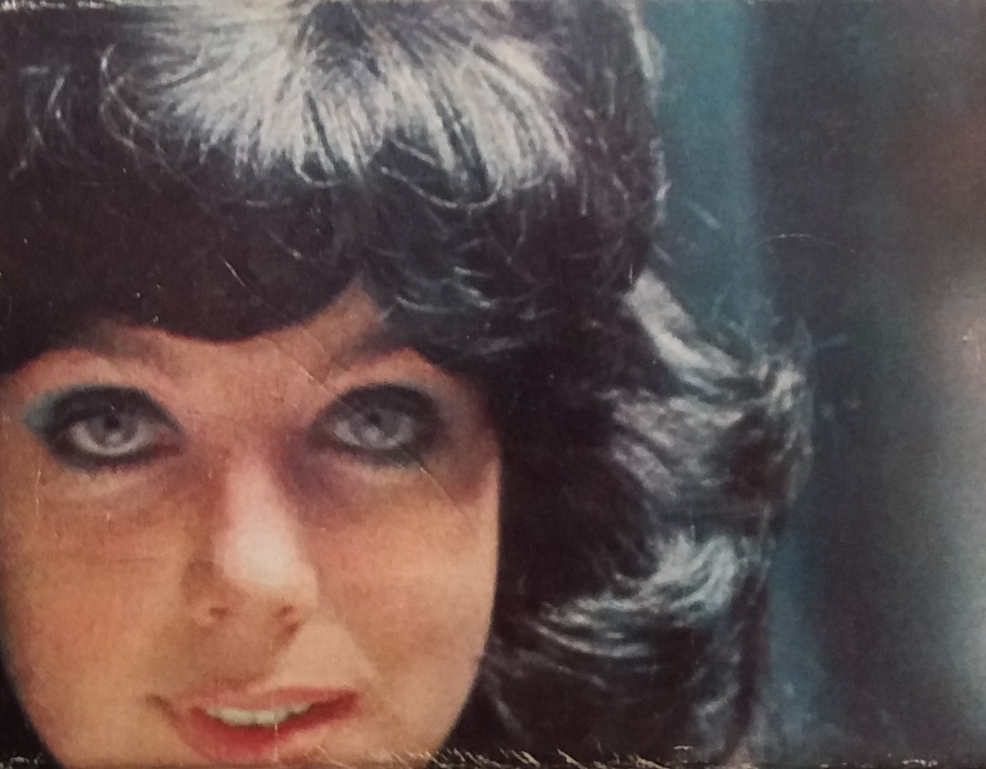

This pack uses objects from Dorman Museum’s 1970s Reminiscence Handling pack, and photos from Teesside Archives.
This month we look back at Middlesbrough in the 1970s. The Cleveland Centre had just been built and the centre of town was the place to shop! We’ll also look into the fashions and hairstyles of the time, and how we entertained ourselves with the latest technology.
Each month we use objects and photos from our museums in the Tees Valley to take a closer look at the lives and stories from people in our area.

Welcome to another edition of the Talking Tees Valley Activity Pack

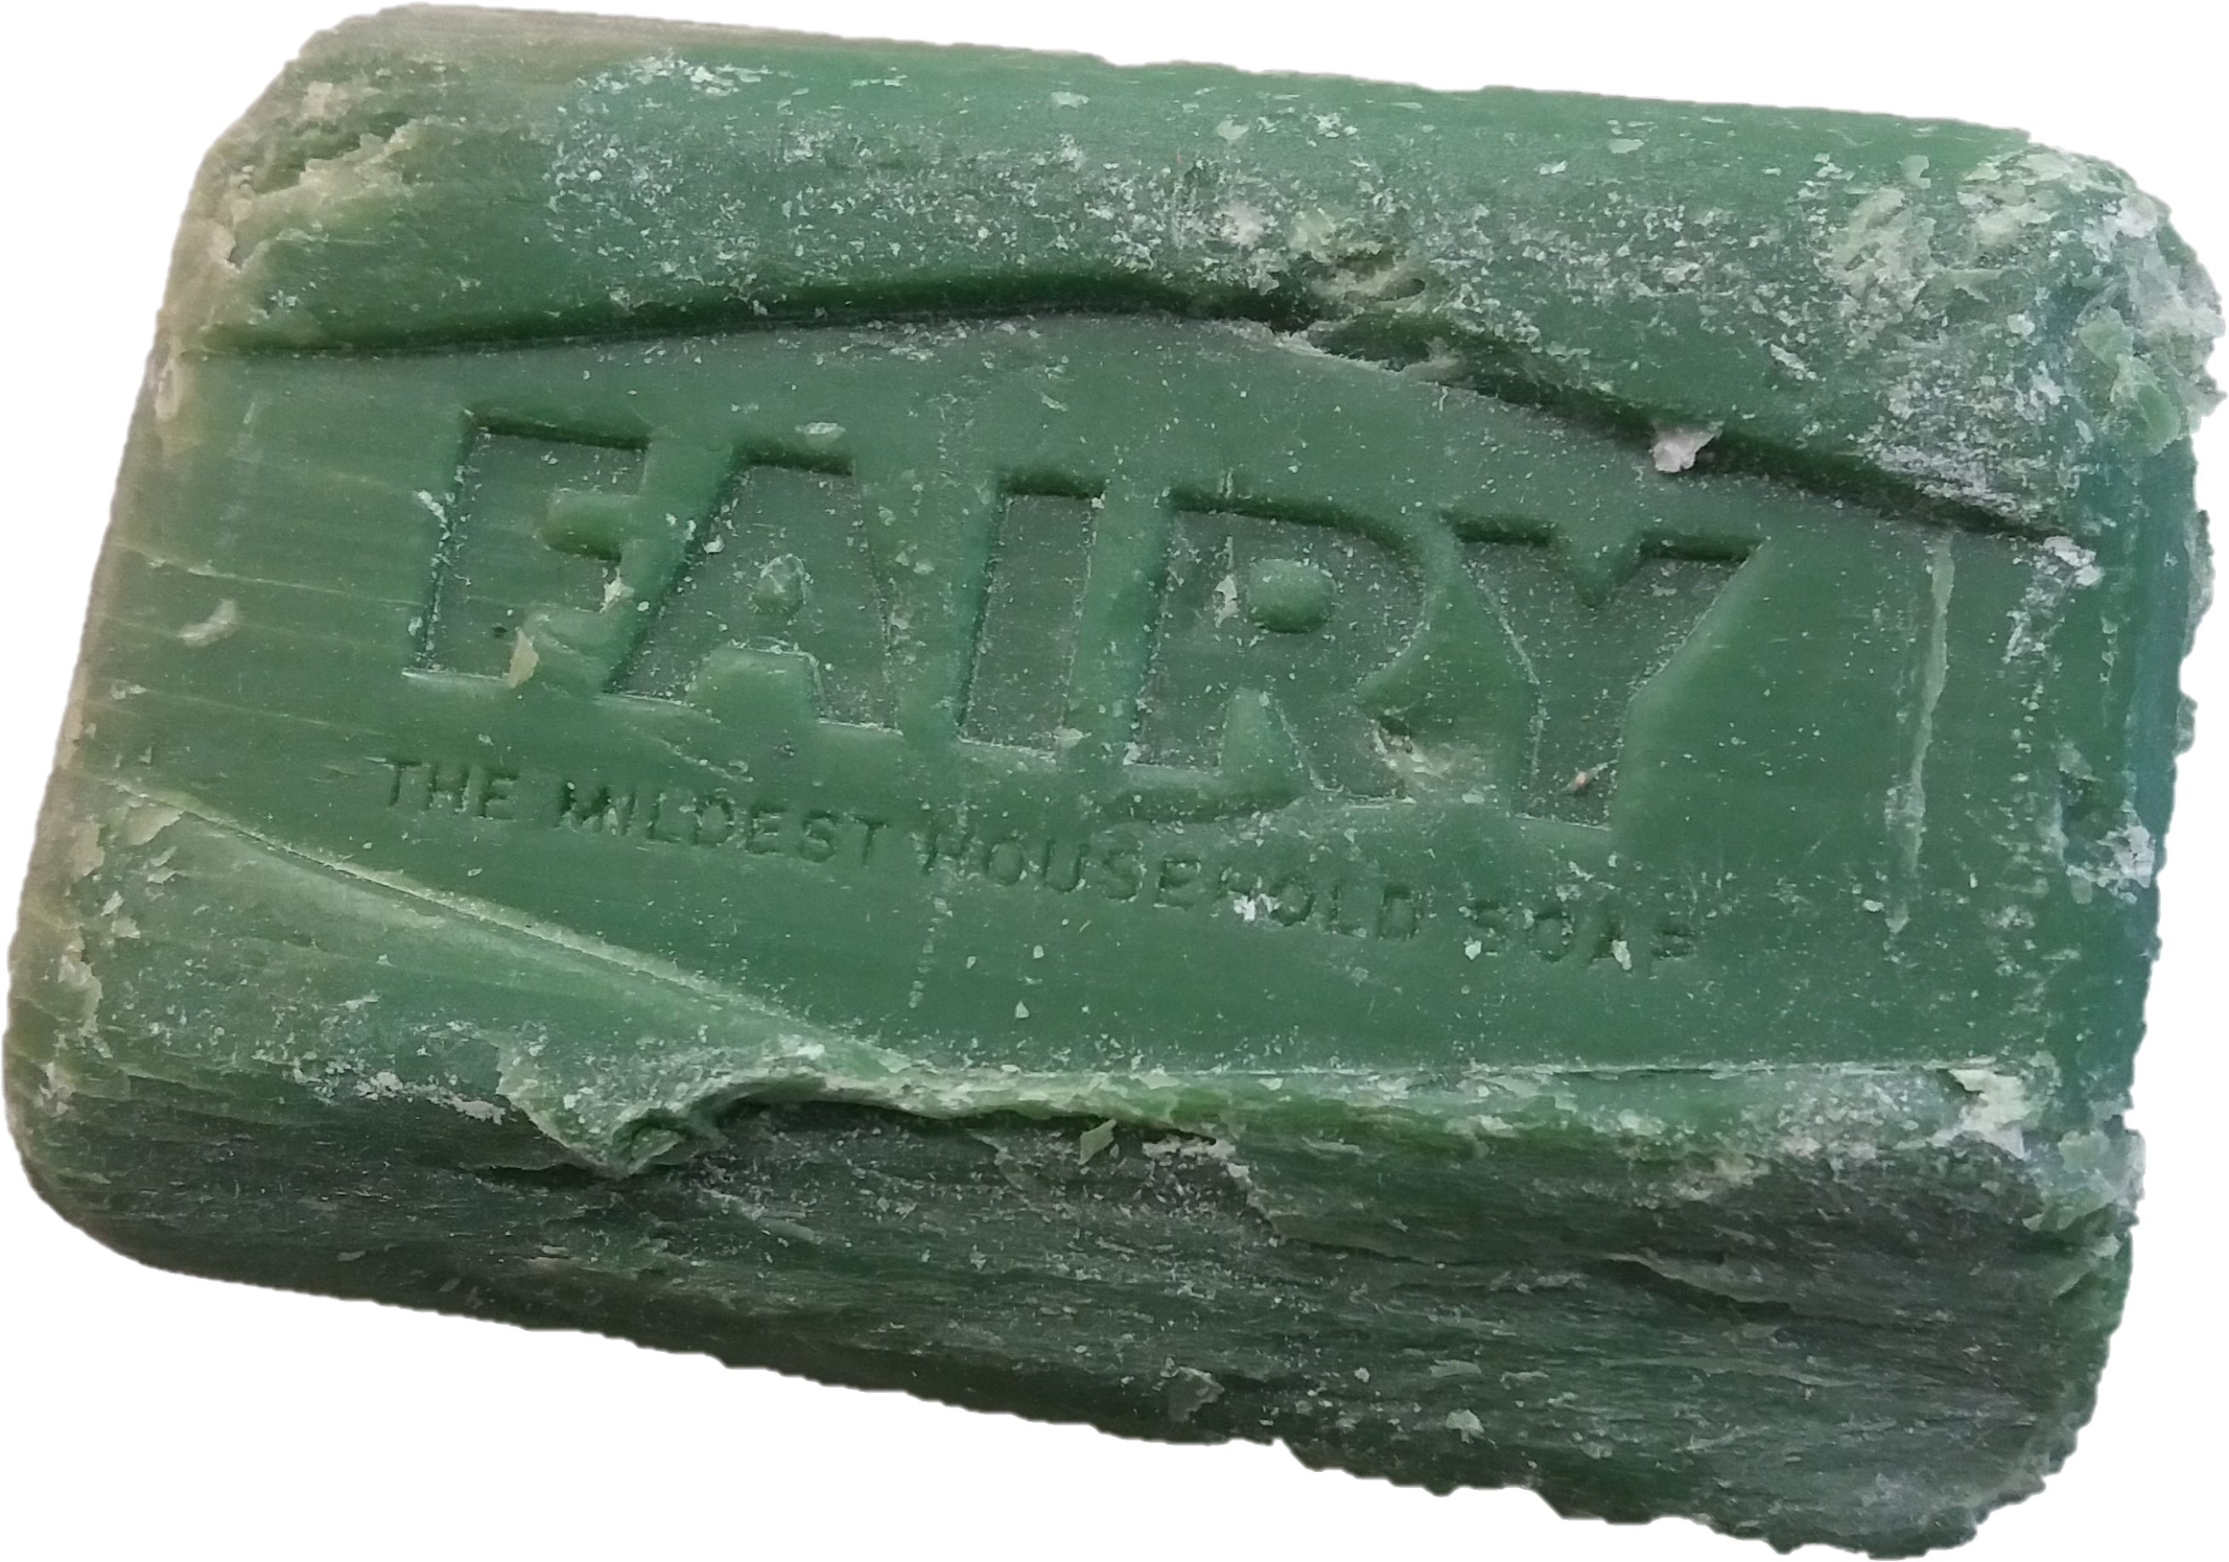
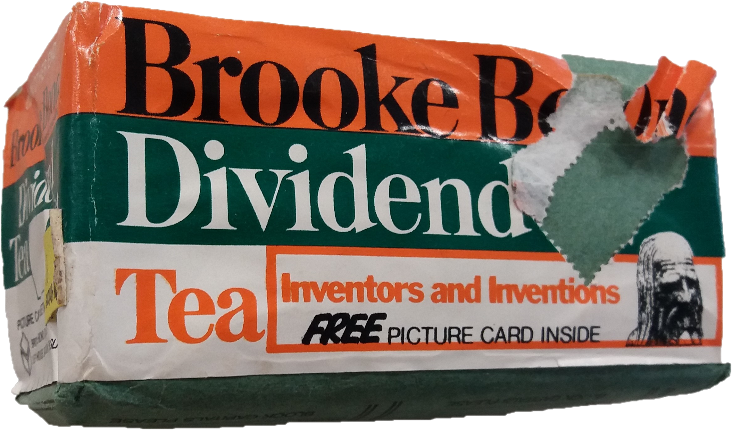
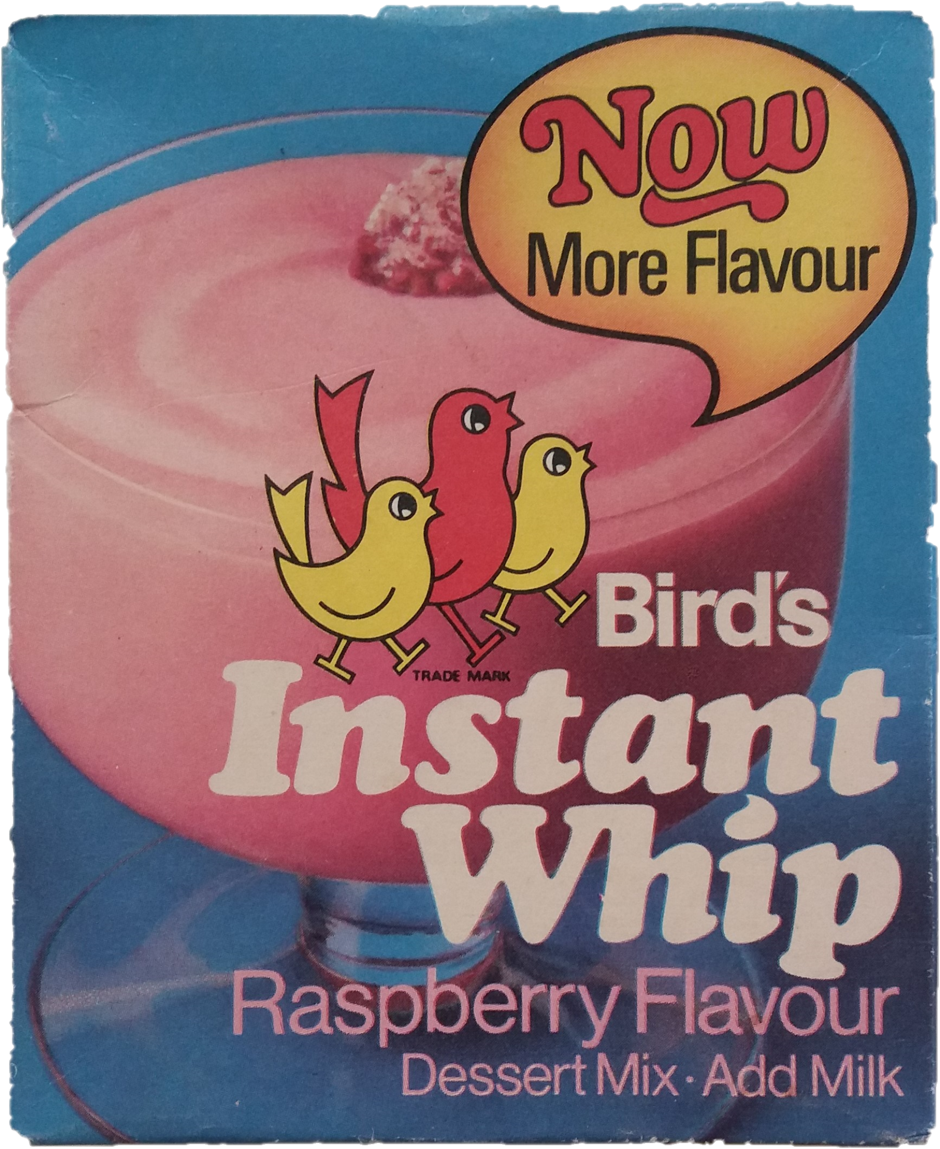
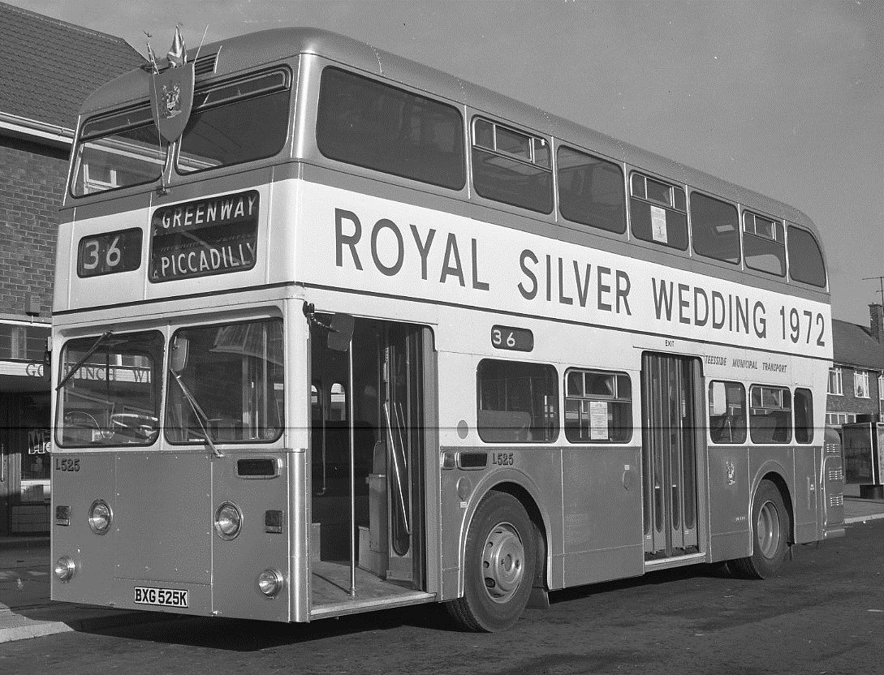
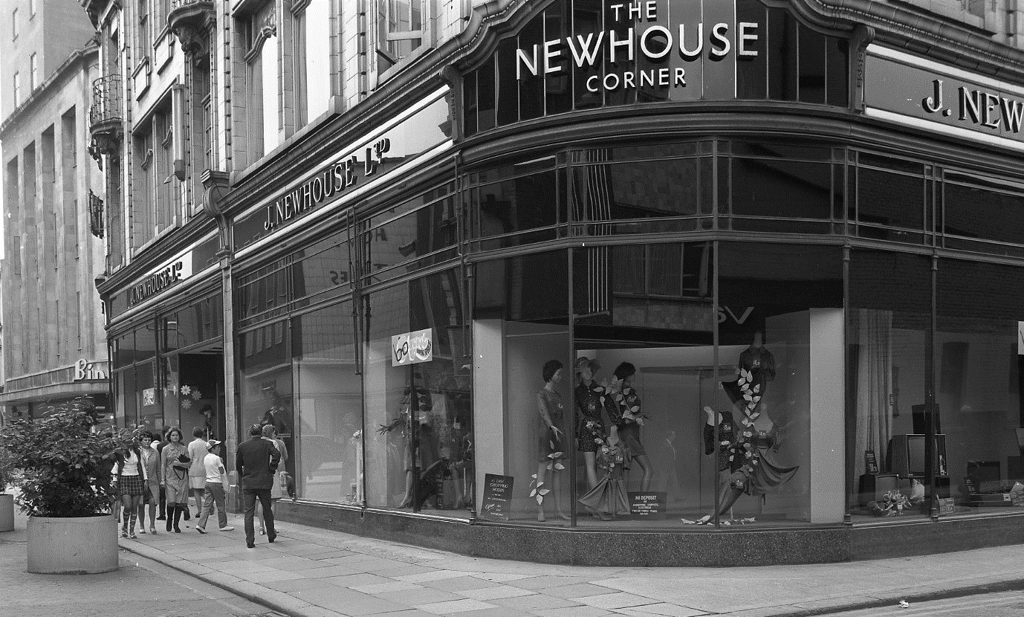
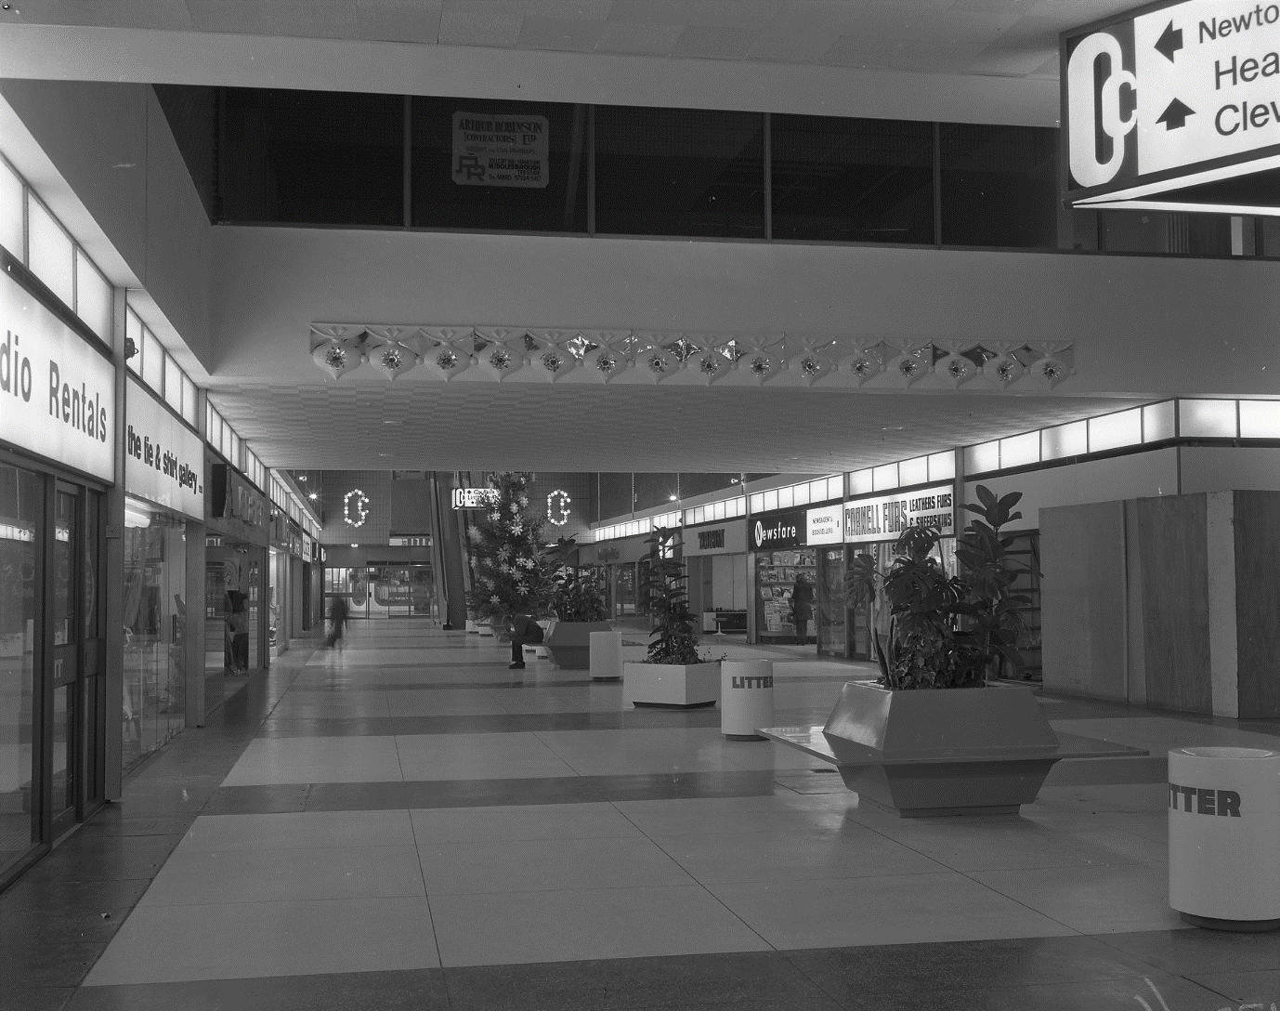
Here are some throw backs to popular products!
‘Bird’s Instant Whip’ was like Angel Delight. You only needed milk and 5 minutes’ whisking to make.
‘Brooke Bond Dividend Tea’ was sold with collectable stamps. You needed 60 stamps to exchange for 25p worth of groceries.
‘Fairy’ came in soap bars. The jingle used to go: “Now hands that do dishes can feel as soft as your face with mild green Fairy Liquid”.
Shopping in Middlesbrough
And there was the Royal Silver Wedding Anniversary in 1972. Silver painted buses were brought in to ferry people to the town on concessionary tickets that allowed free travel.

The centre of Middlesbrough was also a great place for hosting events – the Teesside International Eistedfodd, or Intertie, was a colourful song and dance festival founded by a community of Welsh workers who had come to work at ICI.
Away from the Cleveland Centre were other shops including Binns, Chelsea Girl, and the Newhouse Corner, named after the family who had owned it since 1909.
While it had been sold to Debenhams in 1960, the Newhouse Corner had kept its name well into the 1970s.
While many shops have disappeared from the Centre, some like H Samuel and Boots have stayed.
Dubbed as “The High Street off the High Street” by Brian Morrison, its first Manager, the Cleveland Centre was home to Wycherly’s Record Shop, Timpson’s Shoe Repairs, Forshaw’s Tobacconists and many household names.
From the 1970s shops in the centre of Middlesbrough had undergone a spectacular change. Six streets had been knocked down to make way for the Cleveland Centre.

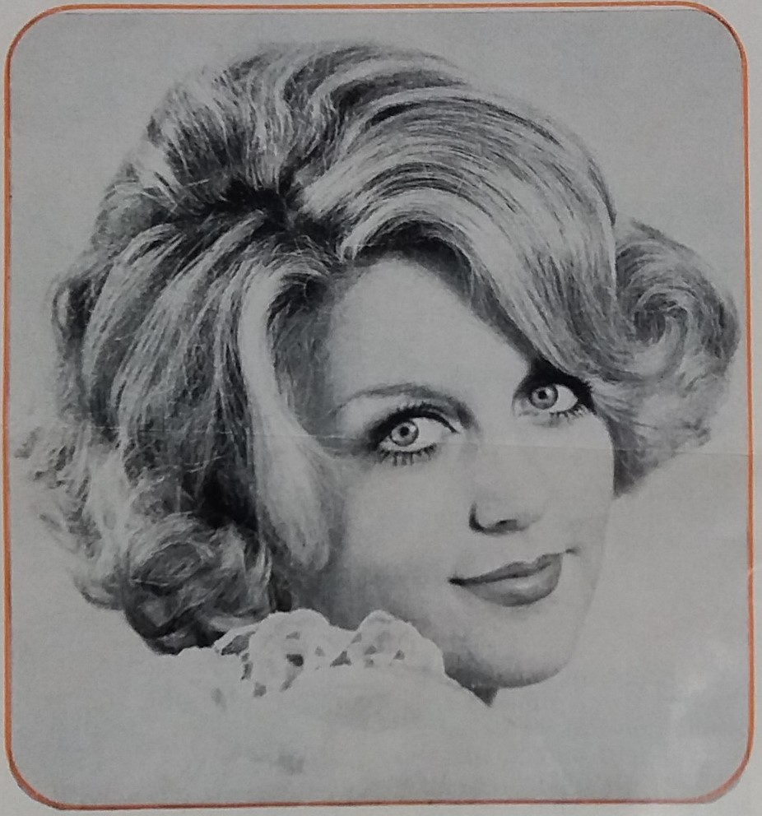
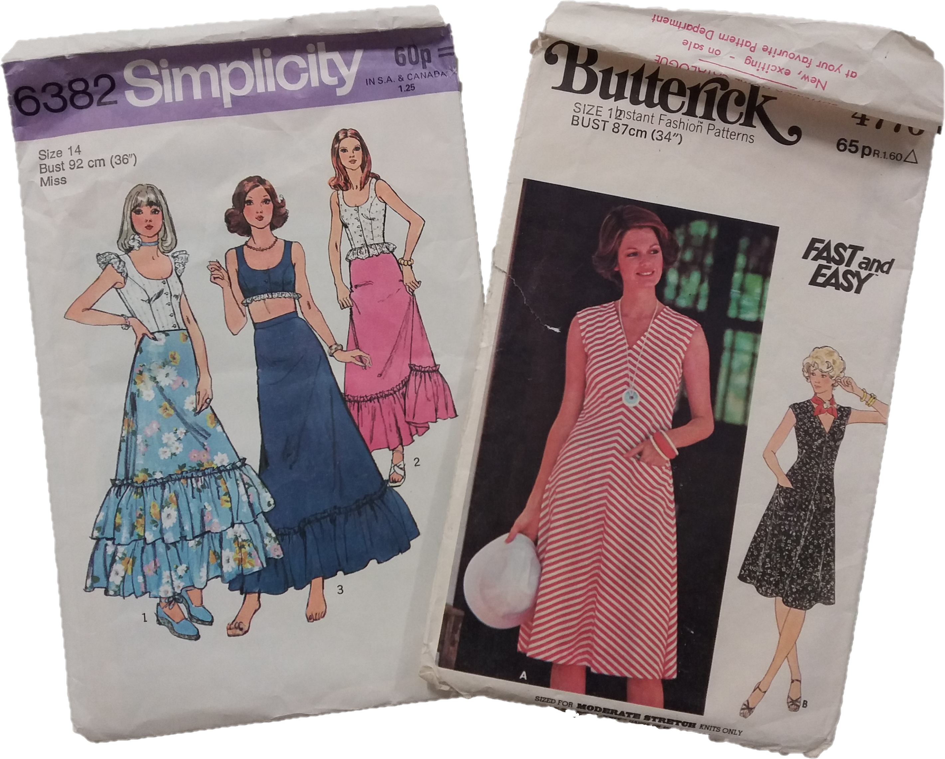
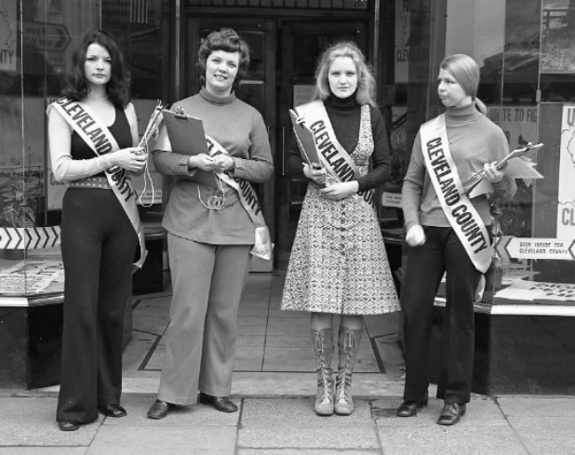
The 1970s was a decade of bold fashion and even bolder hair. Women fully embraced their natural curls, creating voluminous and striking looks. Hair scarves and rollers were regular sights round town as they aimed for those big, glamorous curls.
What was your favourite outfit and how did your parents react?

Dateline curlers and the Ronson Escort 2000
The 1970s also saw a resurgence in people making their own clothes. Sewists eagerly collected sewing patterns such as these ‘Simplicity’ and ‘Butterick’ packs which were sold at most shops.
Patterns came in vintage-inspired designs, bohemian prints, and geometric shapes, and makers chose corduroy, denim and floral fabrics. The variety in these packs allowed endless creativity.
The Sew-It-Yourself (SIY) Movement
The 1970s were also known as the ‘Polyester Decade’ due to the widespread use of synthetic fabrics. Clothes made from polyester were affordable, easy to care for, and available in vibrant colours and patterns, dominating both casual and formal wear.
Teesside was no exception for these new trends as the younger generation embraced clothes that were brightly coloured and allowed them to express themselves.
The 1970s was a dynamic time for fashion, marked by new styles that included disco, soul and punk, and new fabrics that made a whole new wardrobe cheaper to buy.
Fashion and Hairstyles
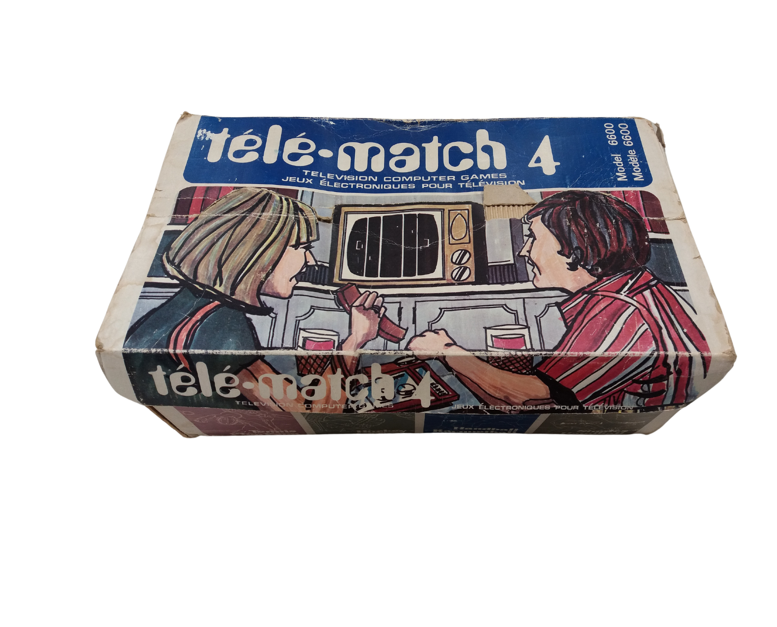
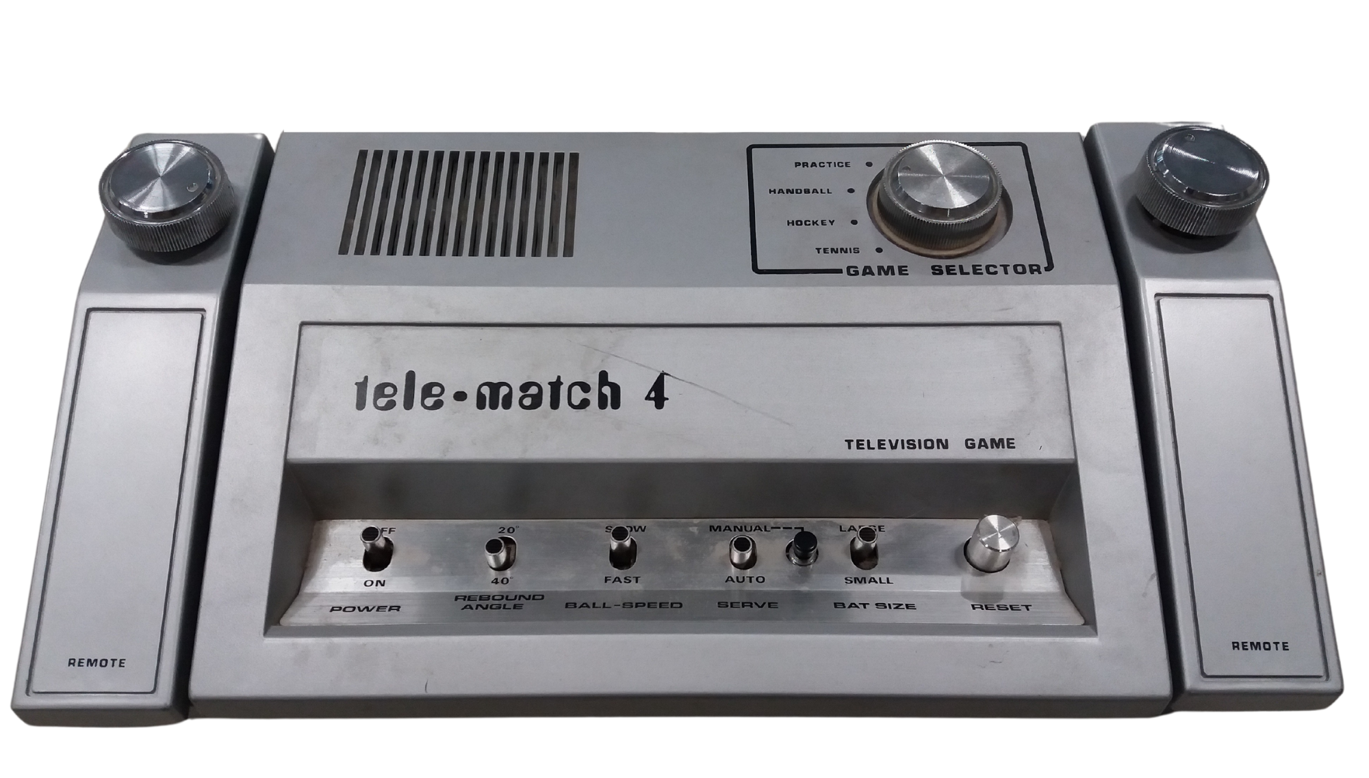
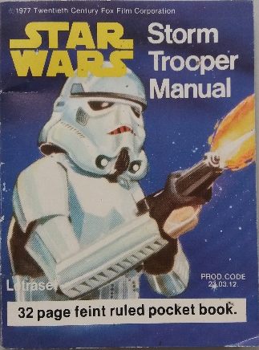
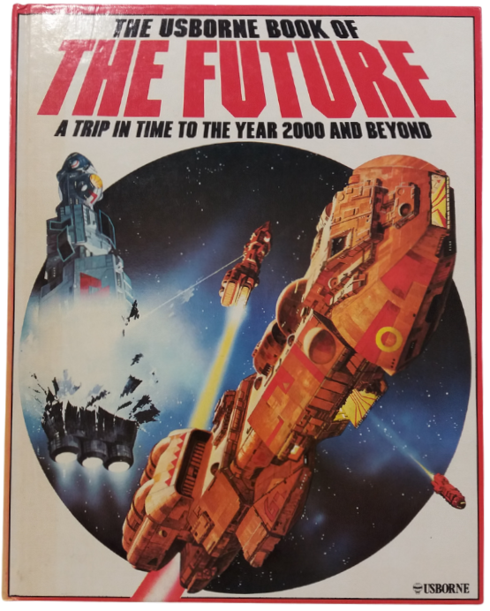
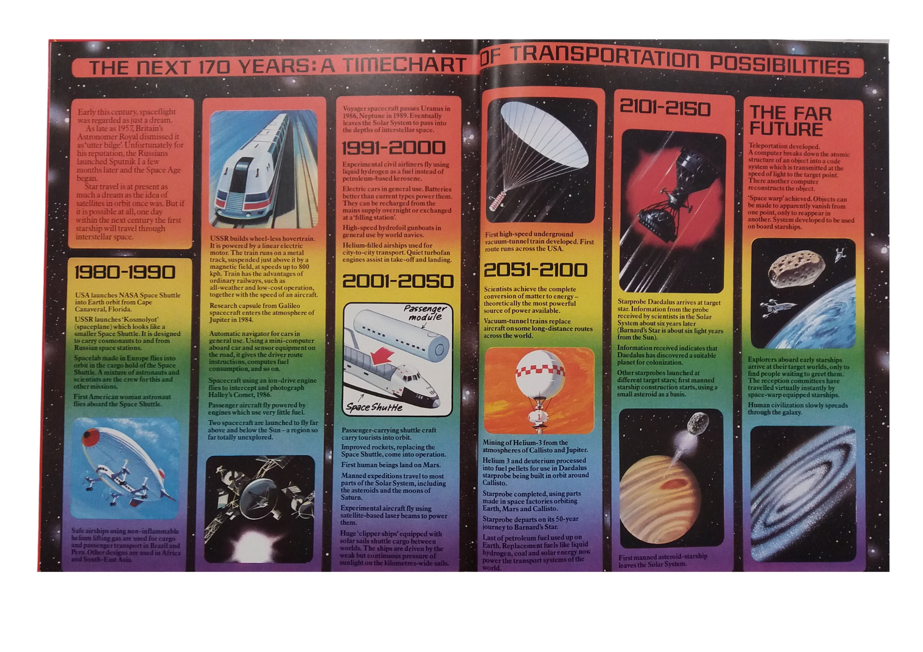
1970’s Video Games
In the 1970s, video game consoles allowed people to play games on a TV at home. Before consoles, people would have played games mainly in arcades. Early home video games such as the ‘Tele-match 4’ had simple graphics and were limited to games that were preloaded on the console.
This ‘Tele-Match 4’ console came with five games, including ‘tennis’ a pong like game.
What games did you enjoy playing?
During the 1970s, blockbuster science fiction films began to make their appearance. These movies reached a much larger audience than previously.
At the time many people dreamed of a future filled with wonder and amazing new technology.
In 1977 the original ‘Star Wars’ movie was released in cinemas in the UK. The film quickly became a blockbuster hit and the movies success quickly led to more movies and merchandise like this pocket book being produced.
Home Entertainment
In 1979 The ‘Usborne book of the future’ was published. The book predicted what some people in 1979 thought life would be like in the future.
Science Fiction

To colour in.

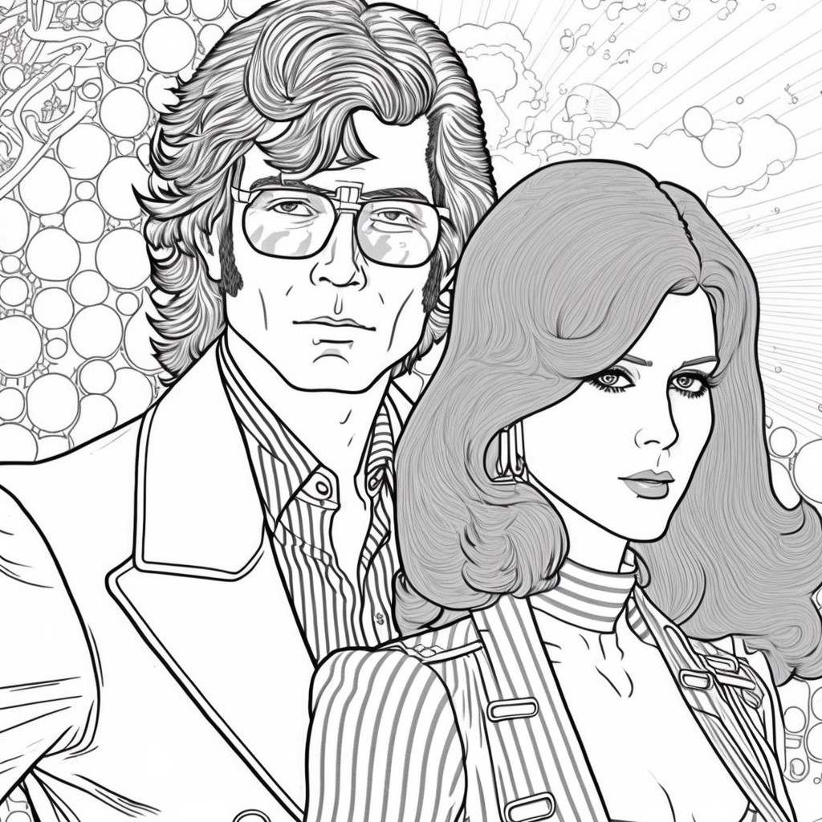

All images used in this pack are courtesy of Dorman Museum and Teesside Archives.

If you would like to share your stories or contact us about the packs please e-mail teesvalleymuseums@stockton.gov.uk

You can find all our Talking Tees Valley packs through the Tees Valley Museums website under ‘Latest News’ or here: https://teesvalleymuseums.org/news/

