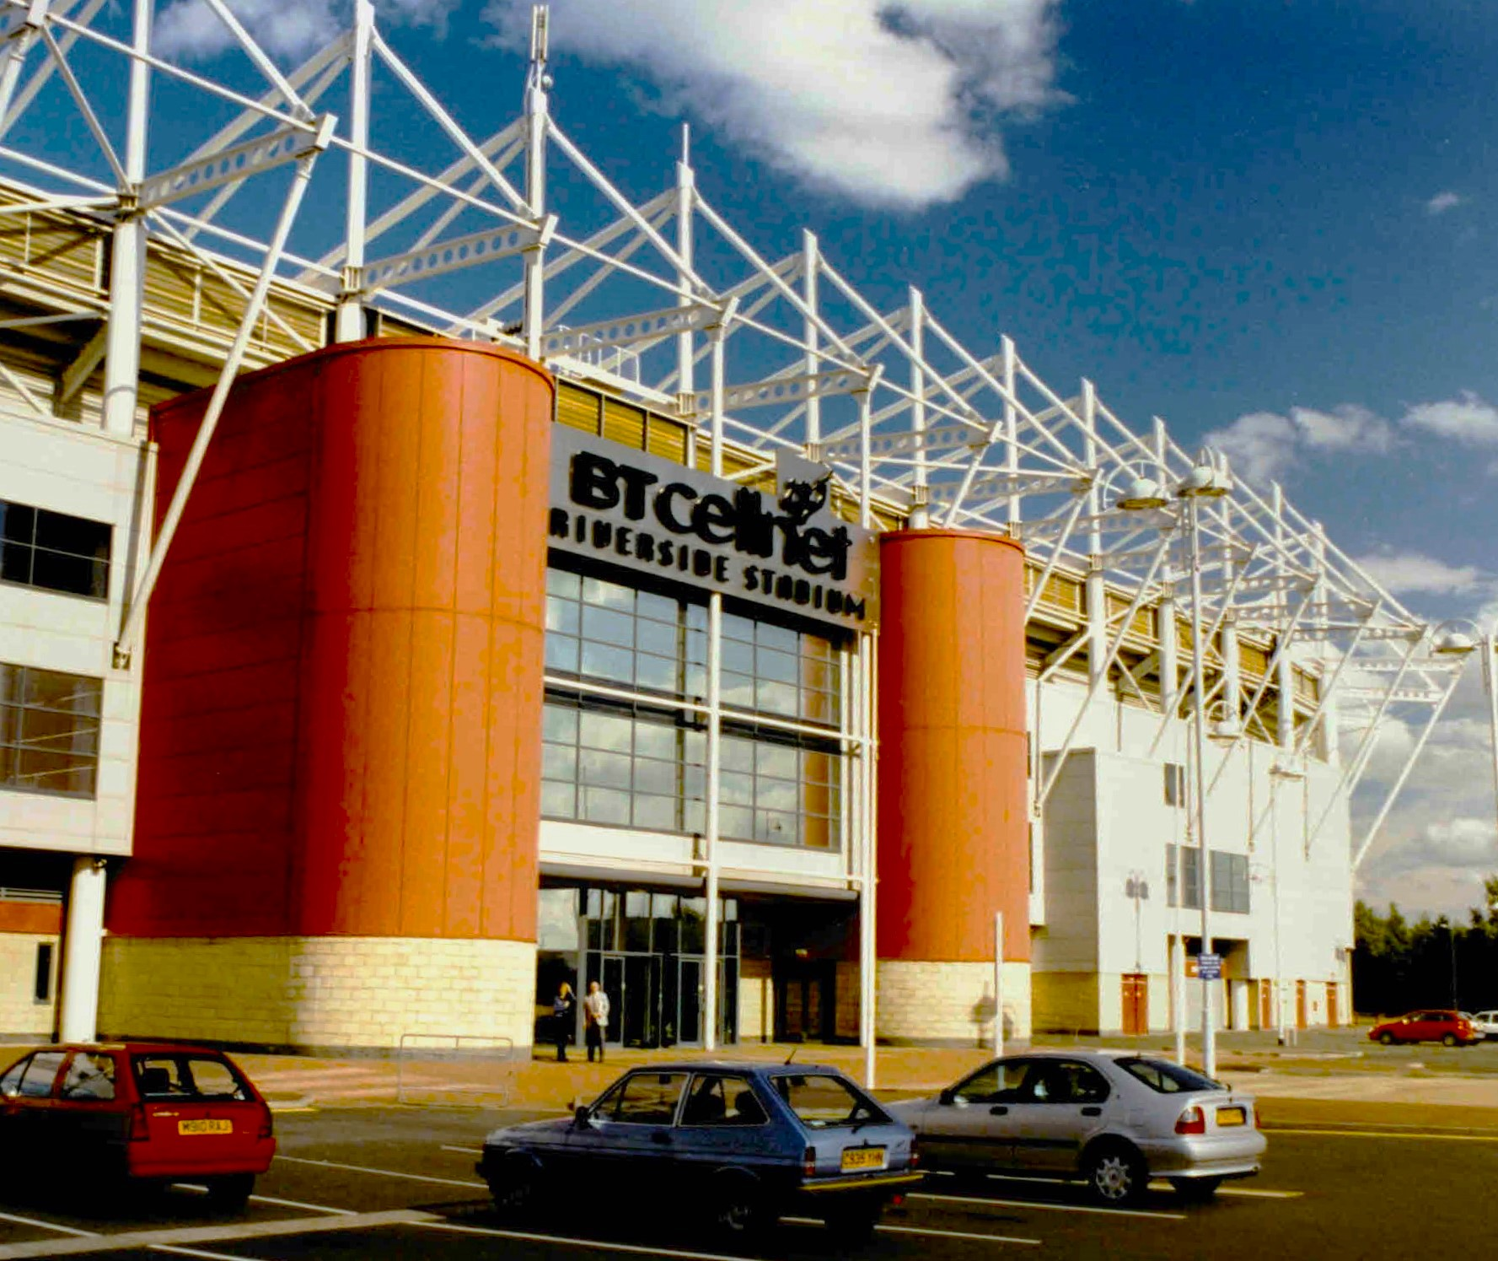

Middlesbrough Football Club
Talking Tees Valley Activity Pack
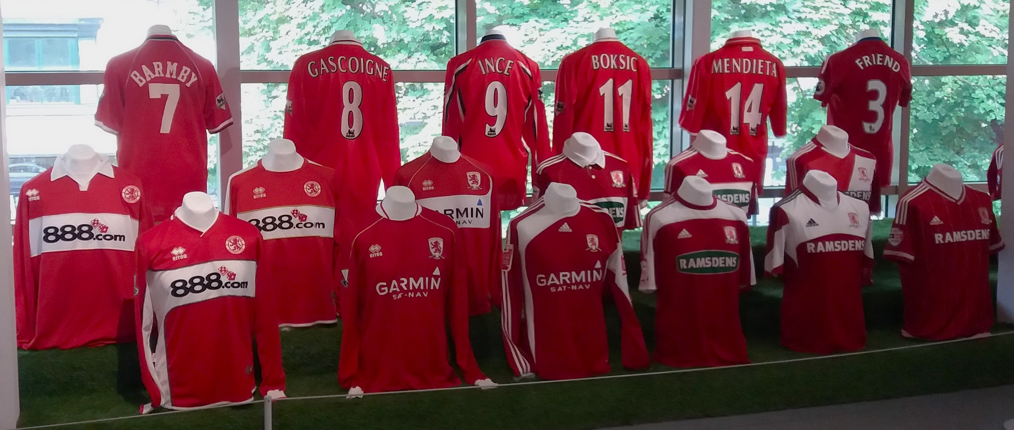

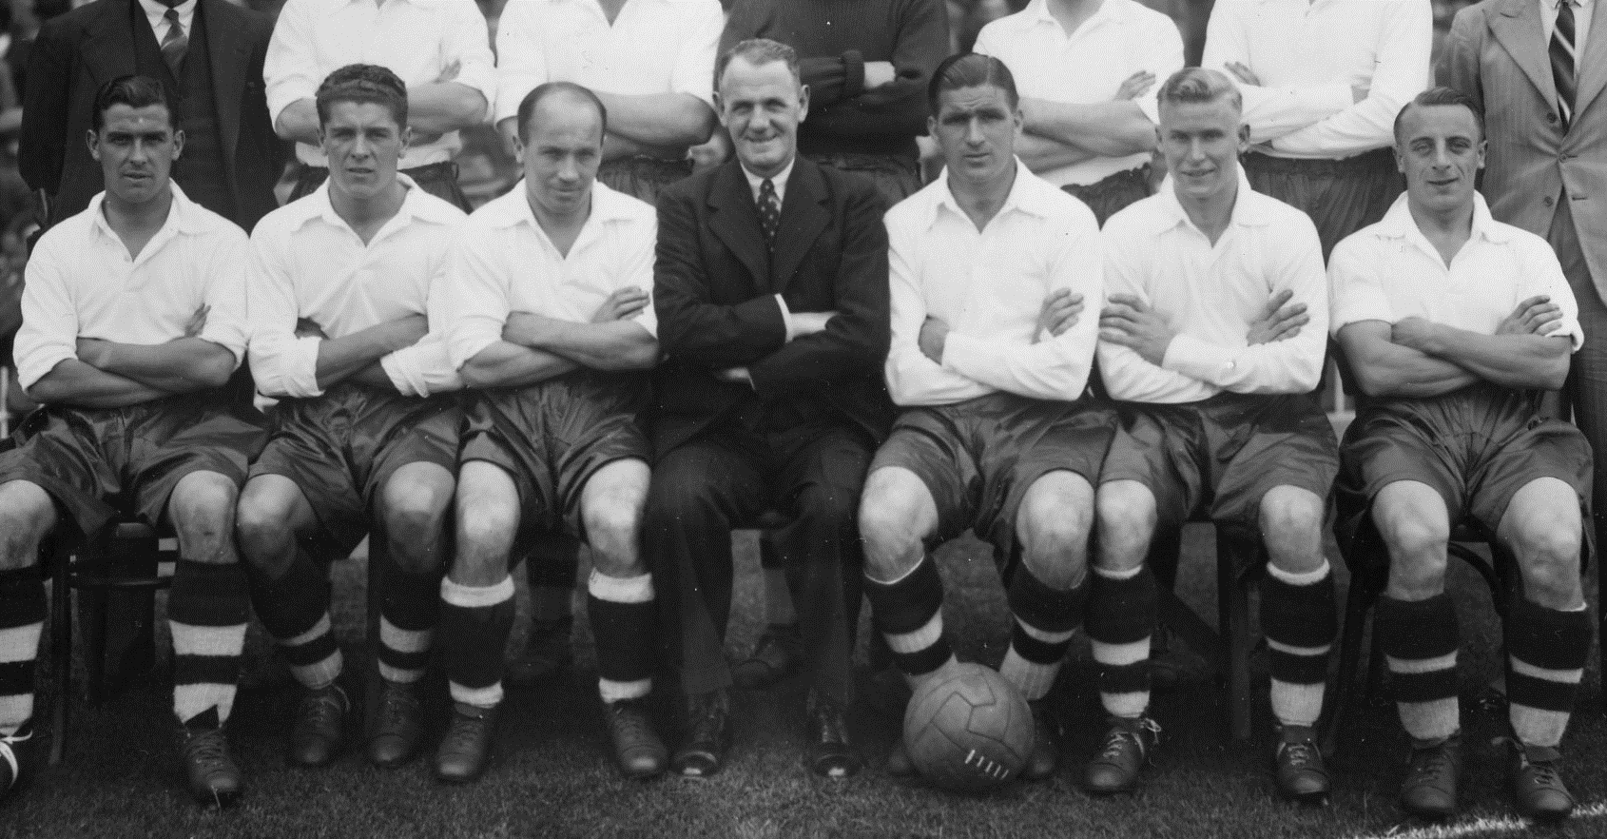
This month we look at the history of Middlesbrough’s most well-known Football Club. We will also look at Dorman Museum’s new exhibition from the Boro T-Shirt Museum, showing decades of Football T-Shirts, and have a go at making your own Football Shirt.
Welcome to another edition of the Talking Tees Valley Activity Pack
Each month we use objects and photos from our museums in the Tees Valley to take a closer look at the lives and stories from people in our area.

Dorman Museum currently have a paid exhibition of Middlesbrough Football Club’s T Shirts over the decades. Make sure you get to see this exhibition before it closes on 29th September!

How the Football Club Started
Middlesbrough Cricket Club founded their own Football Club in the 1870s. They usually could not play cricket during the winter months, so wanted to play football during these months in order to keep fit.
Today Football is played all year long, but it was traditionally a winter sport, since rain and snow did not impact play in the same way they could in cricket.

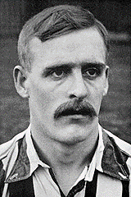
In 1889 Middlesbrough Football Club became a professional team after years of playing as an amateur team and entered the First Division. The Boro used to play at their old cricket grounds, but a new stadium was needed. Just in time for the 1903-1904 season, Ayresome Park was built.

It was in 1905 that Alf Common joined Middlesbrough Football Club for, at the time, a record £1,000. For the 5 years he was with the Club he played 168 games and scored 58 goals.

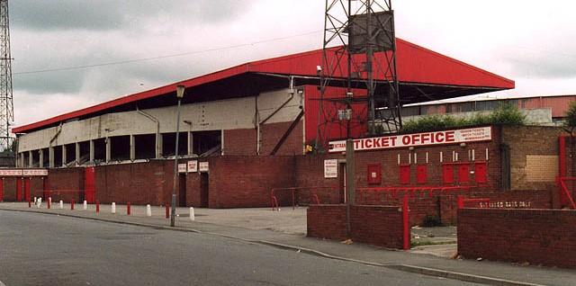
Ayresome Park

Ayresome Park was the home of Middlesbrough Football Club for 92 years. It was sometimes called ‘The Stink’ since it was built close to the chemical factories and smells would waft over. It was also distinctive for having a large main stand.

Ayresome Park, dated June 1995. Stephen McCulloch, CC BY-SA 2.0 https://creativecommons.org/licenses/by-sa/2.0 via Wikimedia Commons

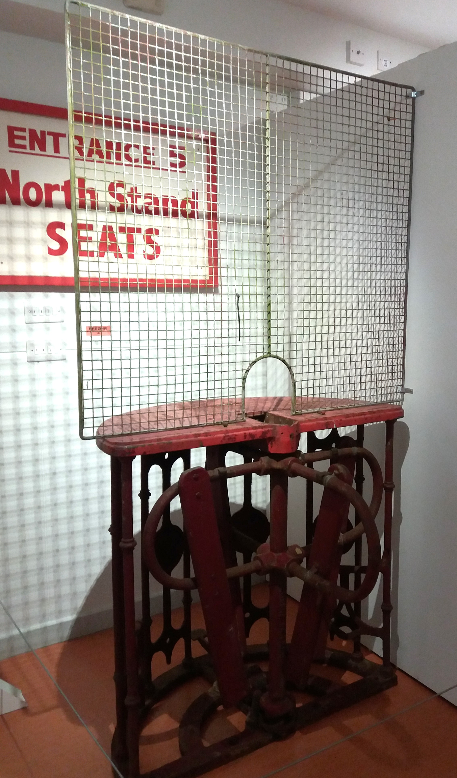
The Boro excelled in the 1913-14 season, which was to be one of their last seasons for a while when the First World War was declared.

Dorman Museum has in their collection a turnstile from Ayresome Park with it’s original wire mesh and iron stand.
Can you imagine all the people that once passed through?
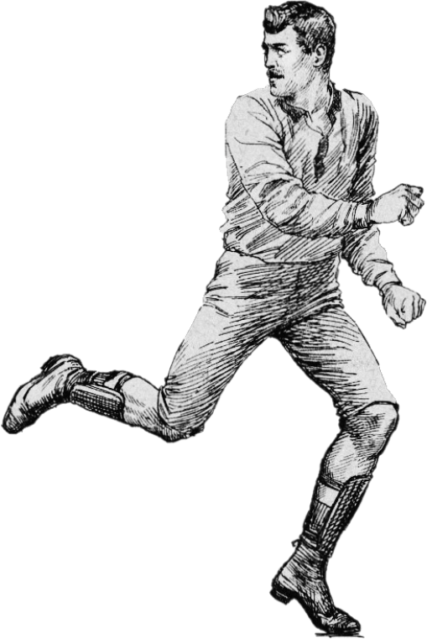
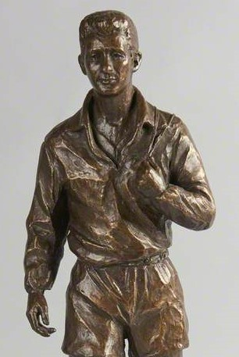
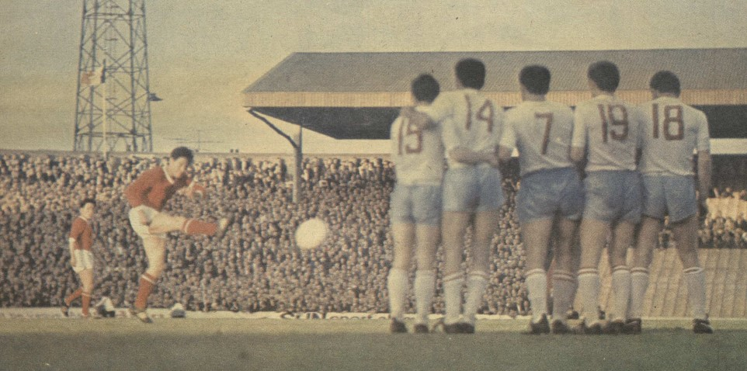
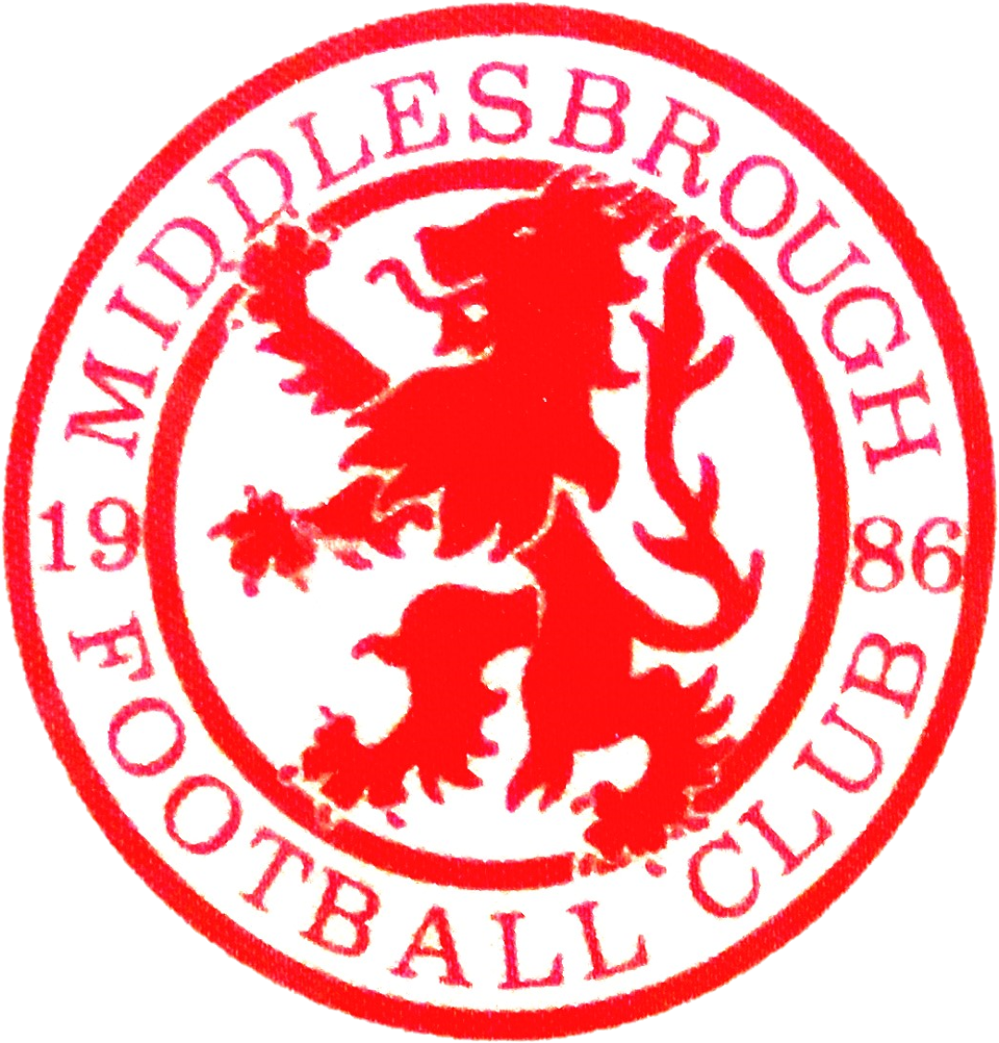
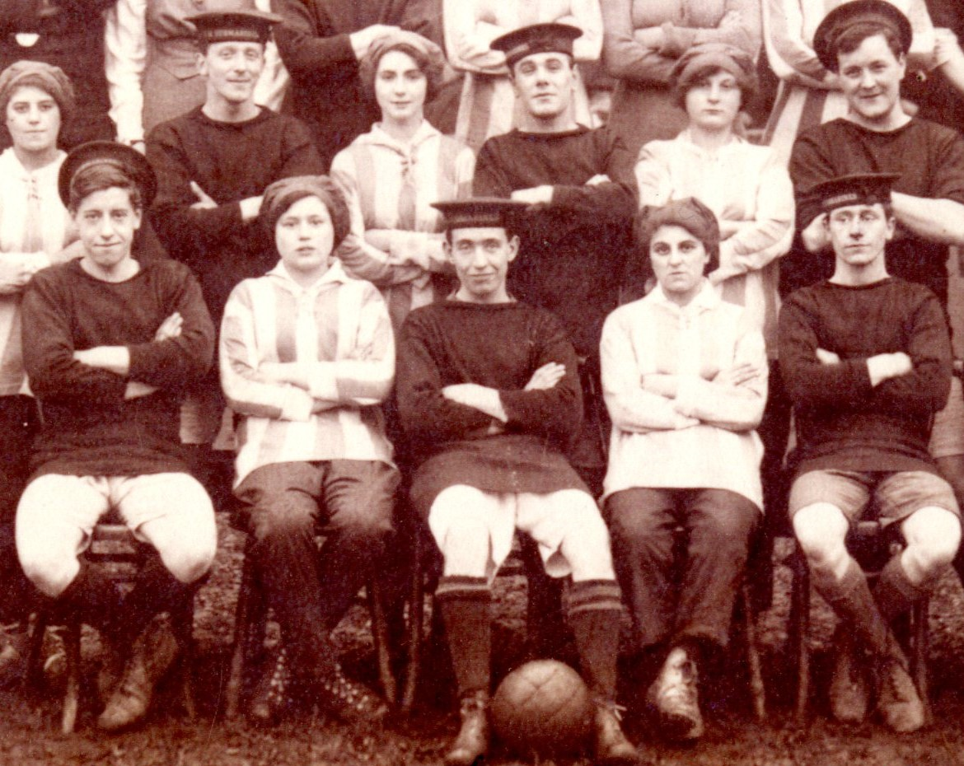

In the 1950s and 60s the Club signed on some of their more well-known players – both Wilf Mannion and George Hardwick joined before the War and stayed on afterwards.
Brian Clough played as a striker for MFC and Sunderland, before becoming a manager for Hartlepool, Derby and Nottingham Forest.
In 1966 Middlesbrough Football Club was relegated to the Third Division for the first time, but this year also saw a new surprise for Ayresome Park when they were selected to host three of the FIFA World Cup Games.

The first on the 12th July saw the USSR beat North Korea by 3-0. On the 15th North Korea returned to draw 1-1 with Chile, and it was on the 19th when North Korea beat Italy 1-0 and made it to the quarter finals.
In 1986 Middlesbrough Football Club faced their biggest challenge. Financial difficulties and relegation to the Third Division saw the Club nearing its end.
It was the actions of Steve Gibson, a member of the board at the time, which saved the Club. With minutes to spare Middlesbrough Football Club entered the new 1986-1987 season.
Middlesbrough entered the First Division in the late 1920s, staying until 1954. More intervention from the Second World War saw the Club relegated.
After the War
The Munitionettes Cup was held in 1918 and another home-grown team, Bolckow Ladies, made it to the final against Blyth Spartans which was played at Ayresome Park.
During the War, many women’s football teams were founded and played officially to boost morale. This included Smiths Dock Ladies Team, named after the company they worked in during the War.
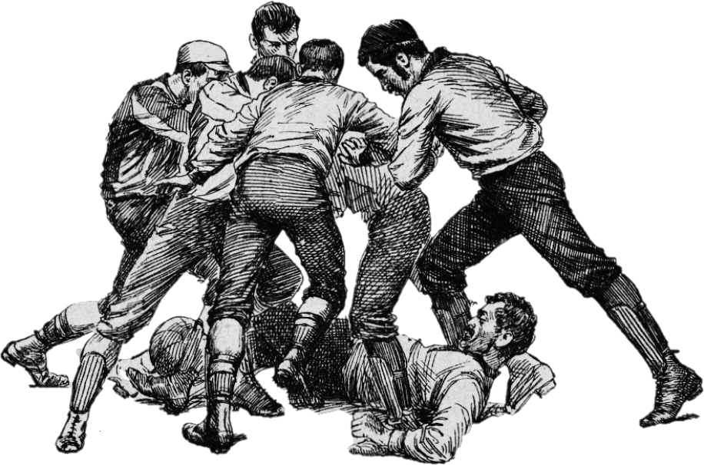
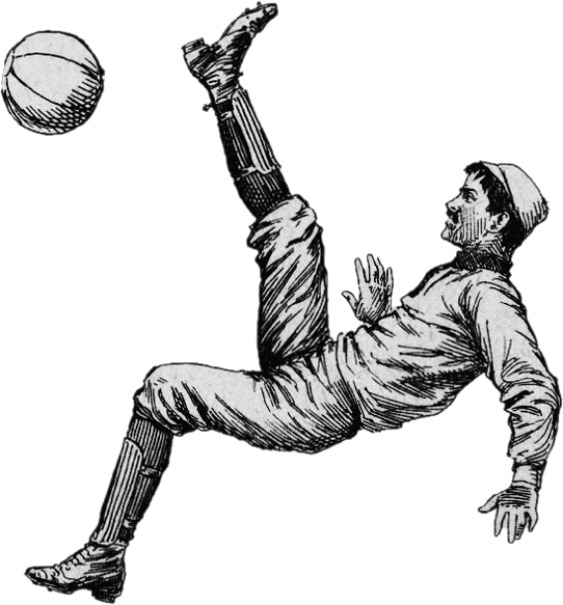
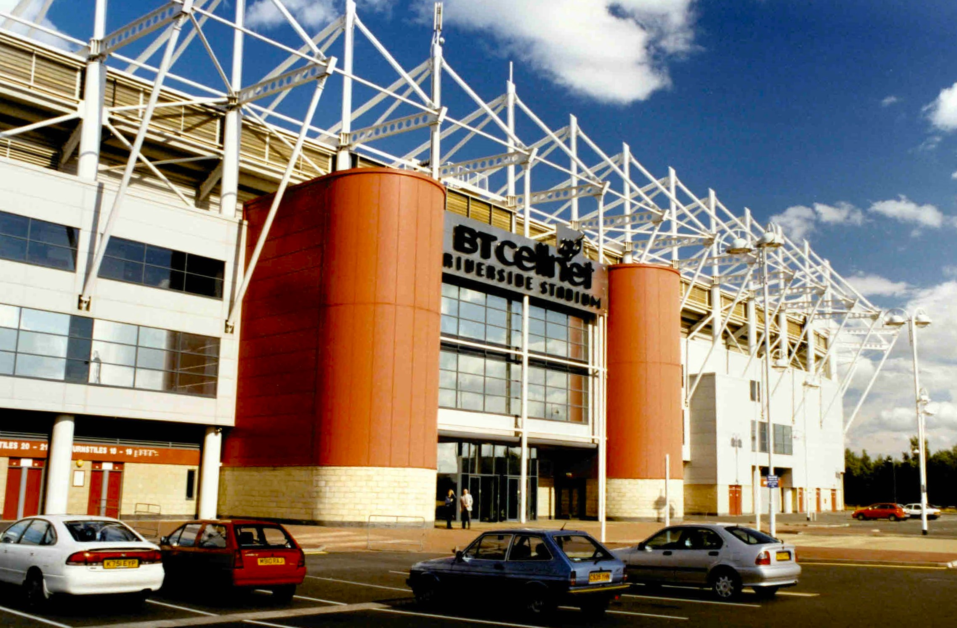

Over the years Middlesbrough Football Club have become one of the most influential clubs in the town, and football is still as popular today as it was over a hundred years ago.
In recent years the Stadium grounds have included the original gates of Ayresome Park and statues of some of the Club’s best players.
After years of playing in the leagues, the Boro won the Carling Cup in 2004, and this was celebrated as one of the Club’s greatest achievements.
Middlesbrough Football Club’s new stadium was built in 1995 in Middlehaven. They won their very first game on-site to Chelsea.
All images used in this pack unless stated are courtesy of Middlesbrough Museums Service, Teesside Archives and Public Domain.
You can find all our Talking Tees Valley packs through the Tees Valley Museums website under ‘Latest News’ or here: https://teesvalleymuseums.org/news/

If you would like to share your stories or contact us about the packs please e-mail teesvalleymuseums@stockton.gov.uk

The Riverside Stadium
When Ayresome Park was closed in 1996 everything was auctioned off. This included all the seats in the terraces. Many people who used to watch the Boro bought ‘their’ seat.
Demands for a bigger stadium meant that the writing was on the wall for Ayresome Park. The Boro played one final competitive game against Luton in 1995 winning 2-1, and while the Park stayed open for a year to allow MFC players to train, Ayresome was demolished in 1997.
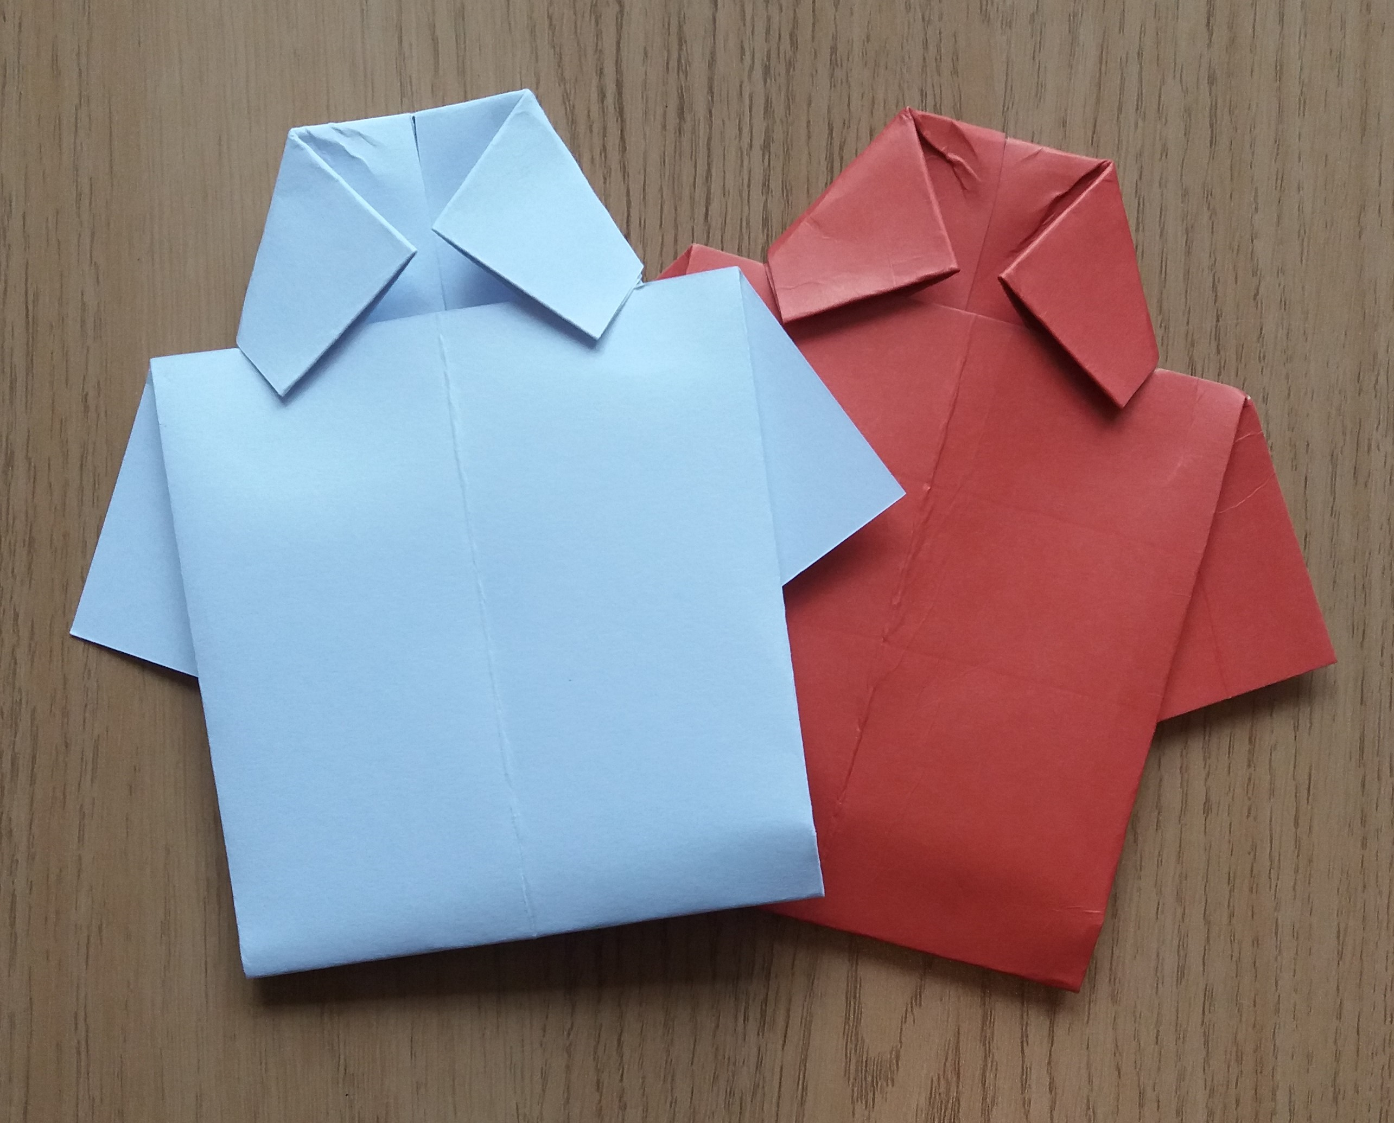
Have a go! Make your own Football Shirt

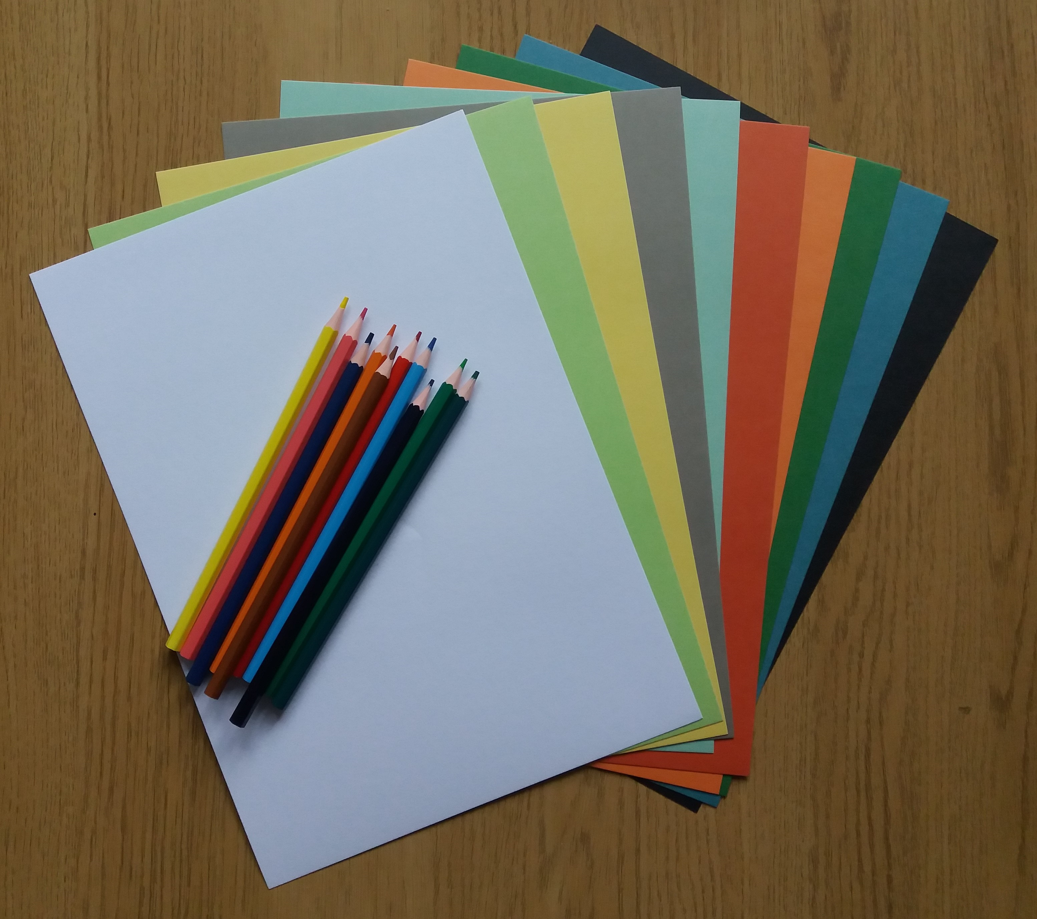
Dorman Museum has lots of Football Shirts on display, why not have a go at making your own?

What you will need –
A4 Paper or Card
Coloured pencils or felt pens

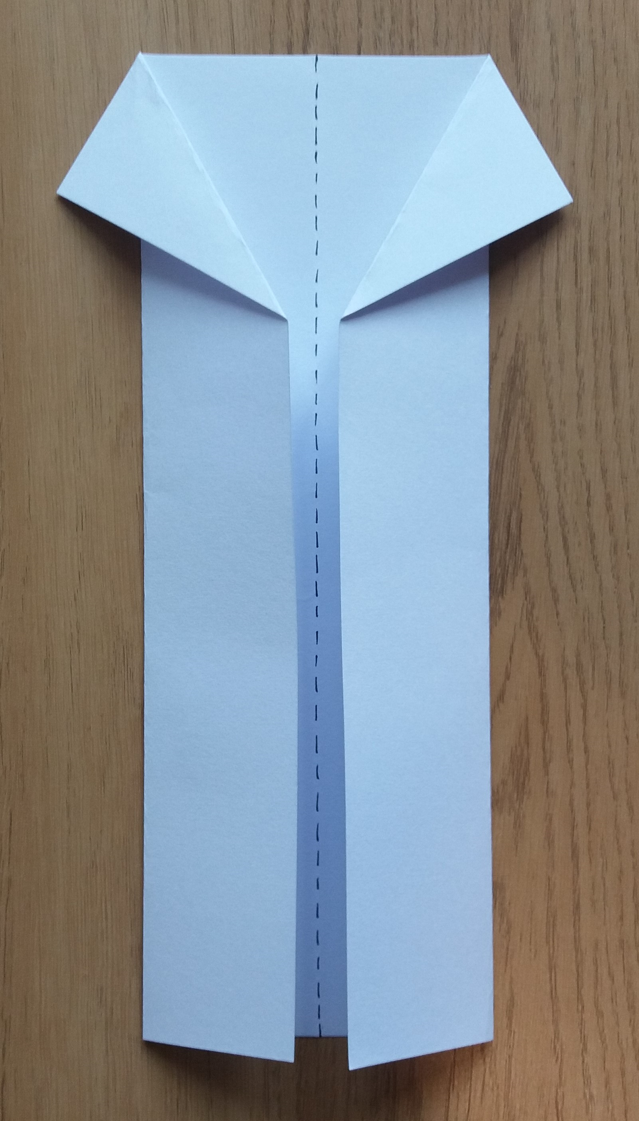
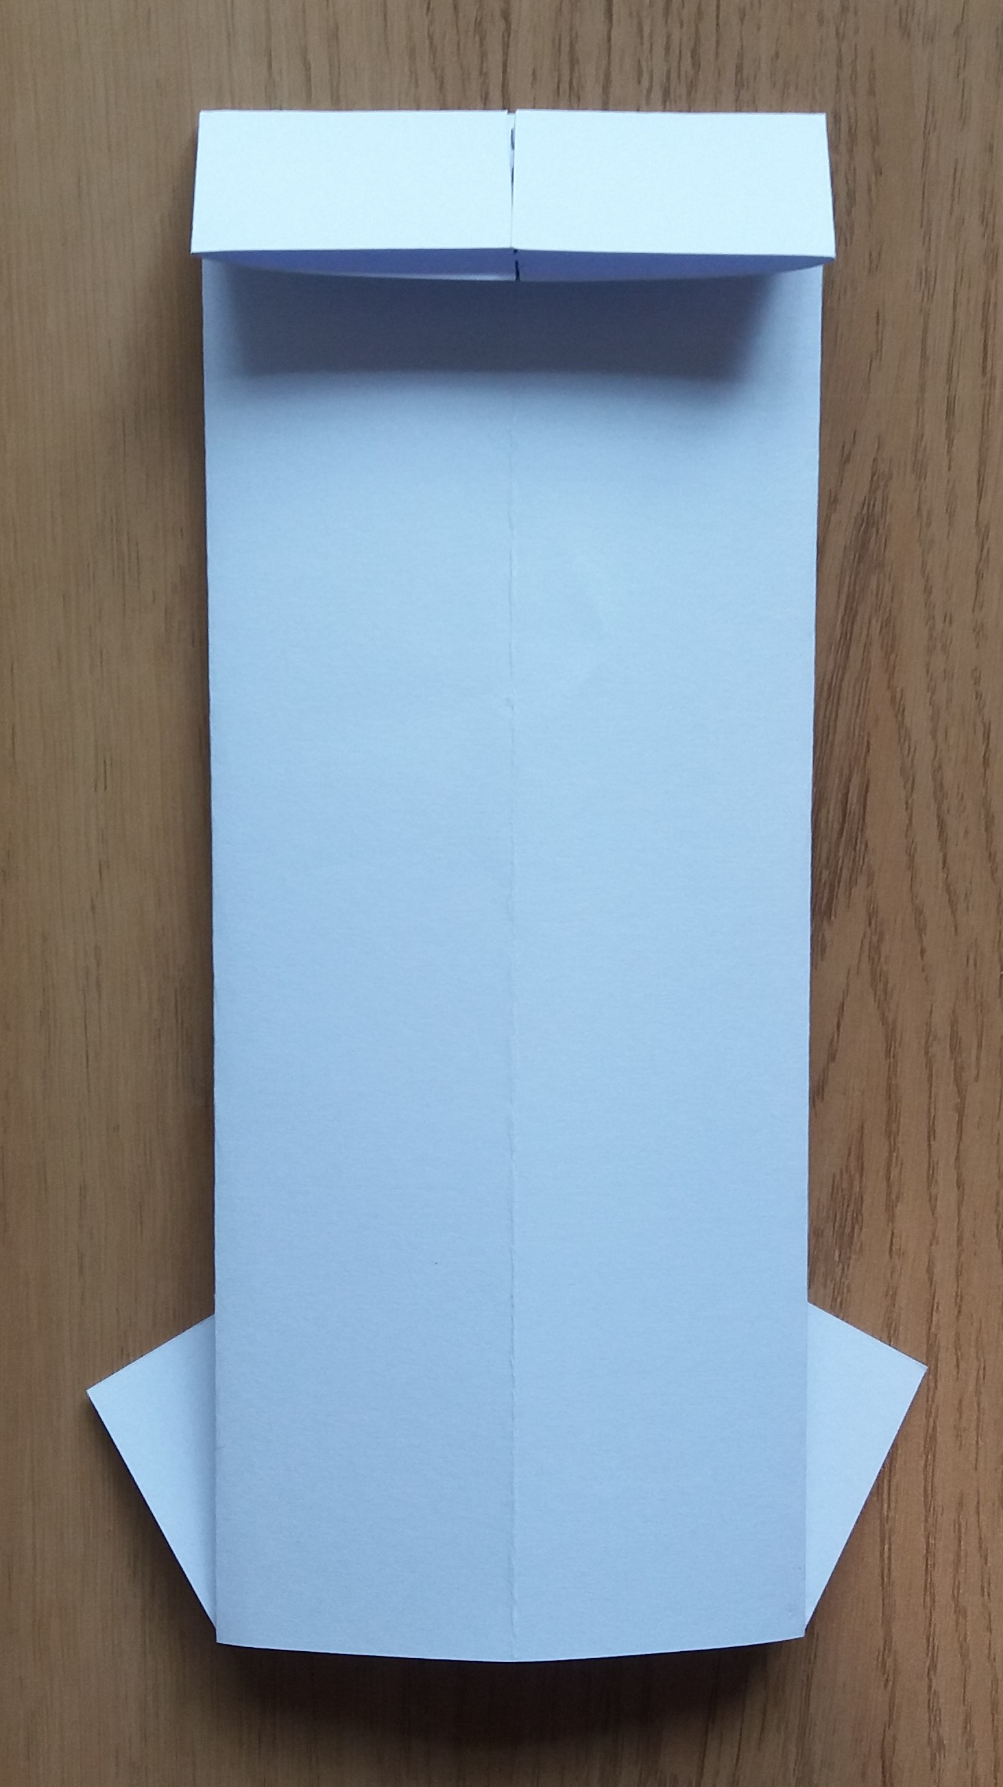
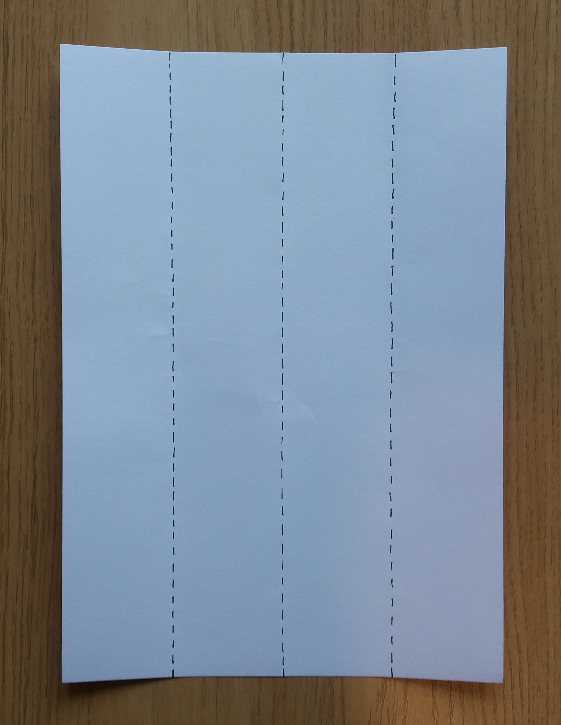

1. Fold an A4 piece of paper twice, first in the middle, then fold the sides of the paper into the middle.
3. Turn your paper upside down and flip it over. Fold down the top of the paper.
2. Fold both left and right side flaps as shown above.

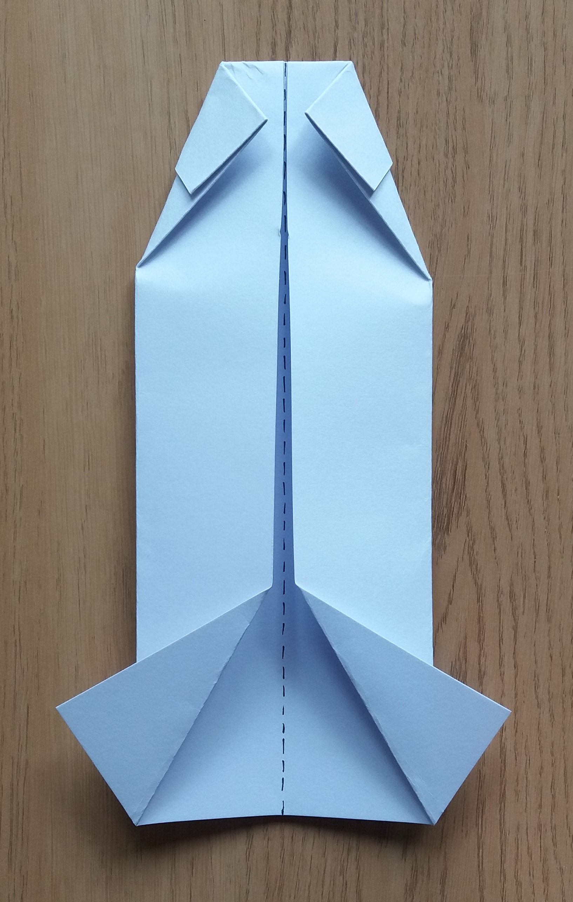
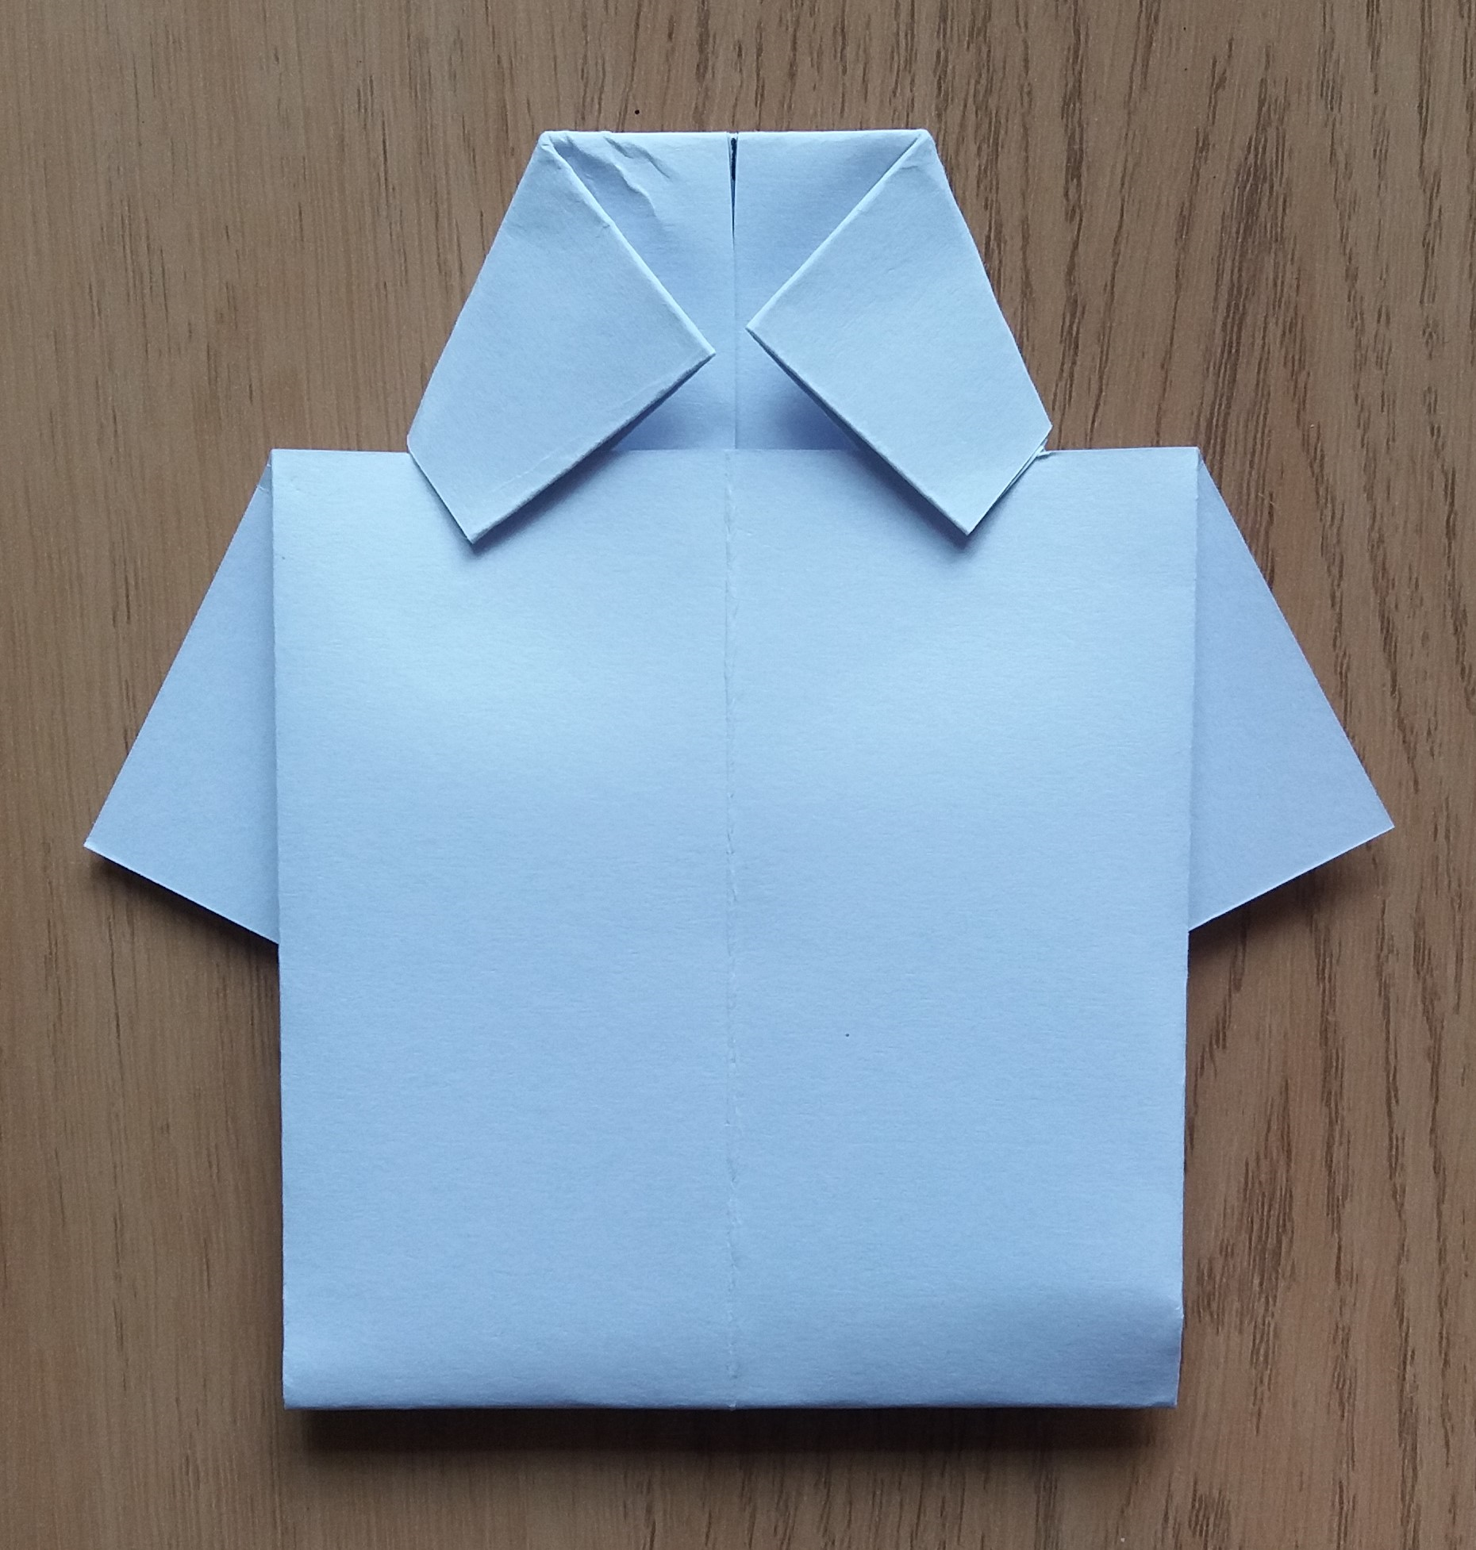
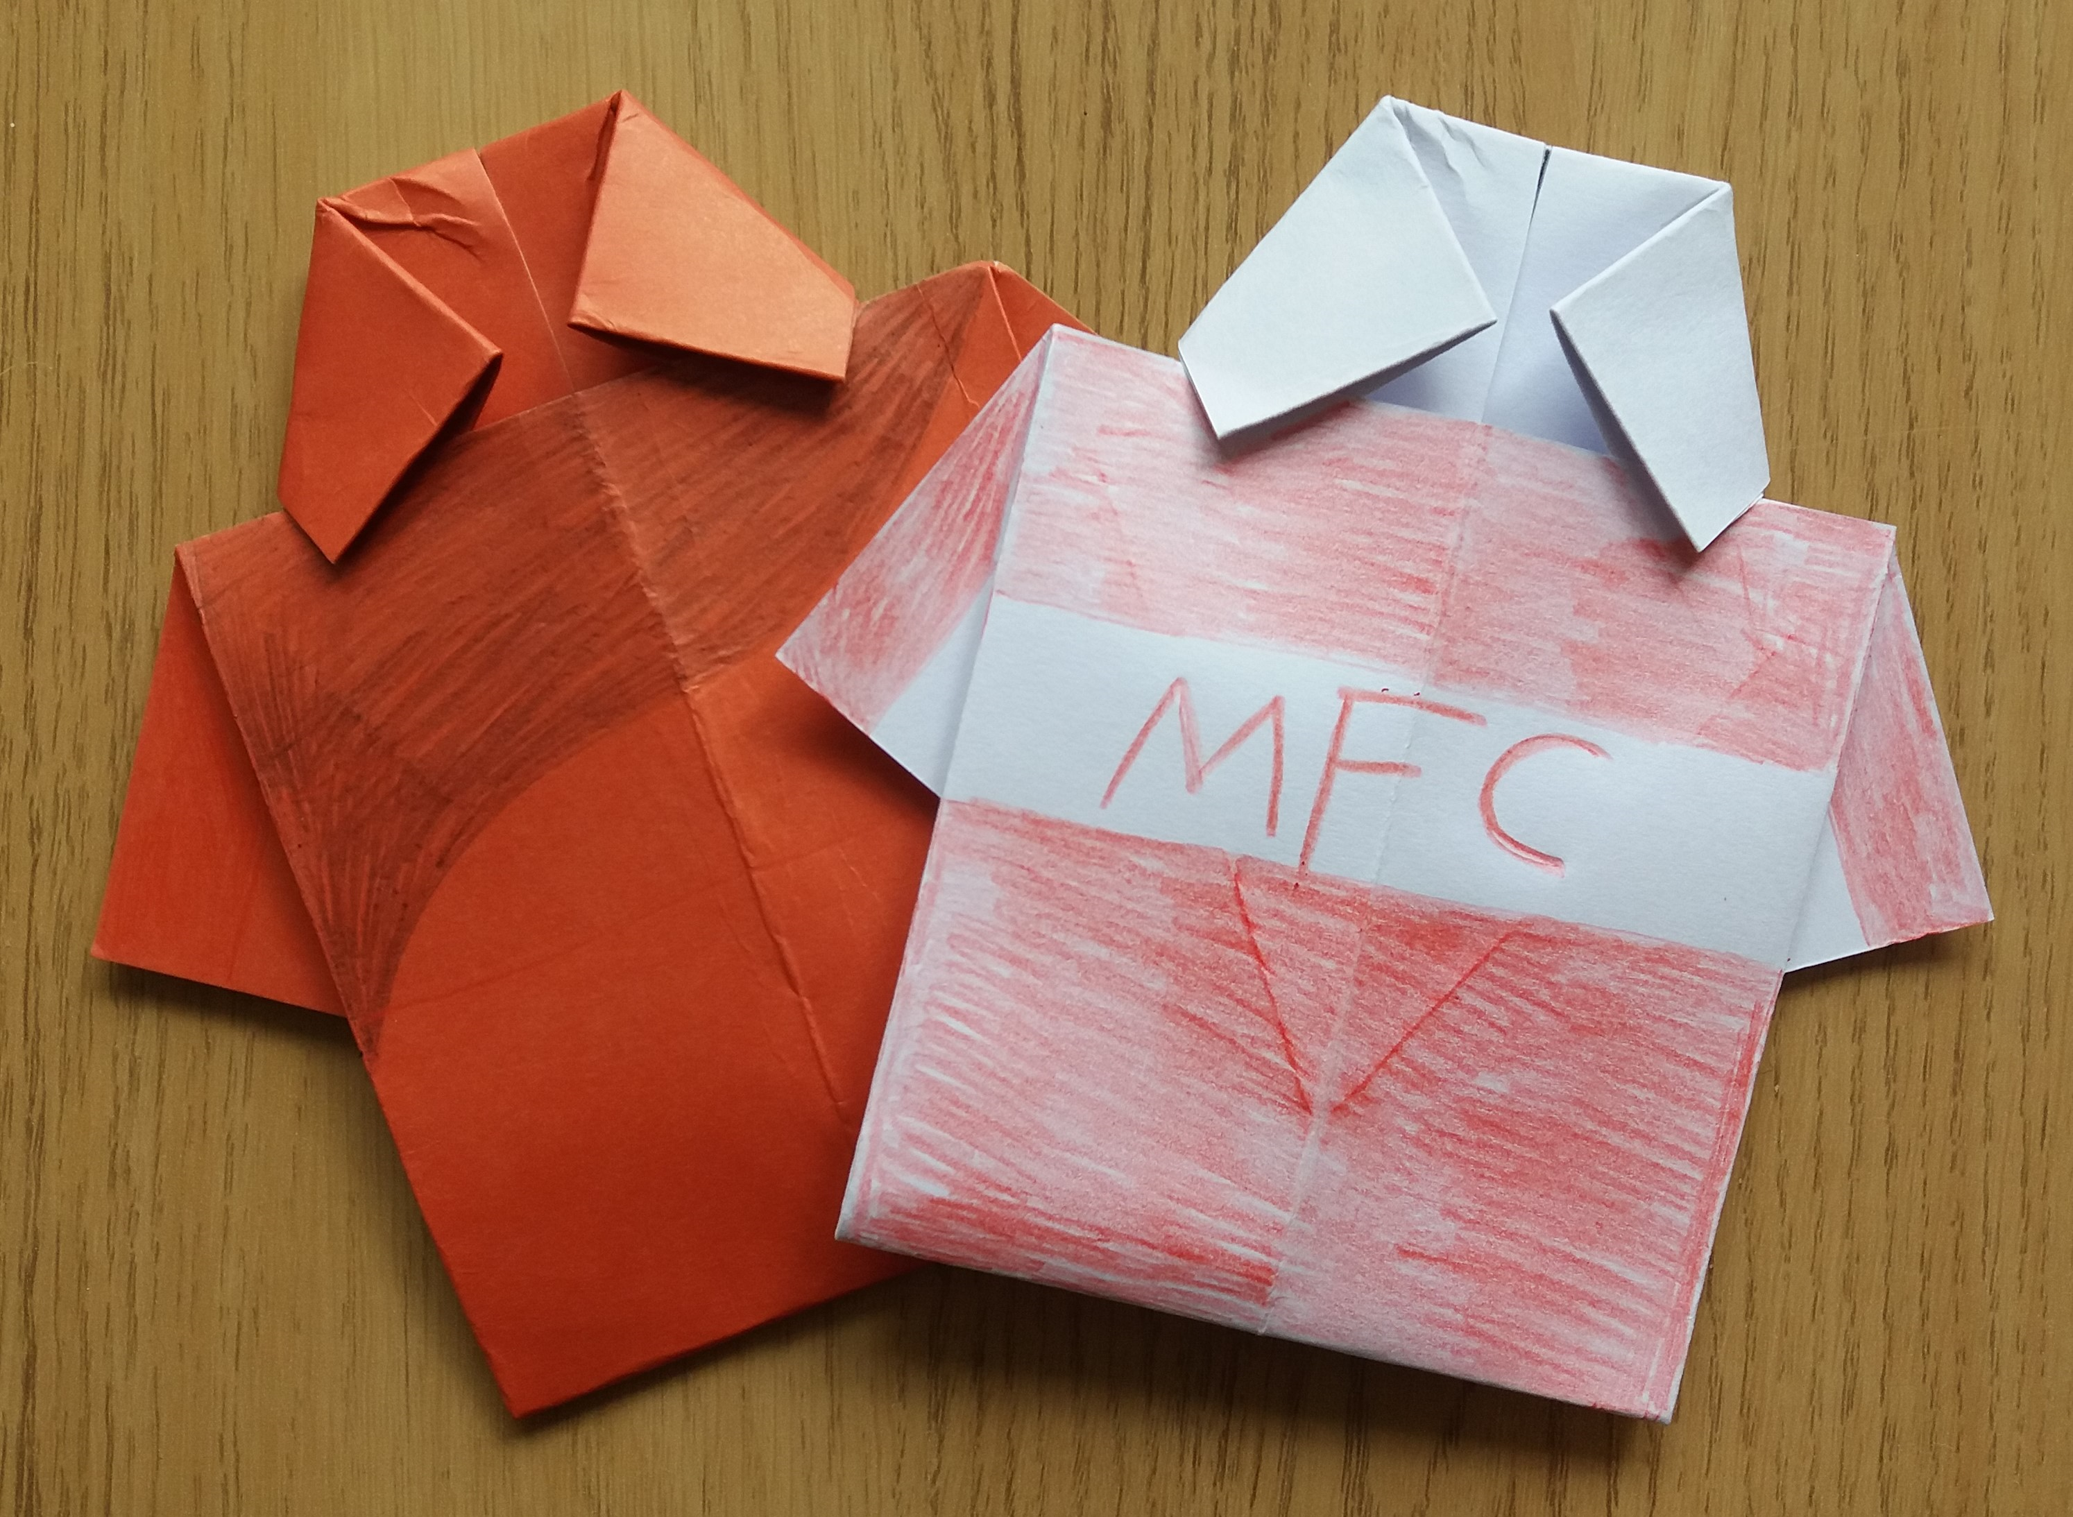

6. Decorate your Football T Shirt with your favourite team, player, or how you like.

4. Turn your paper over again then fold both the left and right side flaps as shown in the picture.
5. Then fold the bottom of your paper upwards and under the flaps you have just made.

