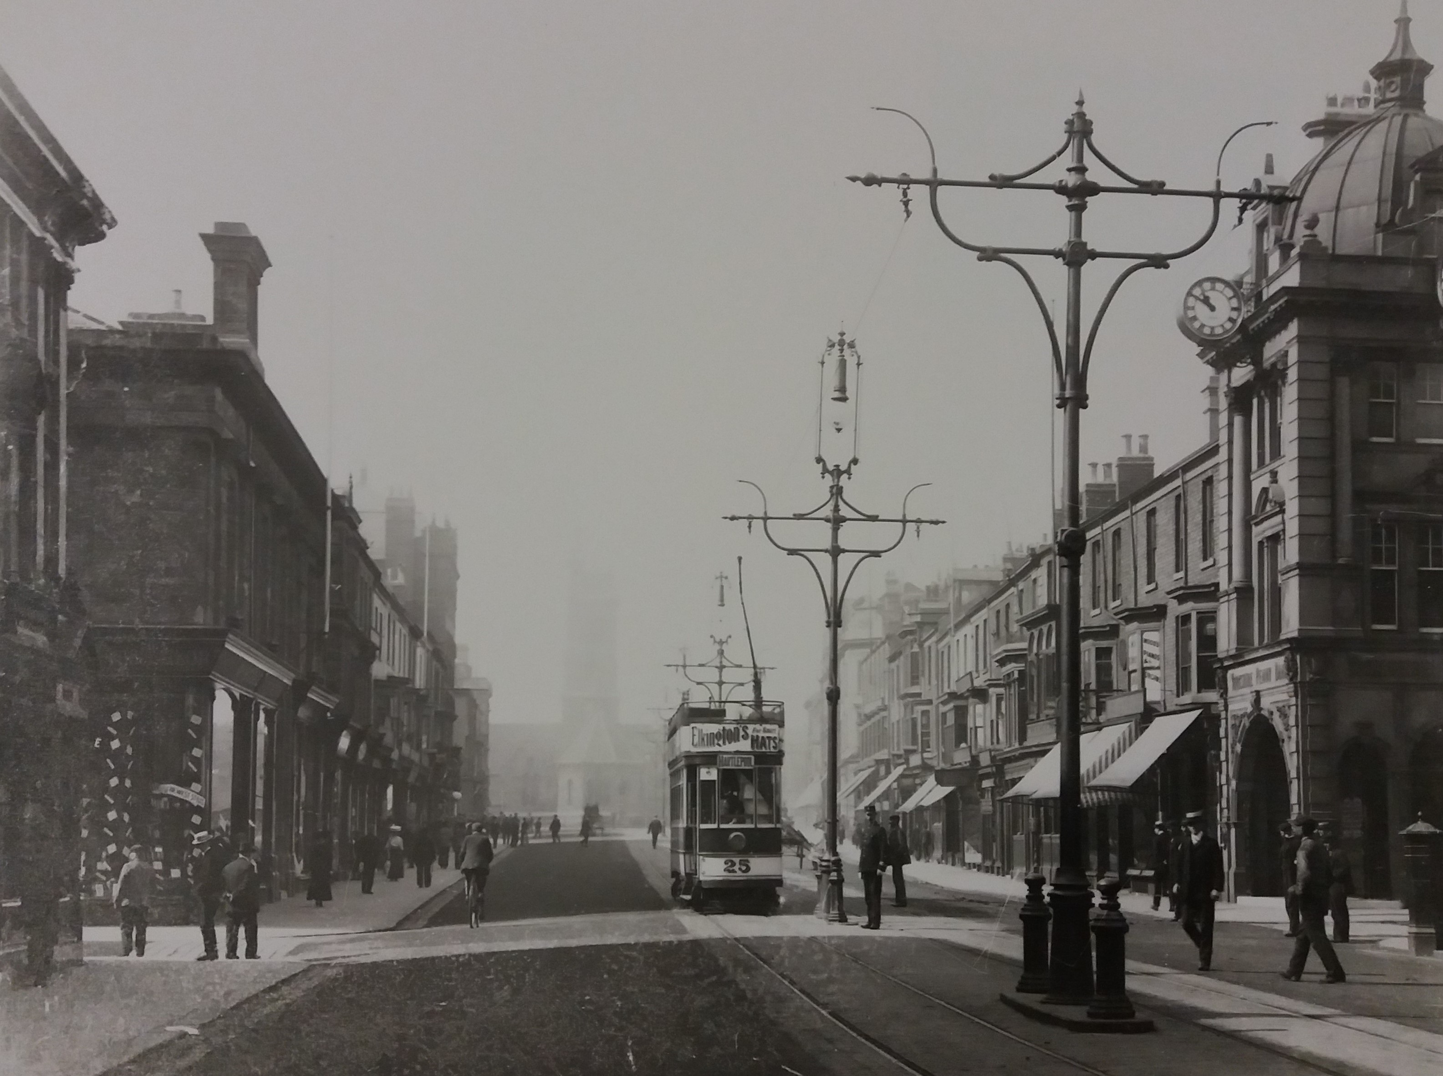

Women Business Owners of Church Street, Hartlepool
Talking Tees Valley Activity Pack

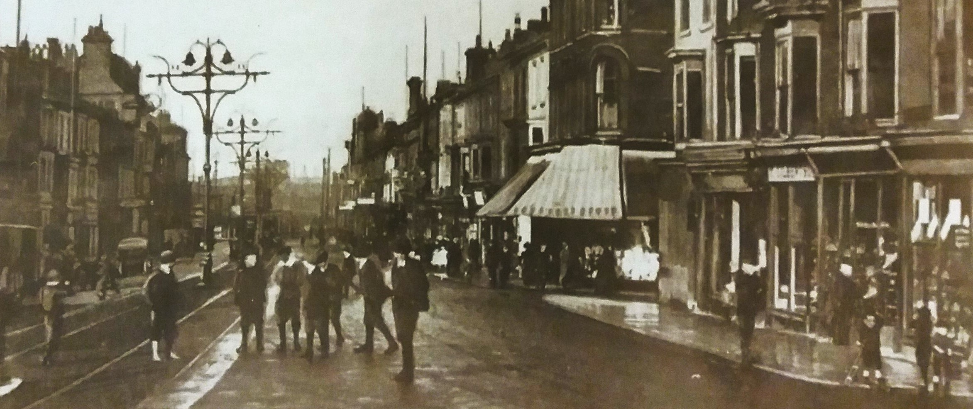



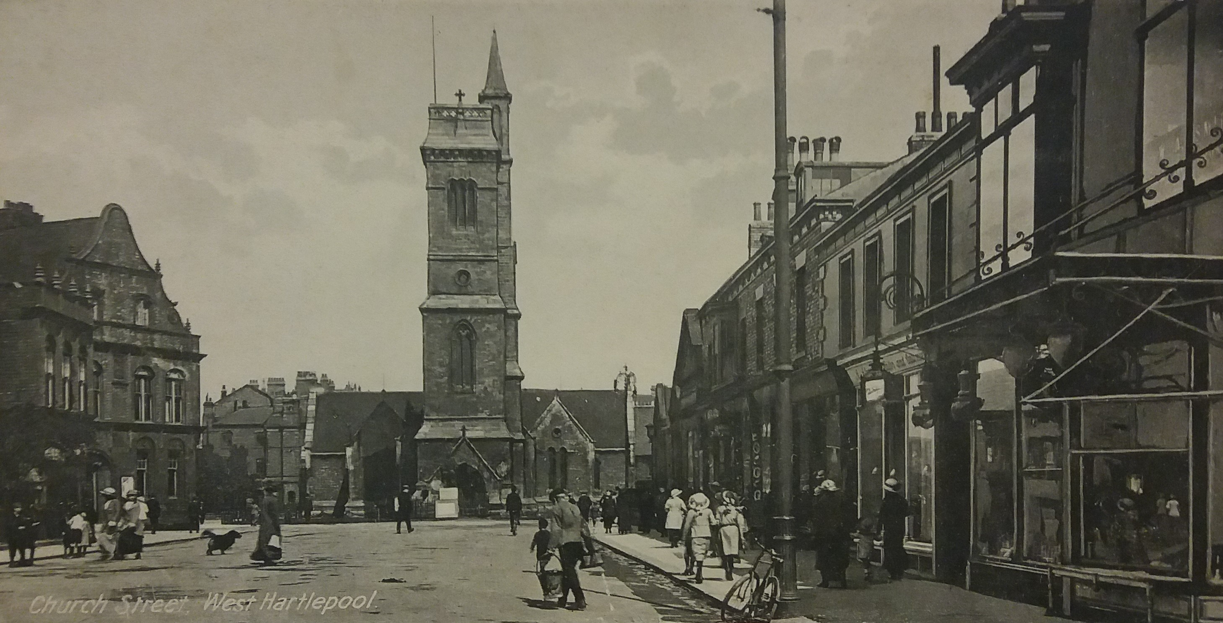
We also don’t have the products these women would have sold, but we have objects that were similar.
Why silhouettes? We don’t have photographs of these women, so we don’t know what they looked like. This was a reality a lot of women business owners faced, so we have chosen to represent them with these silhouettes of women.
For Women’s History Month we are looking at seven women who owned businesses on Hartlepool’s Church Street in the 1880s. We will find out about each of these women and how they started their businesses, and you can have a go at finding all these women and their products with our word search.
Welcome to another edition of the Talking Tees Valley Activity Pack
Each month we use objects and photos from our museums in the Tees Valley to take a closer look at the lives and stories from people in our area.


Annie Ord


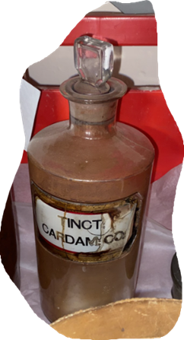
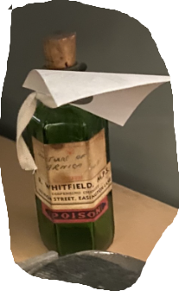

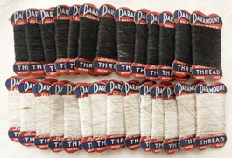
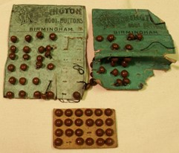

Isabella Emerson
Isabella Brown was born in 1822 in Durham and married Cuthbert Emerson in 1843. Cuthbert was a chemist who opened his own shop on Church Street. The couple had about twelve children, two of who became apprentices in the business.
When Cuthbert died in 1888 Isabella, like many women at the time, continued her husband’s business. The fact that she managed to keep the chemists running under the Emerson name implies that she was very engaged in her husband’s work and may have worked with him for many years.
Here’s a Fact –
Before they were made from plastic in the late 1900s, buttons were made from animal bone, shell, metal and fiber.
With her as the business owner, her sisters worked as fancy dealers, selling objects like buttons and thread at their Church Street shop. When Annie died in 1902 her sister Frances took over as head of the household.
When her father died in 1888, she took over her father’s business selling stationery and hats. She appears to have done this as a way of supporting herself and her large family, which was made up of her mother and her siblings.
Annie Ord was born in Hartlepool in 1844. She worked as an assistant to her father who was a printer and newspaper proprietor.
Sarah and Lucy Hailey

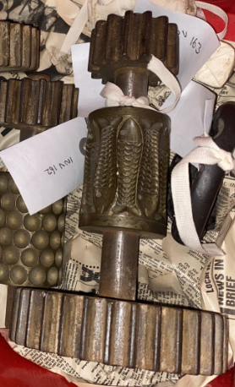



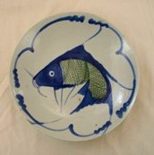
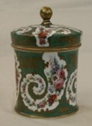
Here’s a Fact –
Sweets were made by boiling sugar and adding flavours. They could be cut into shapes with these rollers or shaped by hand.
While Sarah eventually left the business to get married, it was Lucy who took over and ran the shop. It was quite successful as Lucy would eventually train a team of six women to work with her at Church Street.
Sarah Hailey used to work as a Schoolmasters Assistant in Brighton when she was 23. She later returned and opened a Sweet Shop with her sister Lucy.
The Haileys were another set of sisters who started their own career. Sarah and Lucy Hailey had no relatives in business and chose to become sweet-makers and open their own shop on Church Street.
Julia Burdon
Julia Burdon was married to John Vincent Burdon and they had 8 children. In the 1880s he worked as a ship broker in Hartlepool, and to keep the family’s finances afloat, she became a china and glass dealer.
She opened her shop on Church Street in 1888 and would have sold things like plates, cups and vases. In 1921 she was succeeded by her son Oswald, who became a merchant broker on Church Street.

Here’s a Fact -
Women could not legally own property if they were married. However, they could be in business, usually their husband’s, and were responsible for their own debts.

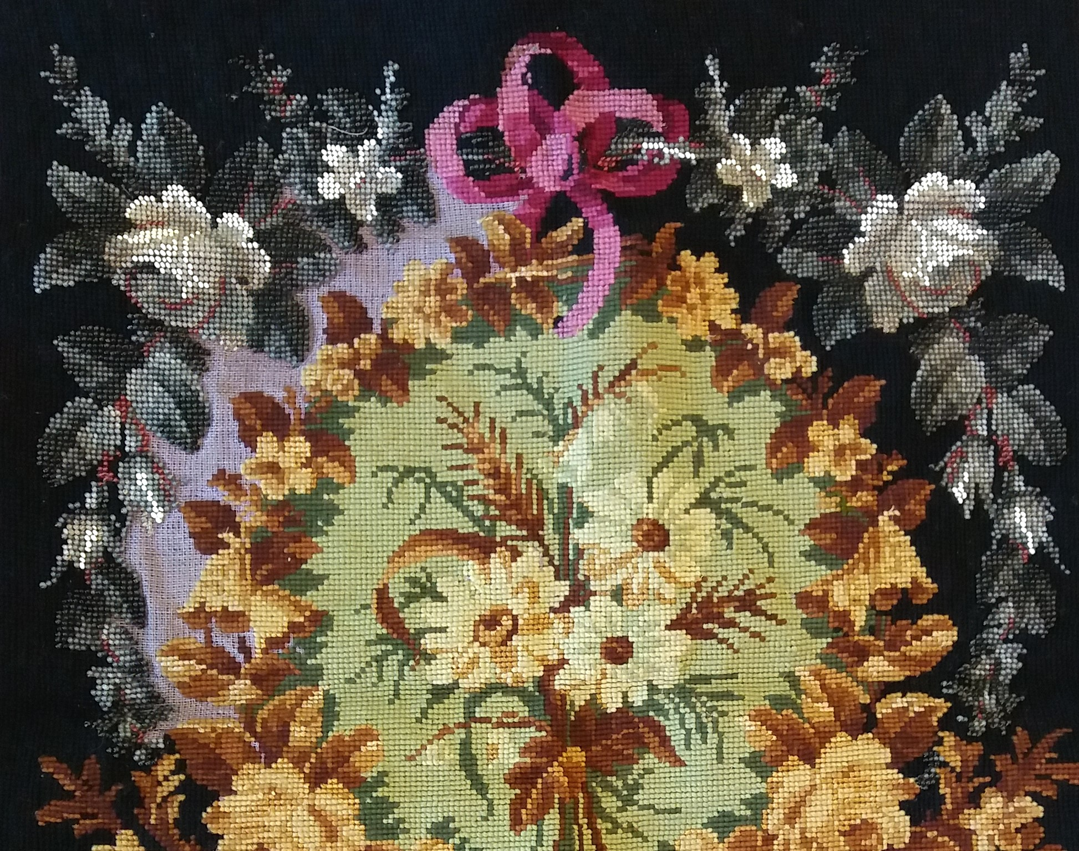
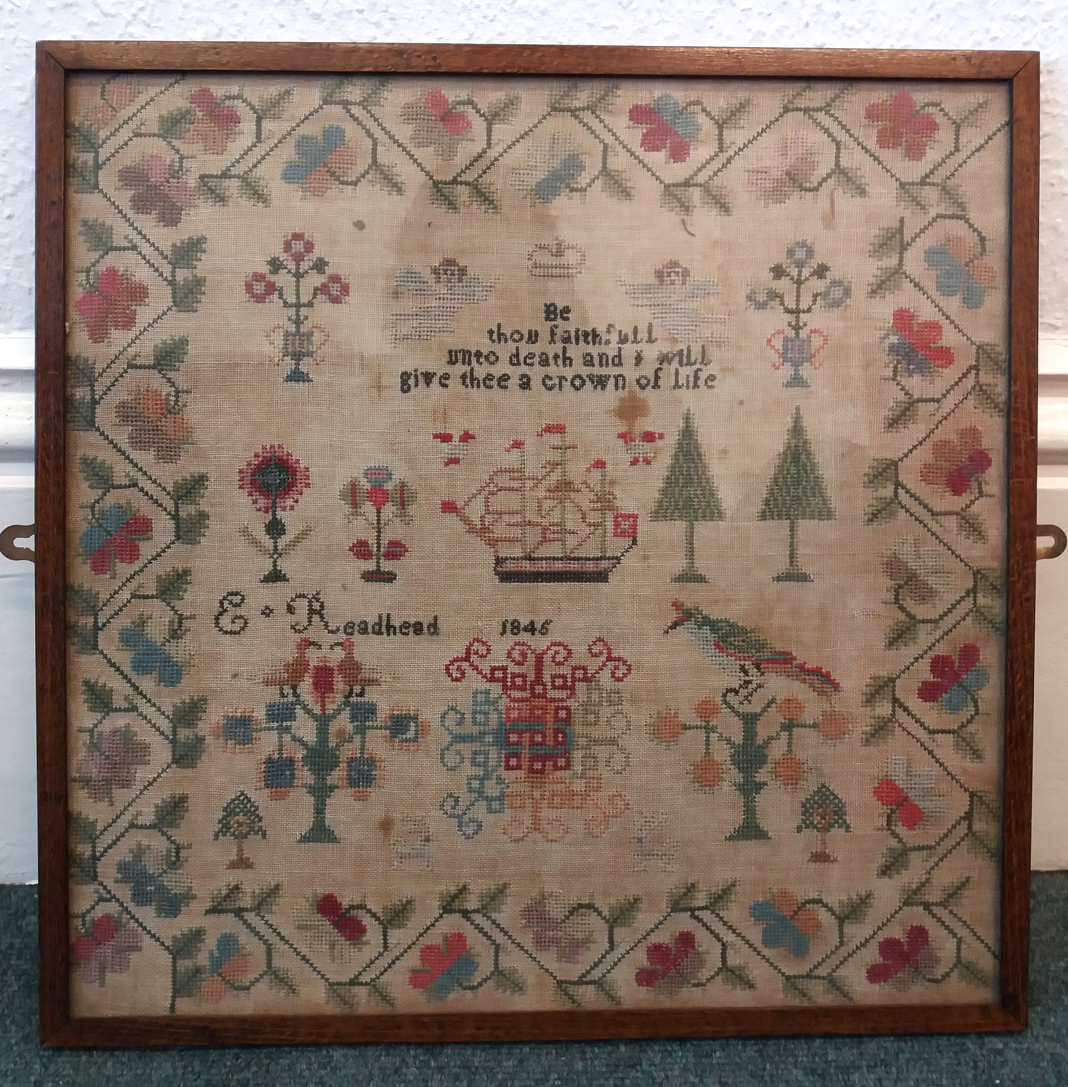

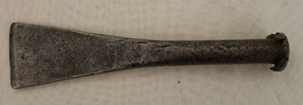
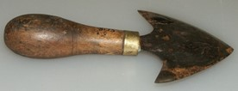

Here’s a Fact –
Berlin wool was like cross stitch or embroidery and was popular. They would use flower patterns or animals or Biblical phrases like ‘God bless our home’.
Her mother decided to open a shop on Church Street, dealing in music and fancy goods, sometimes known today as gifts. Mary worked as an assistant to a draper before she took over the running of the shop.
Mary Ann Taylor was born in Hartlepool in 1841, the eldest daughter of Joseph Taylor, a Professor of Music. She started working as an assistant to her father until he died in 1876.
The shop was marketed as a Berlin Wool Shop selling crocheted items. Taylor would also stock things like slippers, cushion covers and curtain tassels.
Mary Ann Taylor
Here’s a Fact -
Metal working trades may seem unusual for women, but Ellen was far from alone in the trade. For example, in Manchester, there were six female blacksmiths and five female machine makers in 1846.

After he died in 1876, Ellen continued his business for many years and sold tools at the shop. She was also advertising as a roofer in local newspapers.
Ellen Pick was born in 1830 in Thirsk to a family of farmers. She married Robert Clough in 1854 and they moved to West Hartlepool and had six children. Robert opened an ironmongers shop on Church Street.
Ellen Clough
Women Business Owners of Church Street Word Search

Can you find all the women, their products and locations in our Word Search? You can find which words to look for in the column on the right.

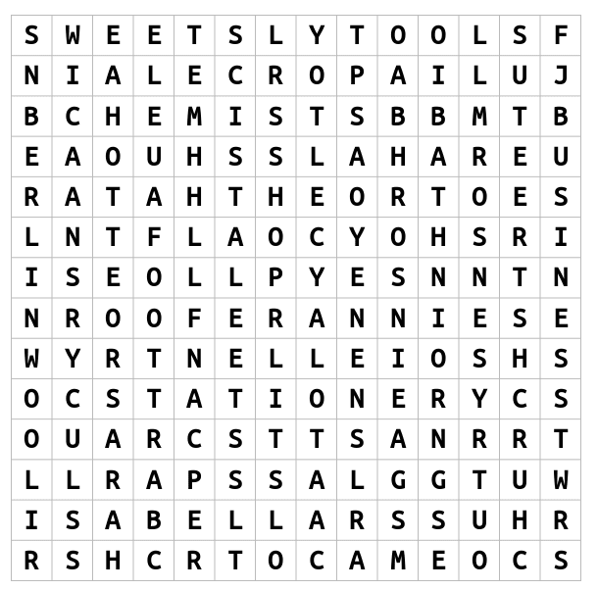
Sarah
Ellen
Mary
Tools
Church Street
Business
Chemists
Shop
Isabella
Roofer
Hats
Stationery
Sweets
Porcelain
Glass
Berlin Wool
Annie
Cameo
Lucy
Julia

All images used in this pack are courtesy of Hartlepool Museums Service.

You can find all our Talking Tees Valley packs through the Tees Valley Museums website under ‘Latest News’ or here: https://teesvalleymuseums.org/news/

If you would like to share your stories or contact us about the packs please e-mail teesvalleymuseums@stockton.gov.uk

